

**A Project Report**

**On**

**Automation Testing using Selenium Webdriver**

**On**

**Tools QA Website**

**By**

**Sayali A Patil**

**Batch-EON(2021-5334)**

**Under the Guidance of,**

**Priyanka Desle**

**(Technical Trainer)**

**At**

**Edubridge India Pvt Ltd**

**Introduction**

This project aims to do overall testing like functional testing, GUI testing on website to check quality of website. It helps to improve quality of website and saves time for manually doing this testing. In this project our main focus is to check functionalities available on website. Also it includes title check and all links count with their working status.

Operating system : Window 10

Browser : Google chromeVersion  91.0.4472.164

IDE : Eclipse IDE 8.1

Language : Java

Framework : Selenium webdriver

**TC 01 -Launch browser and open URL of ToolsQA**

**Selenium WebDriver Test Script :**

System.*setProperty*("webdriver.chrome.driver","C:\\Users\\Asus\\Desktop\\Selenium_jar\\chromedriver.exe");

WebDriver w = **new** ChromeDriver();

w.manage().window().maximize();

w.get("https://demoqa.com/");

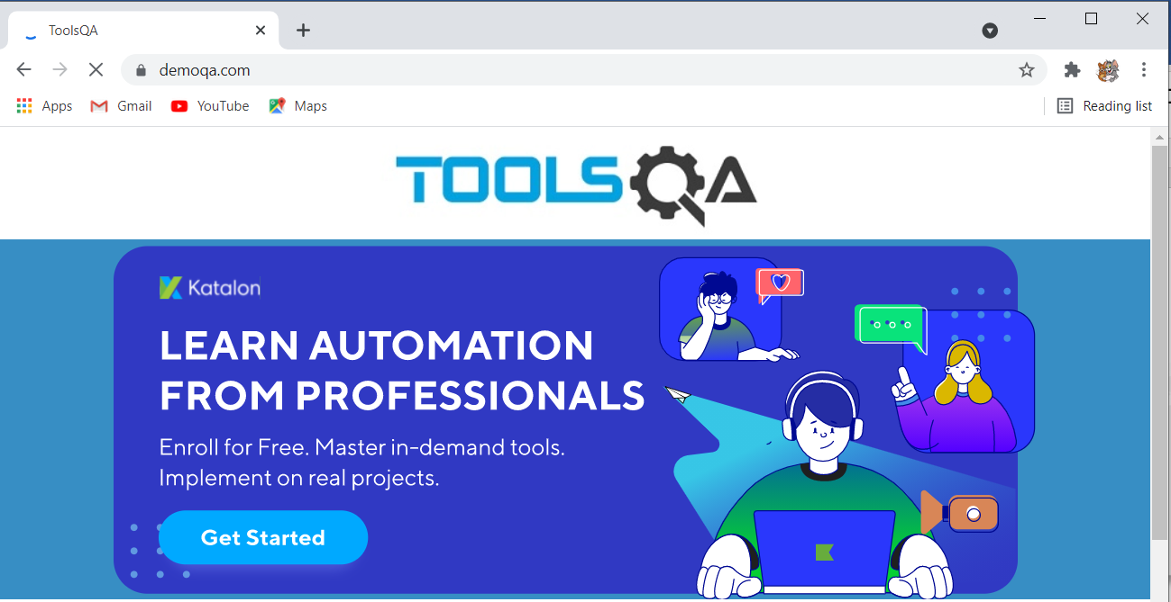Thread.*sleep*(2000);

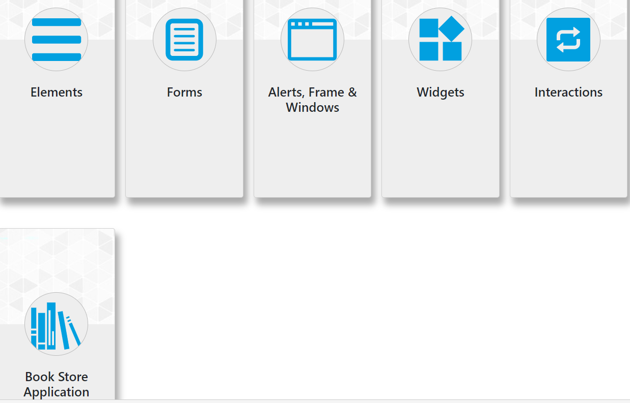

**TC 02- To Check Functionality of Scrolling**

**Selenium WebDriver Test Script :**

JavascriptExecutor js = (JavascriptExecutor) w;

js.executeScript("window.scrollBy(0,1500)");

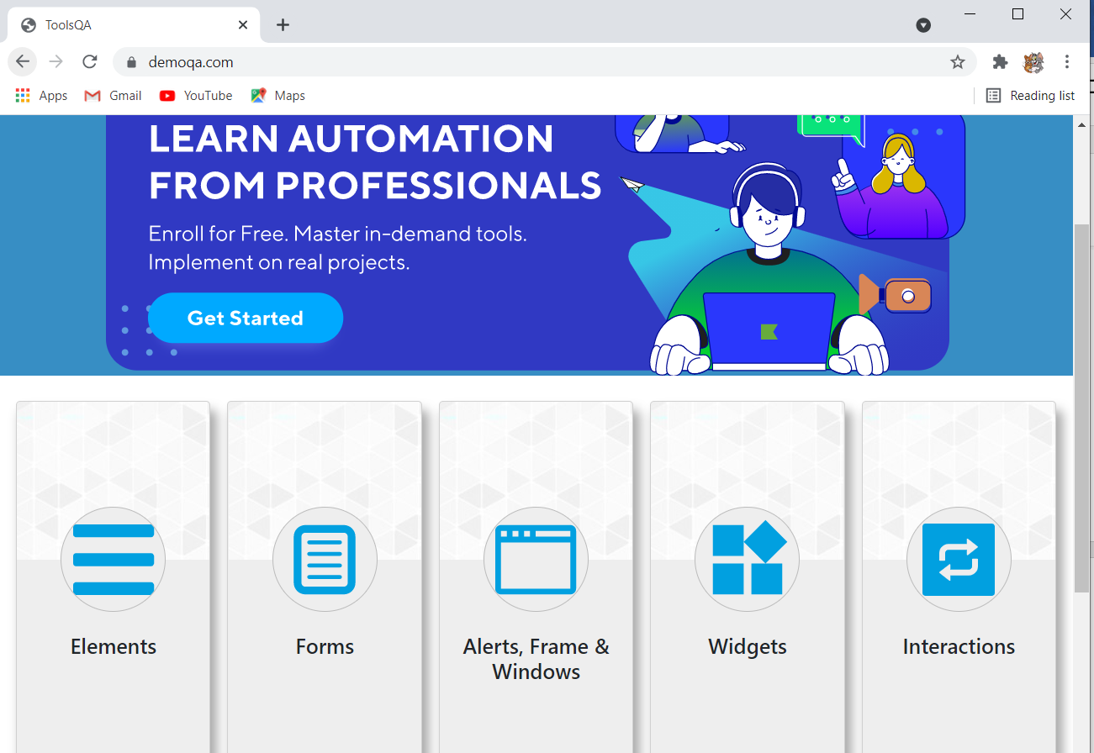

**TC 03–To verify and Display the URL of current page of browser**

**Selenium WebDriver Test Script :**

w.getCurrentUrl();

System.***out***.println("Current URL: "+ w.getCurrentUrl());

**TC 04–To verify and Display the Title of current page of browser**

Selenium WebDriver Test Script :

w.getTitle();

System.***out***.println("Title: "+ w.getTitle());

**TC05 - To check the functionality of Elements button**

**Selenium WebDriver Test Script :**

w.findElement(By.*xpath*("//*[@id=\"app\"]/div/div/div[2]/div/div[1]/div/div[3]"))

.click();

Thread.*sleep*(2000);

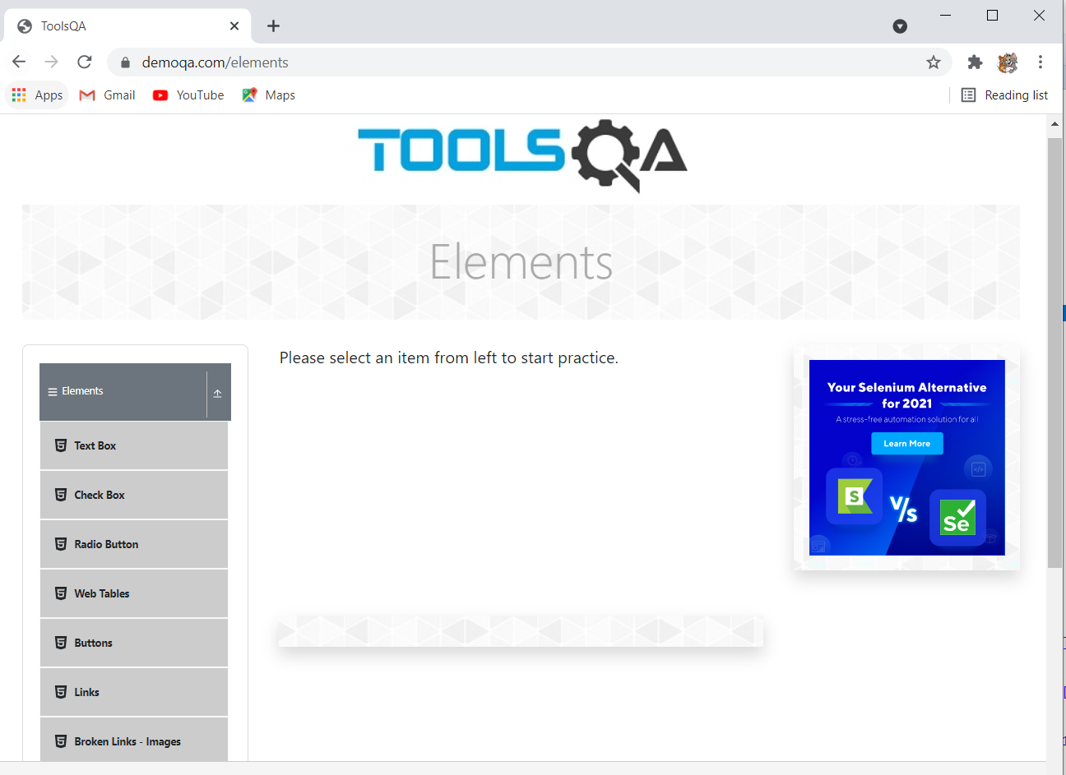

**TC 06–To Check the functionality of Submit button(Text box)**

**Selenium WebDriver Test Script :**

w.findElement(By.*xpath*("//*[@id=\"item-0\"]/span")).click();

w.findElement(By.*id*("userName")).sendKeys("abc");

w.findElement(By.*id*("userEmail")).sendKeys("abc@gmail.com");

w.findElement(By.*id*("currentAddress")).sendKeys("abc");

w.findElement(By.*id*("permanentAddress")).sendKeys("abc");

Thread.*sleep*(2000);

JavascriptExecutor jss = (JavascriptExecutor) w;

jss.executeScript("window.scrollTo(0,document.body.scrollHeight)");

w.findElement(By.*xpath*("//*[@id=\"submit\"]")).click();

Thread.*sleep*(2000);

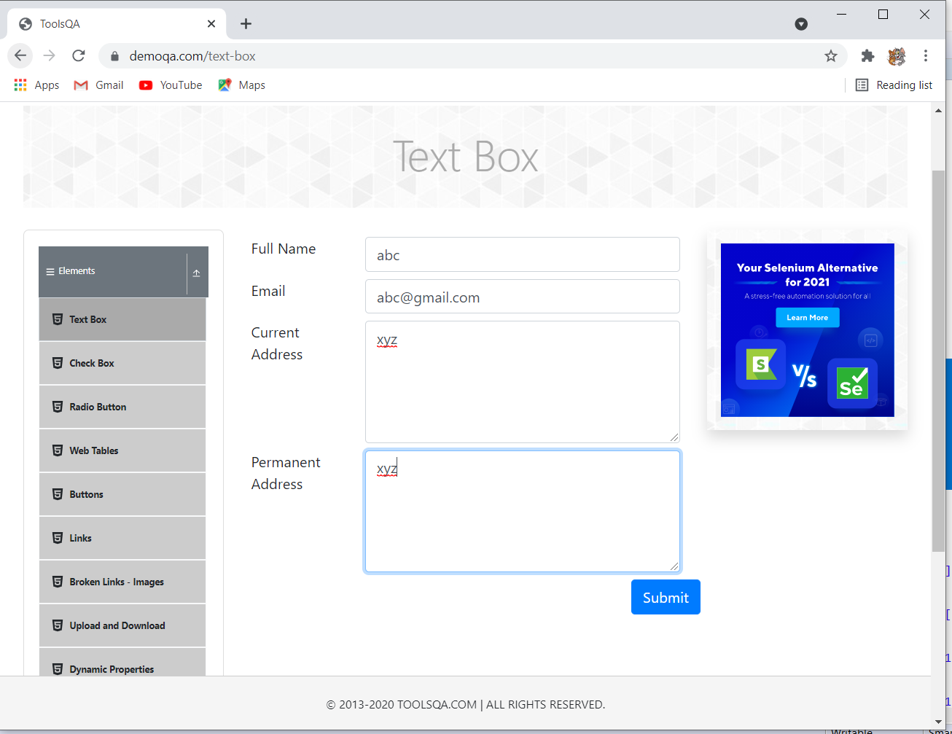

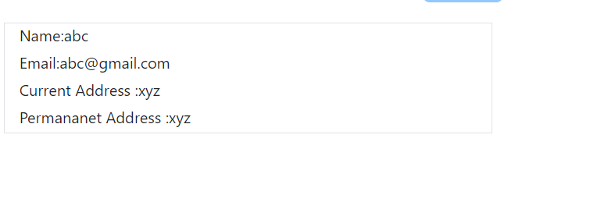

**Defect :**

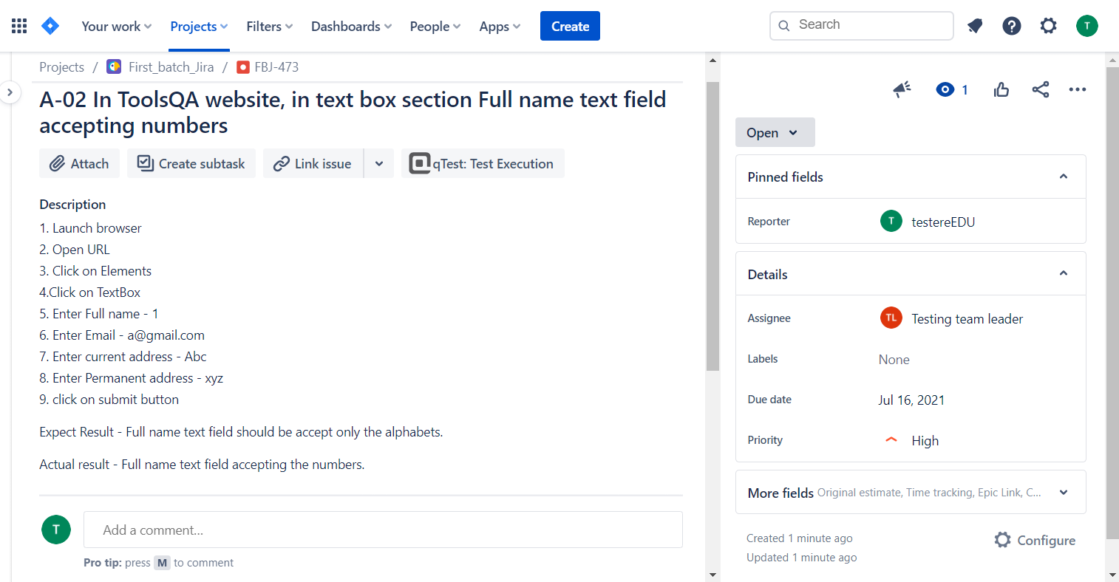

**Selenium WebDriver Test Script :**

**TC 07- To verify and display text of current page of website**

String s = w.findElement(By.*xpath*("//*[@id=\"app\"]/div/div/div[1]")).getText();

System.***out***.println("Text: " +s);

**TC – 08 To Check functionality of Check box**

**Selenium WebDriver Test Script :**

w.findElement(By.*xpath*("//body/div[@id='app']/div[1]/div[1]/div[2]/div[1]/div[1]/div[1]/div[1]/div[1]/ul[1]/li[2]")).click();

Thread.*sleep*(1000);

w.findElement(By.*xpath*("//body/div[@id='app']/div[1]/div[1]/div[2]/div[2]/div[1]/div[1]/div[1]/button[1]/*[1]")).click(); // plus

w.findElement(By.*xpath*("//body/div[@id='app']/div[1]/div[1]/div[2]/div[2]/div[1]/div[1]/ol[1]/li[1]/ol[1]/li[1]/ol[1]/li[1]/span[1]/label[1]/span[1]/*[1]")).click(); // notes

w.findElement(By.*xpath*("//body/div[@id='app']/div[1]/div[1]/div[2]/div[2]/div[1]/div[1]/ol[1]/li[1]/ol[1]/li[2]/ol[1]/li[1]/ol[1]/li[1]/span[1]/label[1]/span[1]/*[1]")).click(); // react

w.findElement(By.*xpath*("//body/div[@id='app']/div[1]/div[1]/div[2]/div[2]/div[1]/div[1]/ol[1]/li[1]/ol[1]/li[2]/ol[1]/li[1]/ol[1]/li[2]/span[1]/label[1]/span[1]/*[1]")).click(); // angular

JavascriptExecutor js1 = (JavascriptExecutor) w;

js1.executeScript("window.scrollBy(0,1500)");

w.findElement(By.*xpath*("//span[contains(text(),'Downloads')]")).click();

Thread.*sleep*(2000);

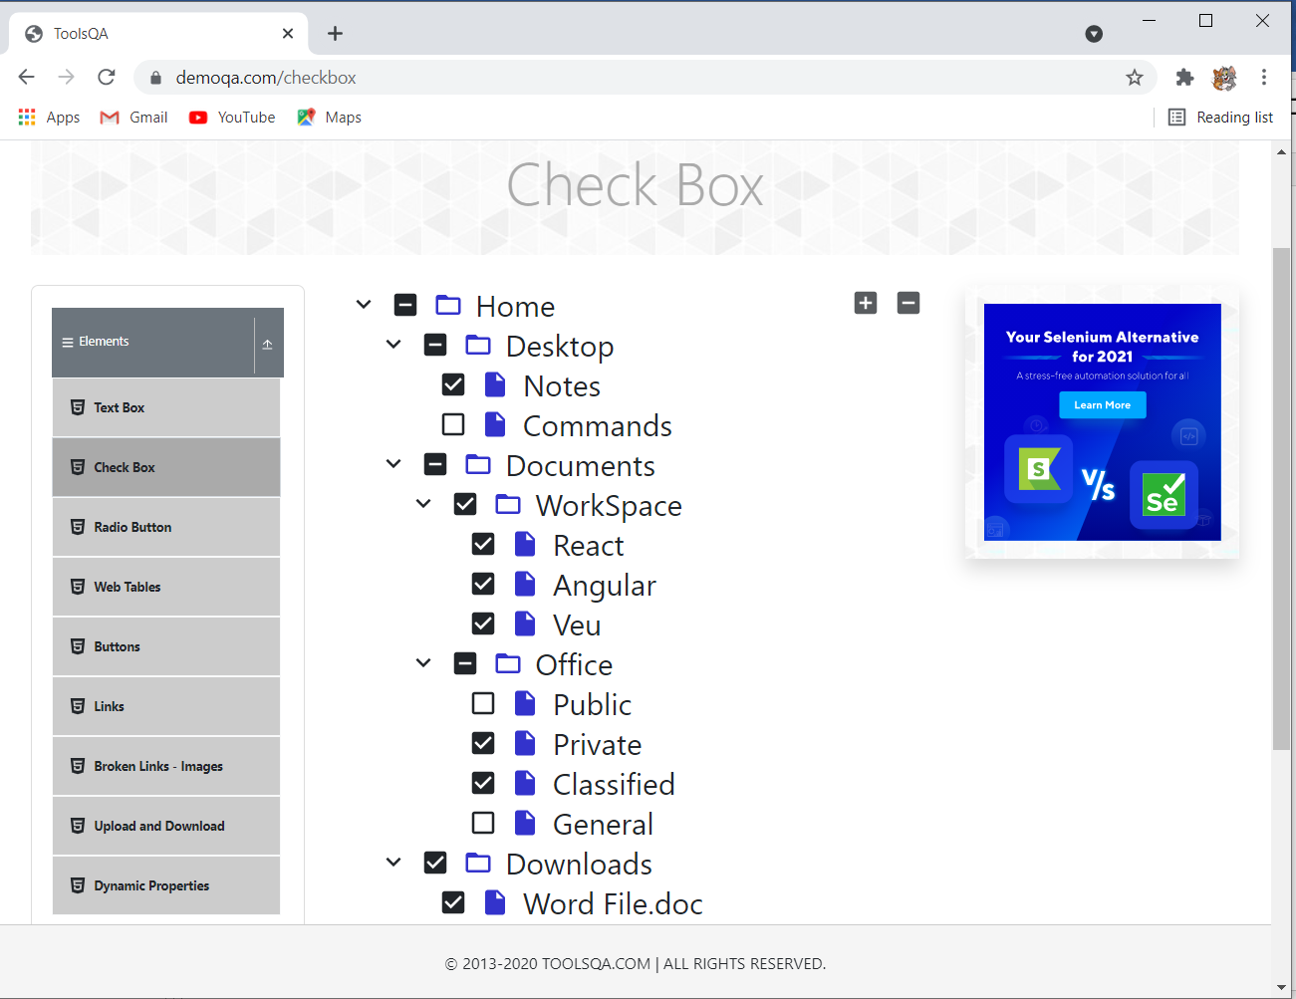

**Selenium WebDriver Test Script :**

**TC 09–To check functionality of radio button**

w.findElement(By.*xpath*("//body/div[@id='app']/div[1]/div[1]/div[2]/div[1]/div[1]/div[1]/div[1]/div[1]/ul[1]/li[3]")).click();

w.findElement(By.*xpath*("//label[contains(text(),'Yes')]")).click();

Thread.*sleep*(1000);

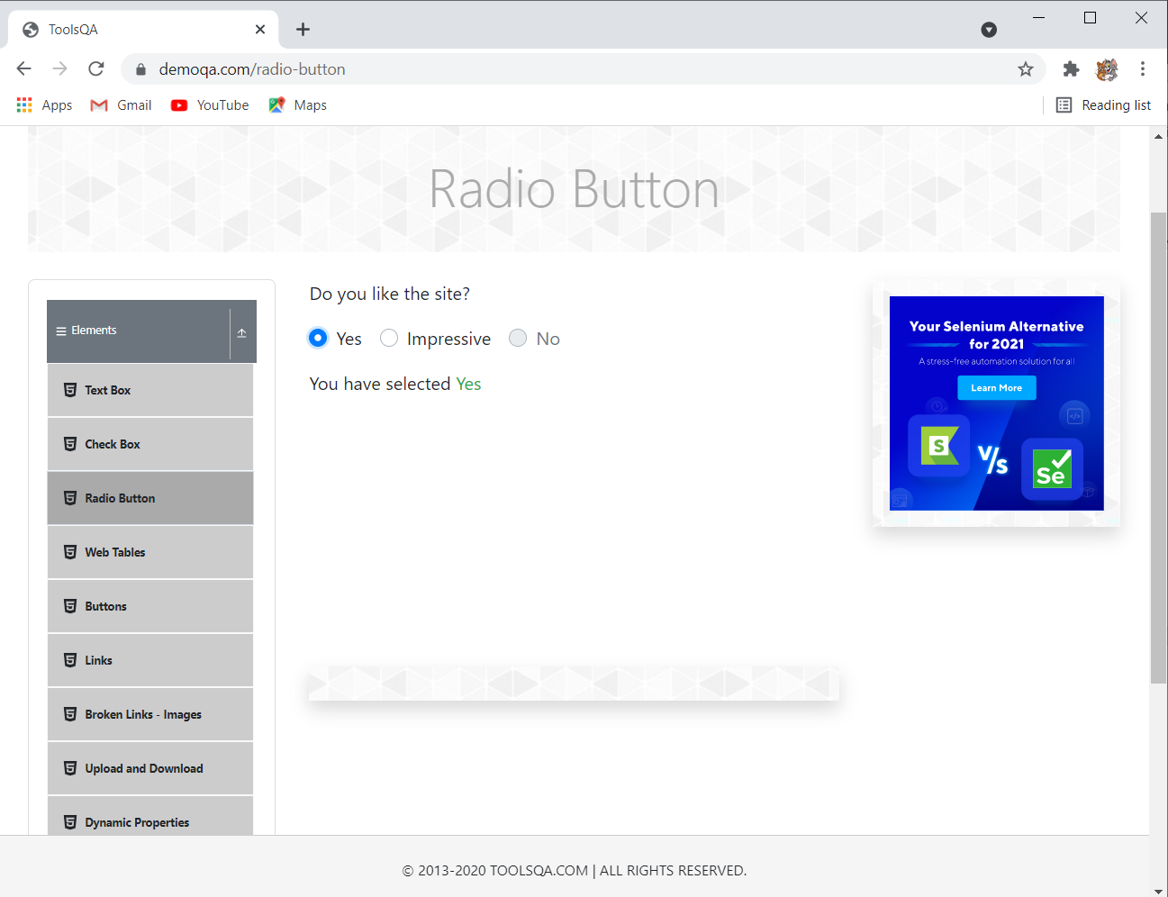

**Defect report :**

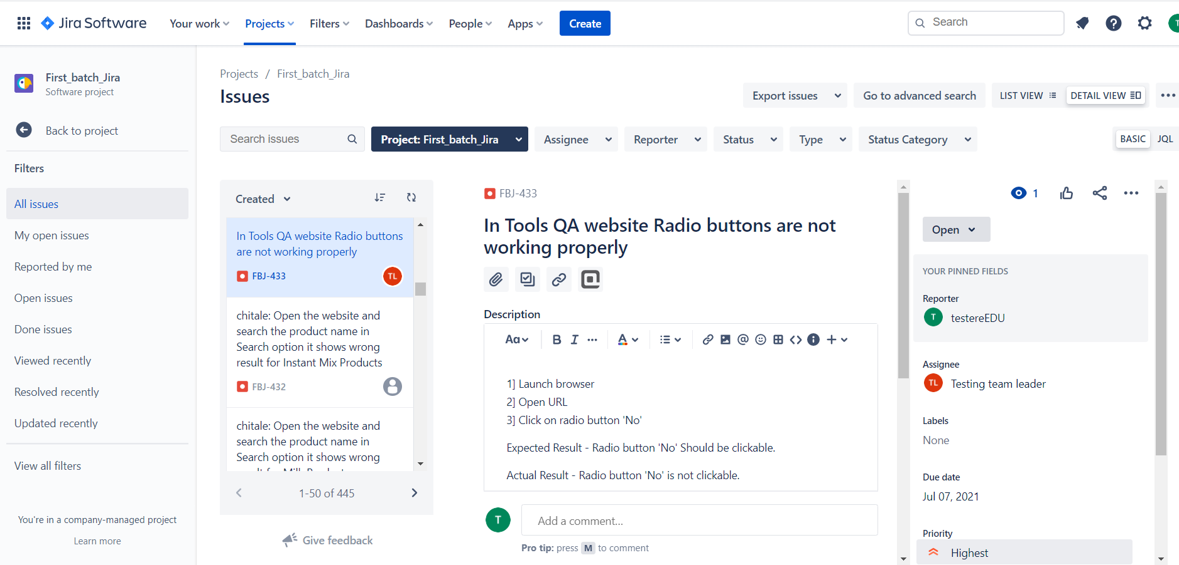

**Selenium WebDriver Test Script :**

**TC10 –To check functionality of Web Tables button**

w.findElement(By.*xpath*("//*[@id=\"item-3\"]")).click();

Thread.*sleep*(1000);

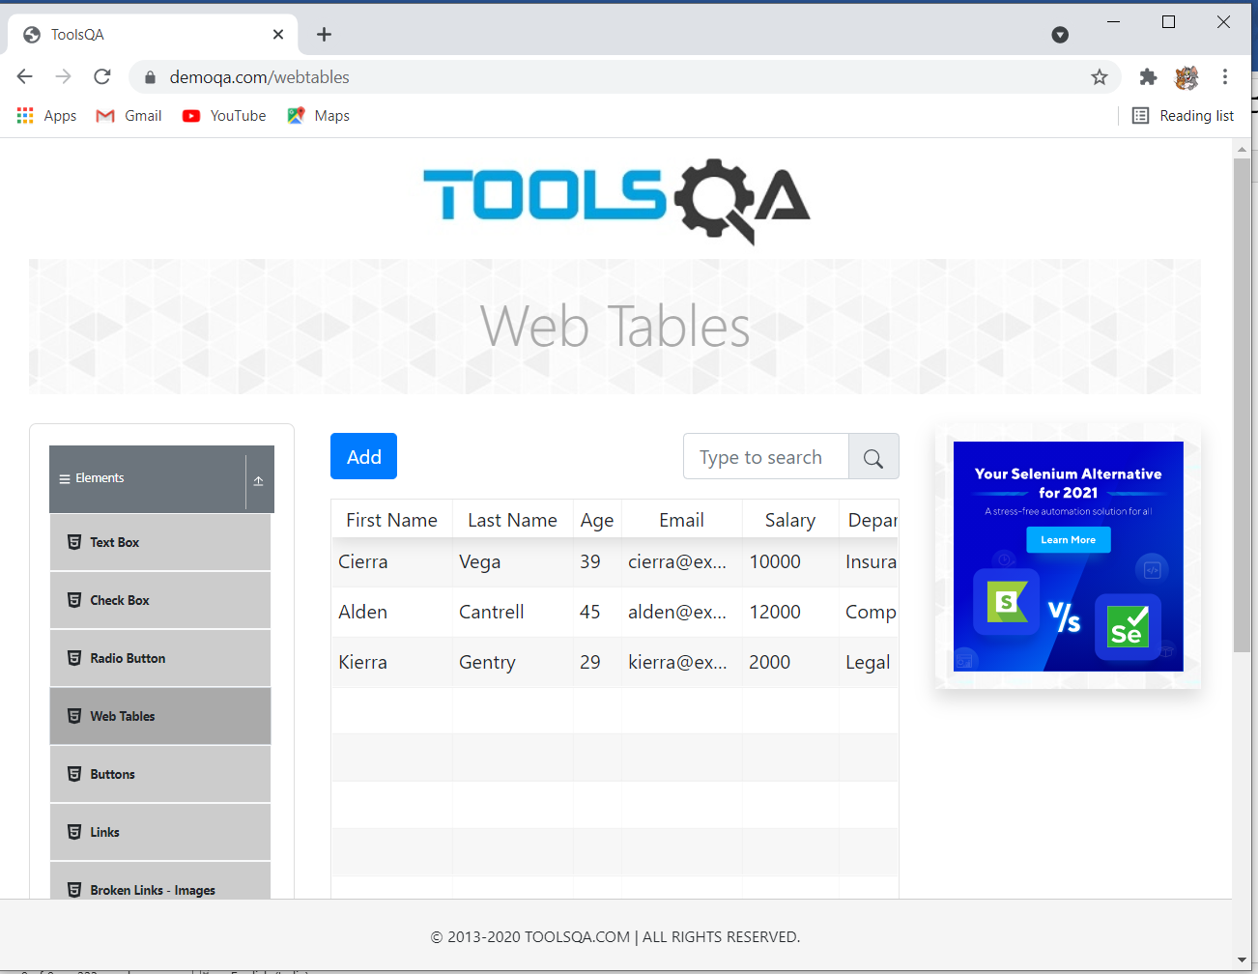

**TC 11 –To Check functionality of Web Tables-add button**

**Selenium WebDriver Test Script :**

w.findElement(By.*xpath*("/html[1]/body[1]/div[2]/div[1]/div[1]/div[2]/div[2]/div[1]/div[2]/div[1]/button[1]")).click();

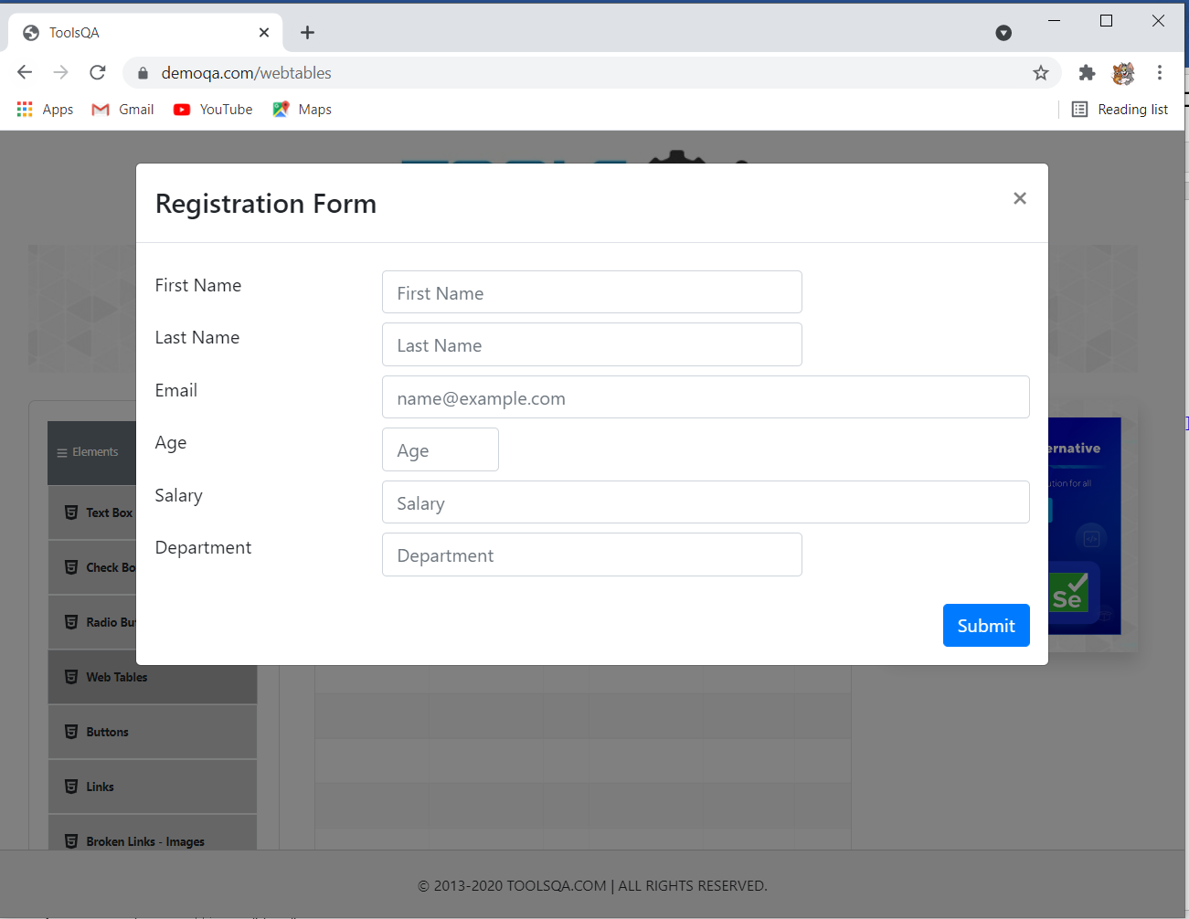

**Selenium WebDriver Test Script :**

**TC 12 –To check functionality WebTables- add-submit button**

w.findElement(By.*id*("firstName")).sendKeys("a");

w.findElement(By.*id*("lastName")).sendKeys("s");

w.findElement(By.*id*("userEmail")).sendKeys("as@gmail.com");

w.findElement(By.*id*("age")).sendKeys("24");

w.findElement(By.*id*("salary")).sendKeys("20000");

w.findElement(By.*id*("department")).sendKeys("abc");

Thread.*sleep*(3000);

w.findElement(By.*xpath*("//*[@id=\"submit\"]")).click();

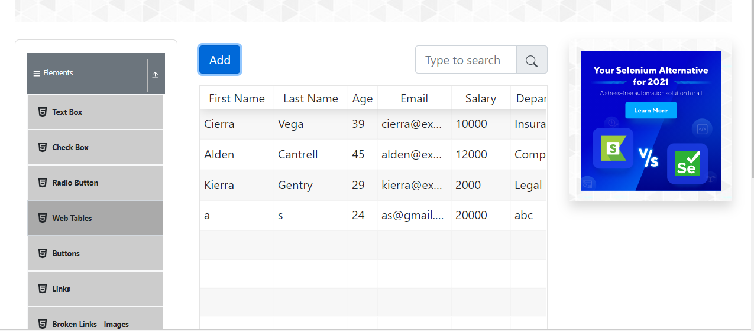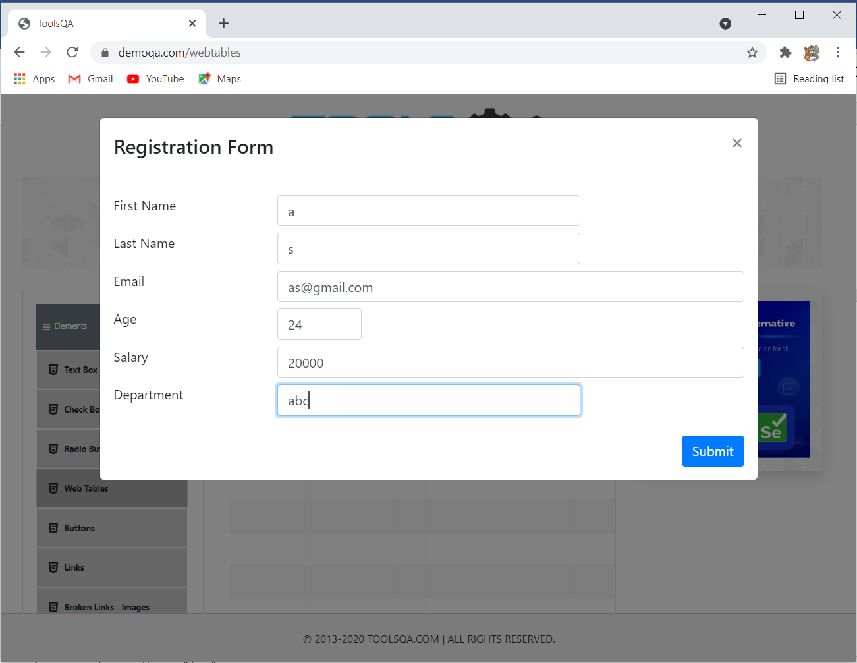

**Defect :**

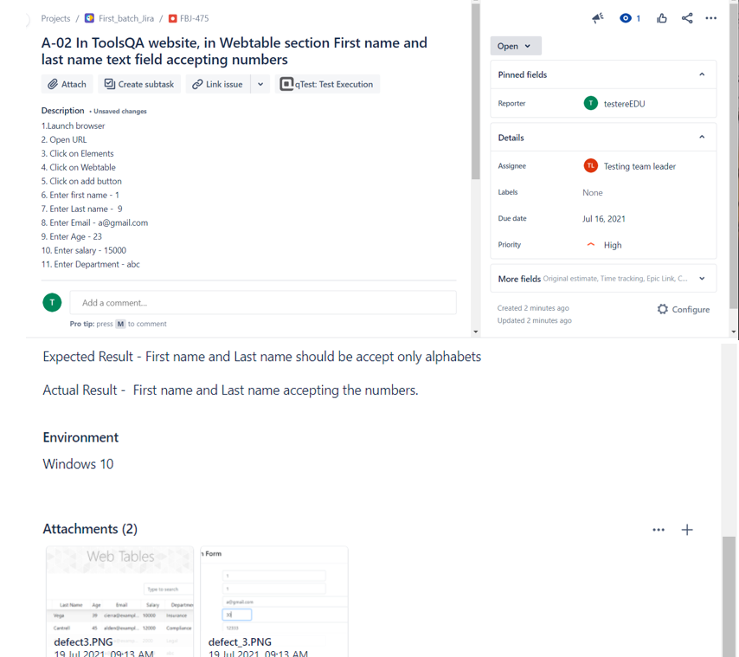

**Selenium WebDriver Test Script :**

**TC 13–To check the functionality of WebTables- Edit button**

w.findElement(By.*xpath*("//body/div[@id='app']/div[1]/div[1]/div[2]/div[2]/div[1]/div[3]/div[1]/div[2]/div[2]/div[1]/div[7]/div[1]/span[1]/*[1]")).click();

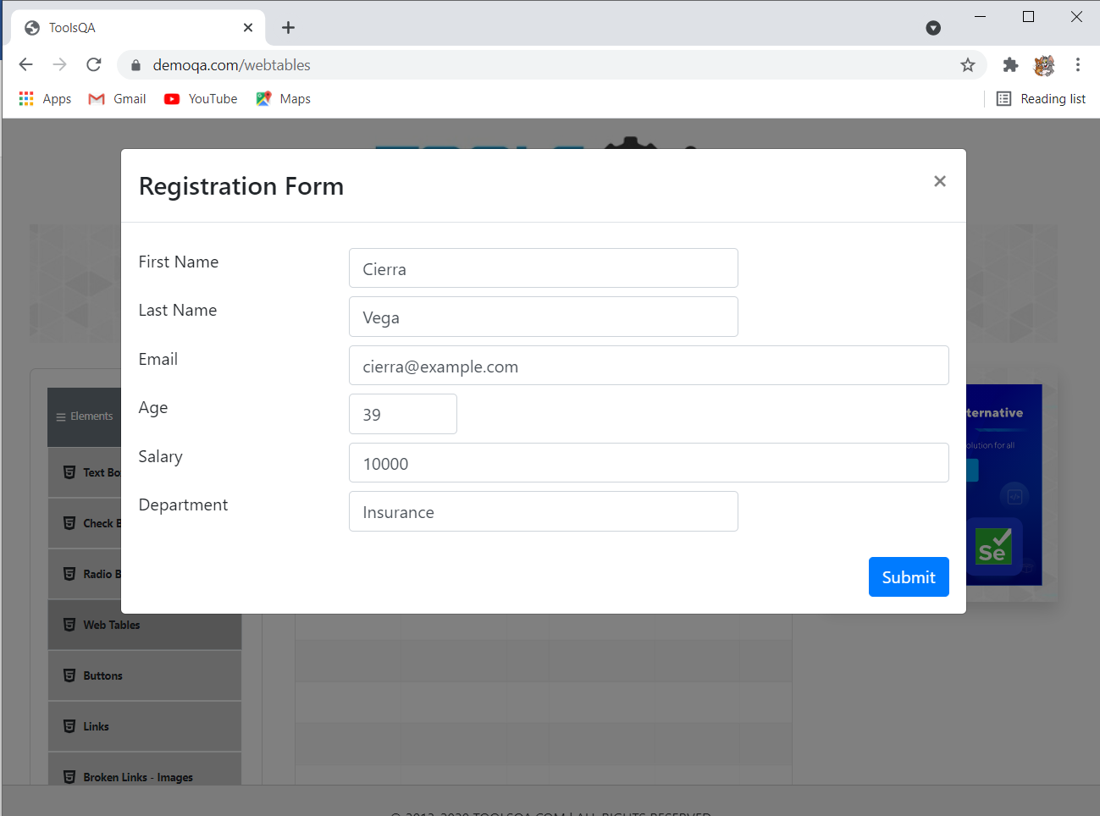

**TC 14–To check the functionality of WebTables- Edit - submit button**

**Selenium WebDriver Test Script :**

w.findElement(By.*id*("age")).clear();

Thread.*sleep*(1000);

w.findElement(By.*id*("age")).sendKeys("40");

Thread.*sleep*(2000);

w.findElement(By.*id*("salary")).clear();

Thread.*sleep*(2000);

w.findElement(By.*id*("salary")).sendKeys("25000");

Thread.*sleep*(2000);

w.findElement(By.*xpath*("//*[@id=\"submit\"]")).click();

Thread.*sleep*(2000);

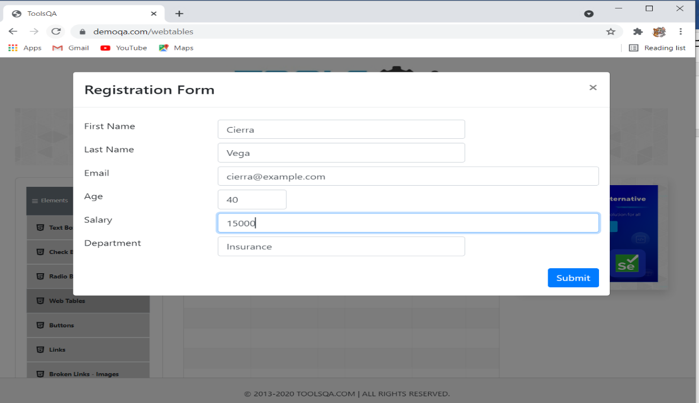

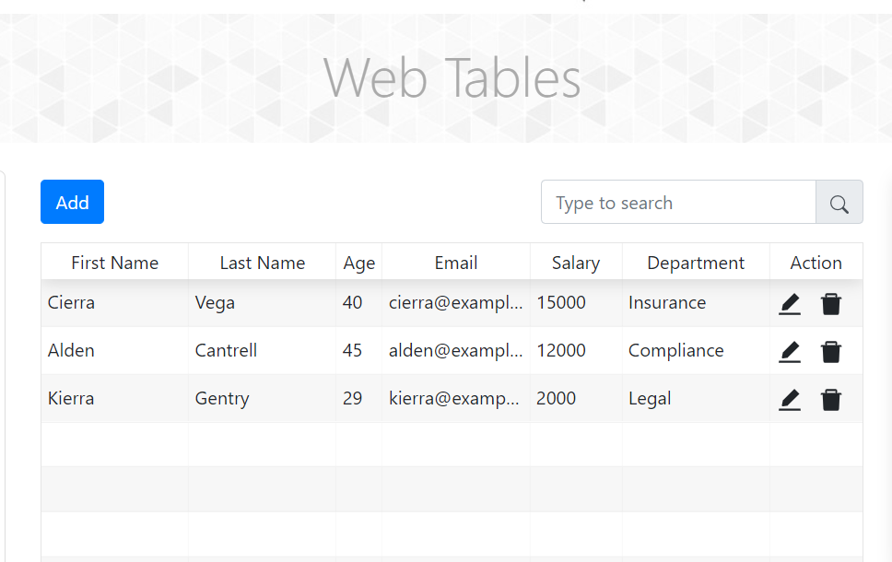

**TC 15–To check the functionality of WebTables- delete button**

**Selenium WebDriver Test Script :**

w.findElement(By.*xpath*("//body/div[@id='app']/div[1]/div[1]/div[2]/div[2]/div[1]/div[3]/div[1]/div[2]/div[1]/div[1]/div[7]/div[1]/span[2]/*[1]")).click();

Thread.*sleep*(2000);

//2 records are deleted

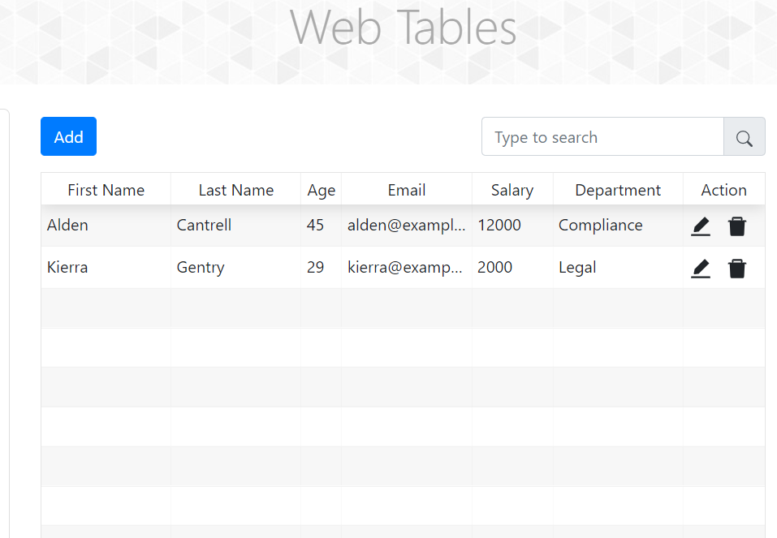

**TC 16–To check the functionality of WebTables- Search box**

**Selenium WebDriver Test Script :**

w.findElement(By.*xpath*("//input[@id='searchBox']")).sendKeys("Alden");

Thread.*sleep*(2000);

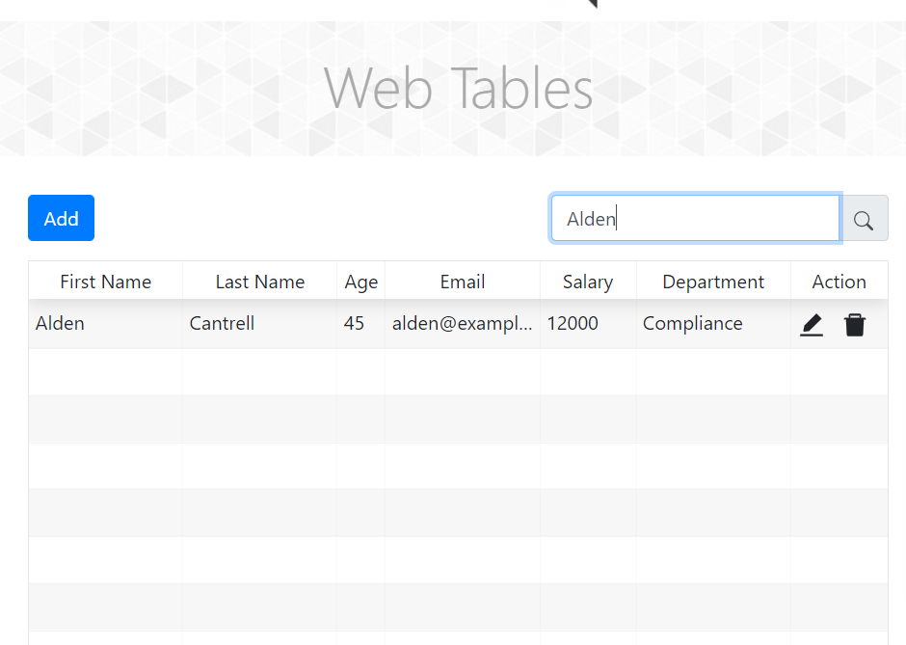

**TC 17–To check the functionality of buttons**

**Selenium WebDriver Test Script :**

w.findElement(By.*xpath*("//*[@id=\"item-4\"]")).click();

Thread.sleep(2000);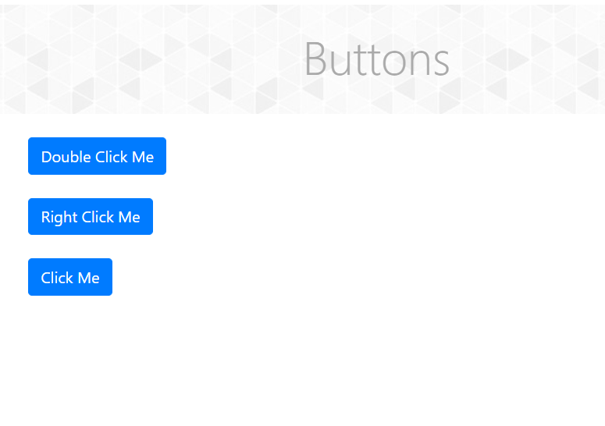

**TC 18 –To check the functionality of buttons – Double click me**

**Selenium WebDriver Test Script :**

Actions a = **new** Actions(w);

WebElement web = w.findElement(By.*xpath*("//button[@id='doubleClickBtn']"));

a.doubleClick(web).build().perform();

Thread.*sleep*(2000);

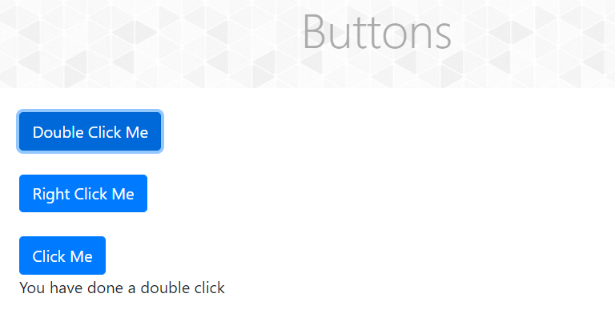

**TC 19–To check the functionality of buttons – Right click me**

**Selenium WebDriver Test Script :**

Actions a1 = **new** Actions(w);

WebElement web1 = w.findElement(By.*xpath*("//button[@id='rightClickBtn']"));

a.contextClick(web1).build().perform();

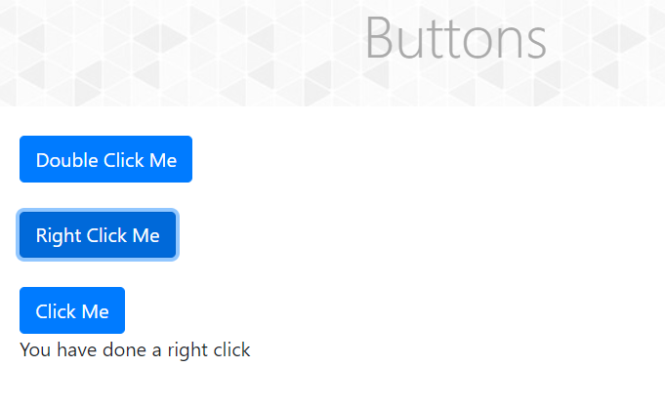Thread.*sleep*(2000)

**TC 20 –To check the functionality of buttons –click me**

**Selenium WebDriver Test Script :**

w.findElement(By.*xpath*("/html[1]/body[1]/div[2]/div[1]/div[1]/div[2]/div[2]/div[1]/div[3]/button[1]")).click();

Thread.*sleep*(2000);

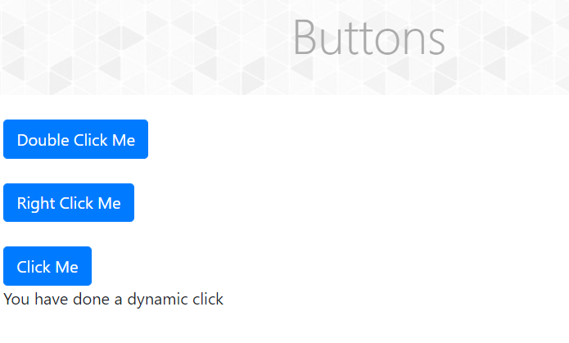

**Selenium WebDriver Test Script :**

**TC 21–To check functionality of Links button**

JavascriptExecutor js3 = (JavascriptExecutor) w;

js3.executeScript("window.scrollBy(0,1500)");

w.findElement(By.*xpath*("//*[@id=\"item-5\"]")).click();

Thread.*sleep*(2000);

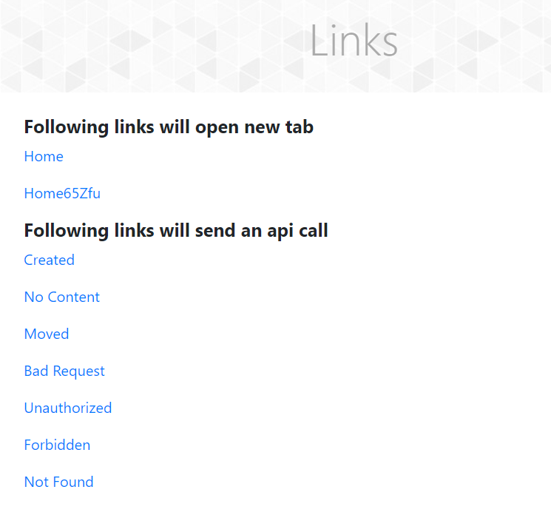

**TC 22–To check functionality of Links - Home link**

**Selenium WebDriver Test Script : Following links will open new tab**

w.findElement(By.*xpath*("//a[@id='simpleLink']")).click();

Thread.*sleep*(3000);



**TC 23–To check functionality of window handling**

**Selenium WebDriver Test Script:**

Set<String> s = w.getWindowHandles();

Iterator<String> it = s.iterator();

String pc = it.next();

String cc = it.next();

w.switchTo().window(cc);

Thread.*sleep*(2000);

w.switchTo().window(pc);

**TC 24–To check functionality of created link**

**Selenium WebDriver Test Script:**

w.findElement(By.*linkText*("Created")).click();

Thread.*sleep*(2000);

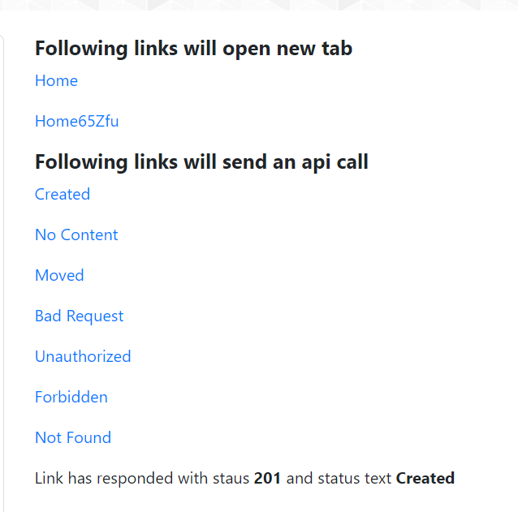

**TC 25–To check functionality of No content link**

**Selenium WebDriver Test Script:**

w.findElement(By.*linkText*("No Content")).click();

Thread.*sleep*(2000);

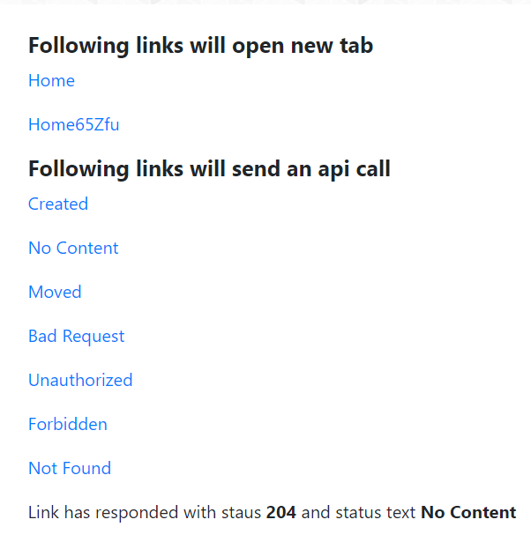

**TC 26–To check functionality of Moved link**

**Selenium WebDriver Test Script:**

w.findElement(By.*linkText*("Moved")).click();

Thread.*sleep*(2000);

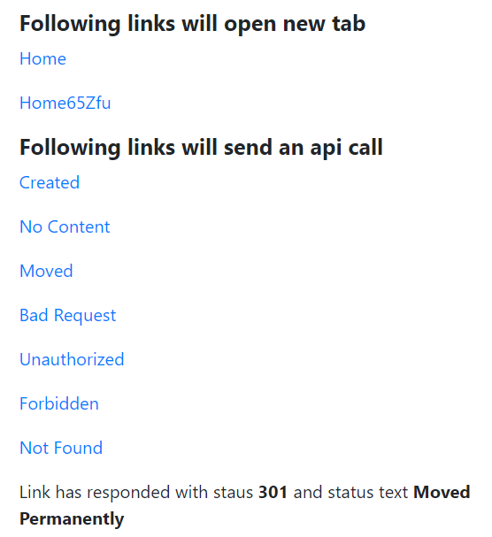

**TC 27–To check functionality of Bad request link**

**Selenium WebDriver Test Script:**

w.findElement(By.*linkText*("Bad Request")).click();

Thread.*sleep*(2000);

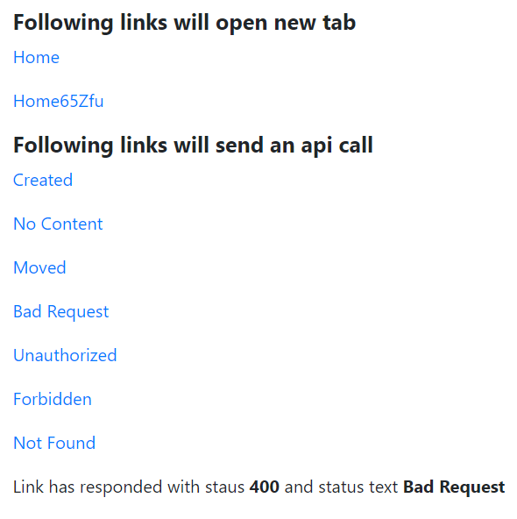

**TC 28–To check functionality of Unauthorized link**

**Selenium WebDriver Test Script:**

w.findElement(By.*linkText*("Unauthorized")).click();

Thread.*sleep*(2000);

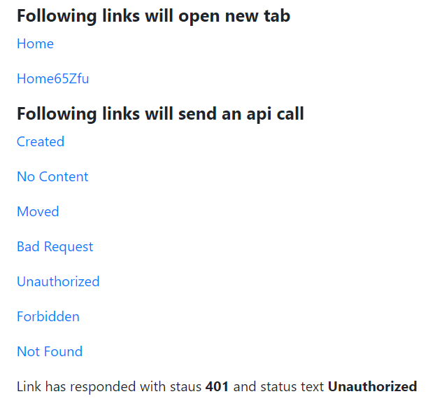

**TC 29 –To check functionality of Forbidden link**

**Selenium WebDriver Test Script:**

w.findElement(By.*linkText*("Forbidden")).click();

Thread.*sleep*(2000);

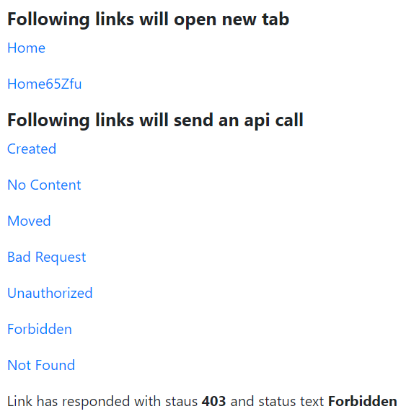

**TC 30–To check functionality of Not found link**

**Selenium WebDriver Test Script:**

w.findElement(By.*linkText*("Not Found")).click();

Thread.*sleep*(2000);

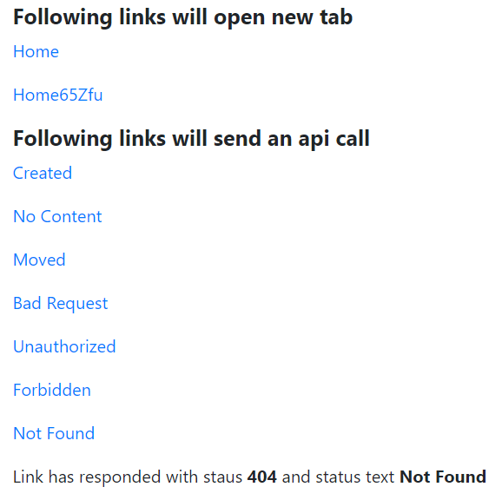

**TC 31–To check functionality of broken images - links**

**Selenium WebDriver Test Script:**

w.findElement(By.*xpath*("//*[@id=\"item-6\"]")).click();

Thread.*sleep*(2000);

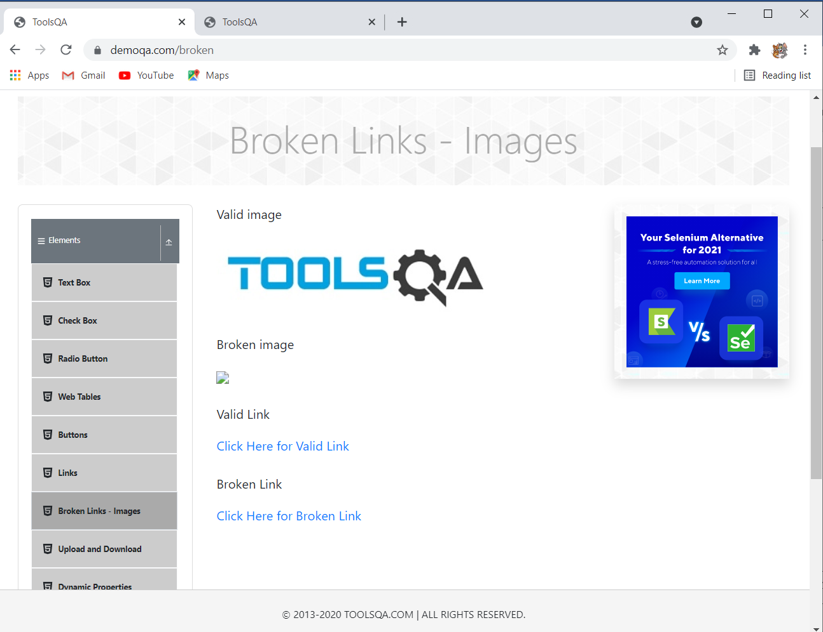

**TC 32–To check functionality of broken images – Valid link**

**Selenium WebDriver Test Script:**

javascriptExecutor js5 = (JavascriptExecutor) w;

js5.executeScript("window.scrollBy(0,500)");

Thread.*sleep*(2000);

w.findElement(By.*xpath*("//*[@id=\"app\"]/div/div/div[2]/div[2]/div[1]/a[1]"))

.click();

Thread.*sleep*(1000);

w.navigate().back();

Thread.*sleep*(2000);



**TC 33–To check functionality of broken images – Broken link**

**Selenium WebDriver Test Script:**

JavascriptExecutor js6 = (JavascriptExecutor) w;

js6.executeScript("window.scrollBy(0,500)");

Thread.*sleep*(2000);

w.findElement(By.*linkText*("Click Here for Broken Link")).click();

Thread.*sleep*(2000);

w.navigate().back();

Thread.*sleep*(2000);

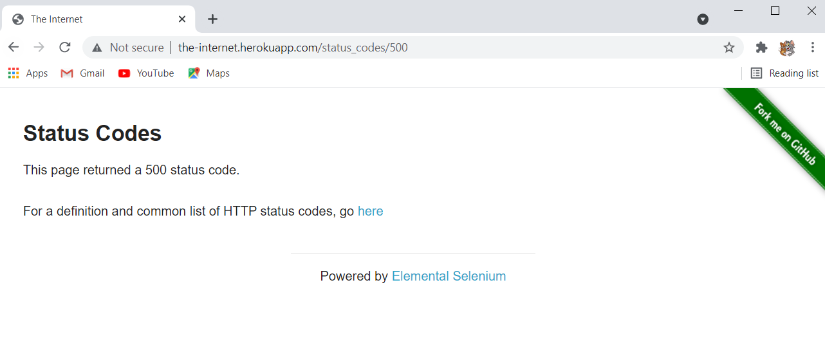

**TC 34–To check functionality of upload and download button**

**Selenium WebDriver Test Script:**

JavascriptExecutor js7 = (JavascriptExecutor) w;

js7.executeScript("window.scrollBy(0,1000)");

Thread.*sleep*(2000);

w.findElement(By.*xpath*("//*[@id=\"item-7\"]")).click();

Thread.*sleep*(2000);

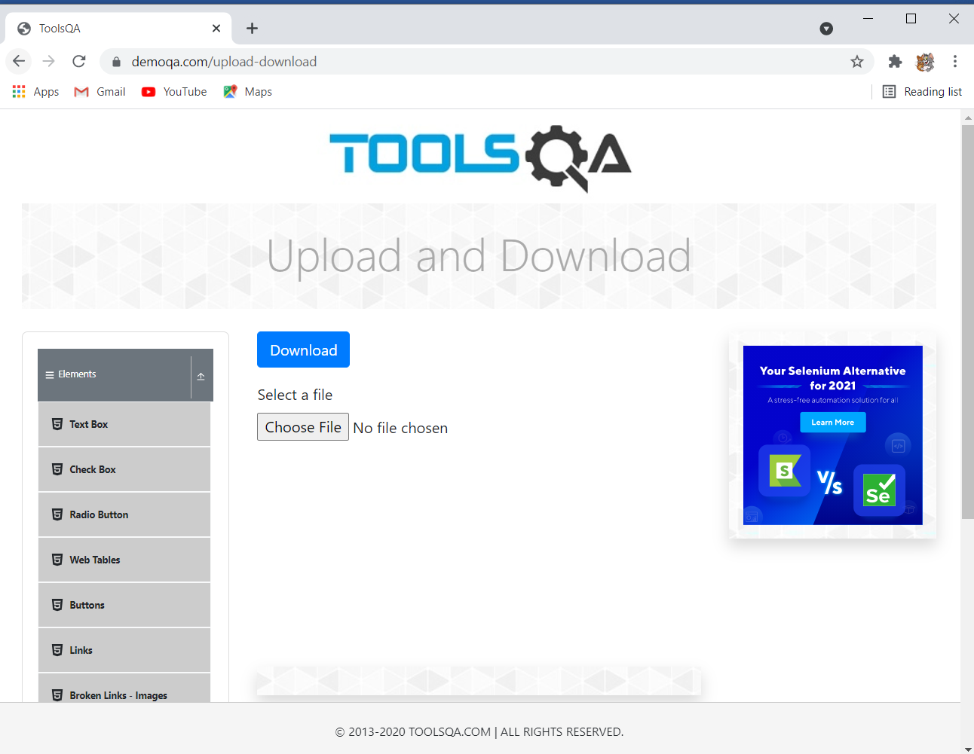

**TC 35–To check functionality of upload and download - Choose file button**

button

**Selenium WebDriver Test Script:**

w.findElement(By.*id*("uploadFile")).sendKeys("C:\\Users\\Asus\\Pictures\\1.jpg");

Thread.*sleep*(2000);

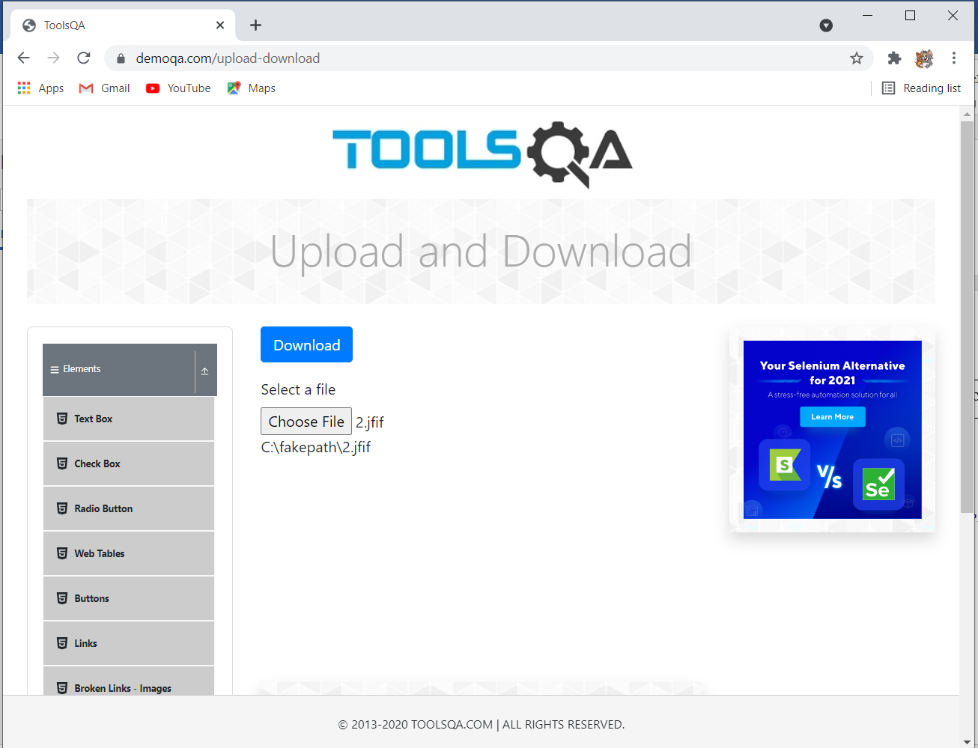

**TC 36–To check functionality of upload and download – Download button**

button

**Selenium WebDriver Test Script:**

w.findElement(By.*id*("downloadButton")).click();

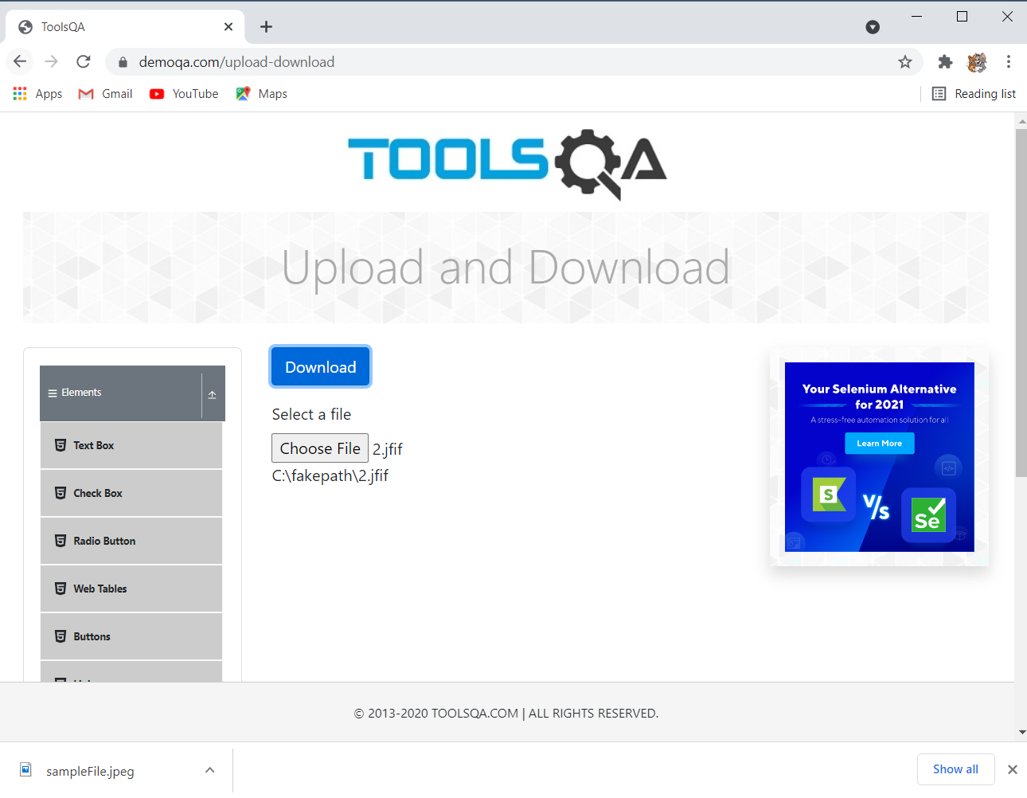

**TC 37– Check the functionality of dynamic property button**

**Selenium WebDriver Test Script:**

JavascriptExecutor js8 = (JavascriptExecutor) w;

js8.executeScript("window.scrollBy(0,1000)");

Thread.*sleep*(2000);

w.findElement(By.*xpath*("//span[contains(text(),'Dynamic Properties')]")).click();

Thread.*sleep*(7000);

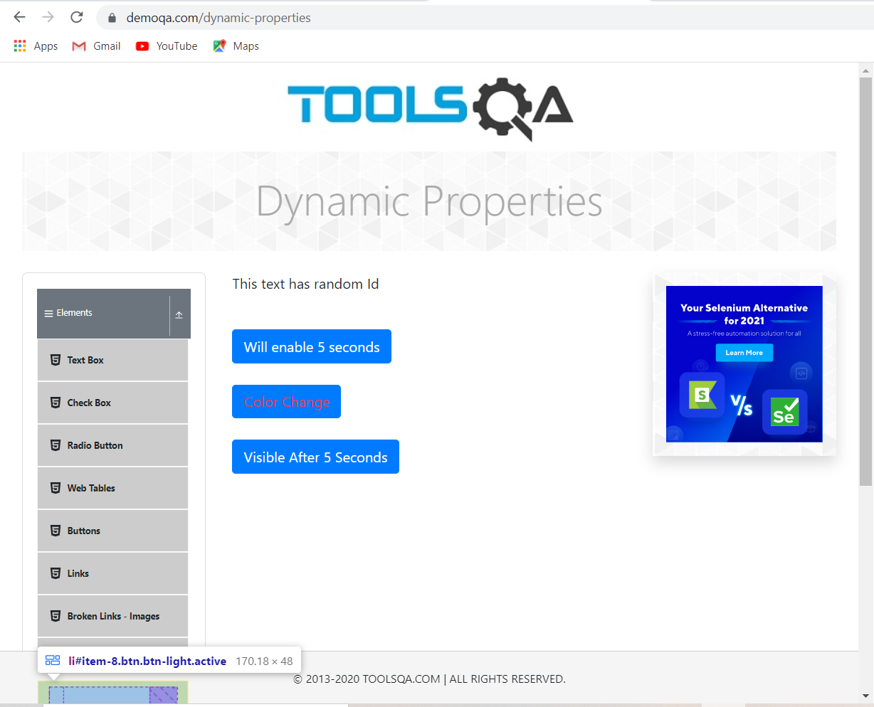

**TC38- To check functionality of forms button**

Selenium WebDriver Test Script :

w.findElement(By.*xpath*("//h5[contains(text(),'Forms')]")).click();

Thread.*sleep*(2000);

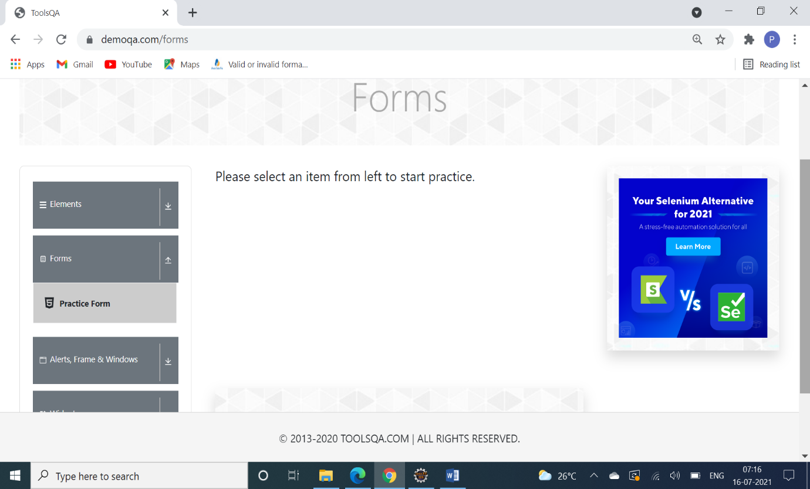

TC39- To check functionality of Practice form button

Selenium WebDriver Test Script:

w.findElement(By.*xpath*("//body/div[@id='app']/div[1]/div[1]/div[2]/div[1]/div[1]/div[1]/div[2]/div[1]/ul[1]/li[1]")).click();

Thread.*sleep*(2000);

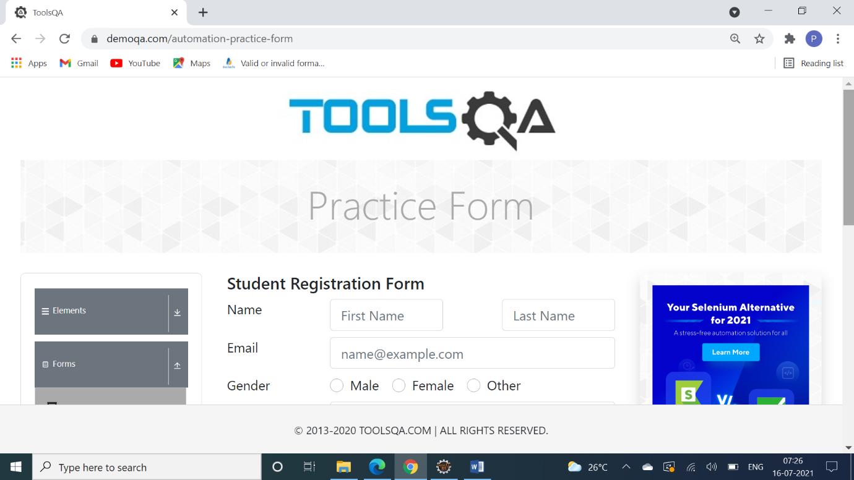

TC40- To check functionality of Submit Button (Practice form)

Selenium WebDriver Test Script:

w.findElement(By.*id*("firstName")).sendKeys("PPP"); //first and last name

w.findElement(By.*id*("lastName")).sendKeys("RRR");

w.findElement(By.*id*("userEmail")).sendKeys("PBR@gmail.com"); //gmail

w.findElement(By.*xpath*("//label[contains(text(),'Female')]")).click(); //gender

Threa d.*sleep*(2000);

js.executeScript("window.scrollBy(0,500)", "");

w.findElement(By.*id*("userNumber")).sendKeys("1234567899"); //mb no.

Thread.*sleep*(2000);

//hobbies

w.findElement(By.*xpath*("/html[1]/body[1]/div[2]/div[1]/div[1]/div[2]/div[2]/div[1]/form[1]/div[7]/div[2]/div[1]/label[1]")).click();

w.findElement(By.*xpath*("/html[1]/body[1]/div[2]/div[1]/div[1]/div[2]/div[2]/div[1]/form[1]/div[7]/div[2]/div[3]/label[1]")).click();

Thread.*sleep*(2000);

js.executeScript("window.scrollBy(0,350)", "");

//file upload

w.findElement(By.*id*("uploadPicture")).sendKeys("C:\\Users\\PC\\OneDrive\\Desktop\\edb.docx");

w.findElement(By.*id*("currentAddress")).sendKeys("Address"); //address

// Select s = new Select(w.findElement(By.xpath("//div[contains(text(),'Select State')]"))); //state

//s.selectByIndex(1);

w.findElement(By.*id*("submit")).click();

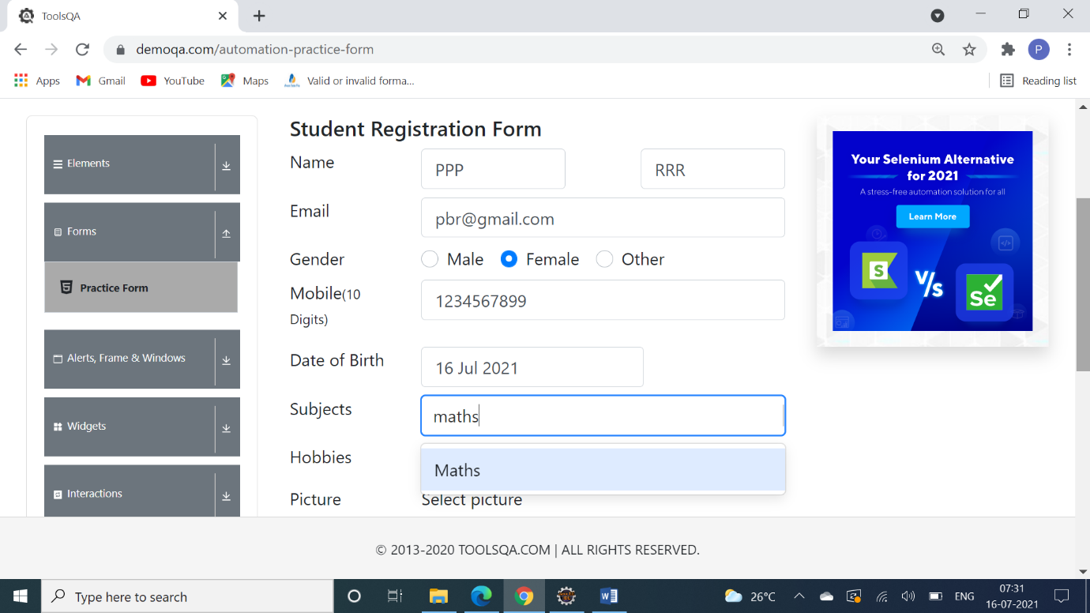

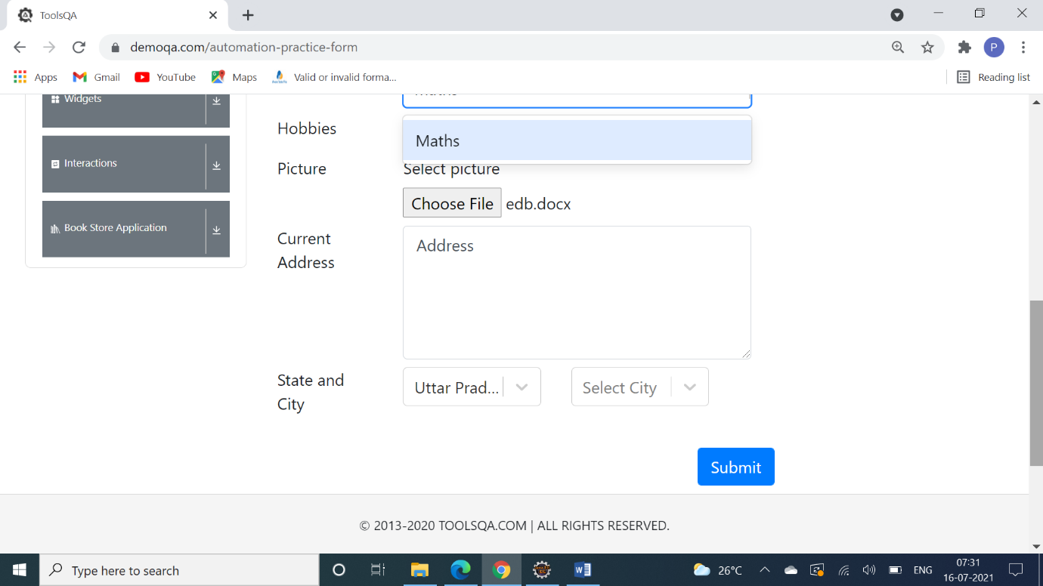

**Test data:**

First Name: PPP

Last name: RRR

Gmail: [pbr@gmail.com](mailto:pbr@gmail.com)

Gender: Female

Mobile no. 1234567899

Date of Birth: By automation not working

Subjects: By automation not working

Hobbies: Music, Sports

Picture: edb.docx

Current address: Address

State and City: not working

**Defect Report:**

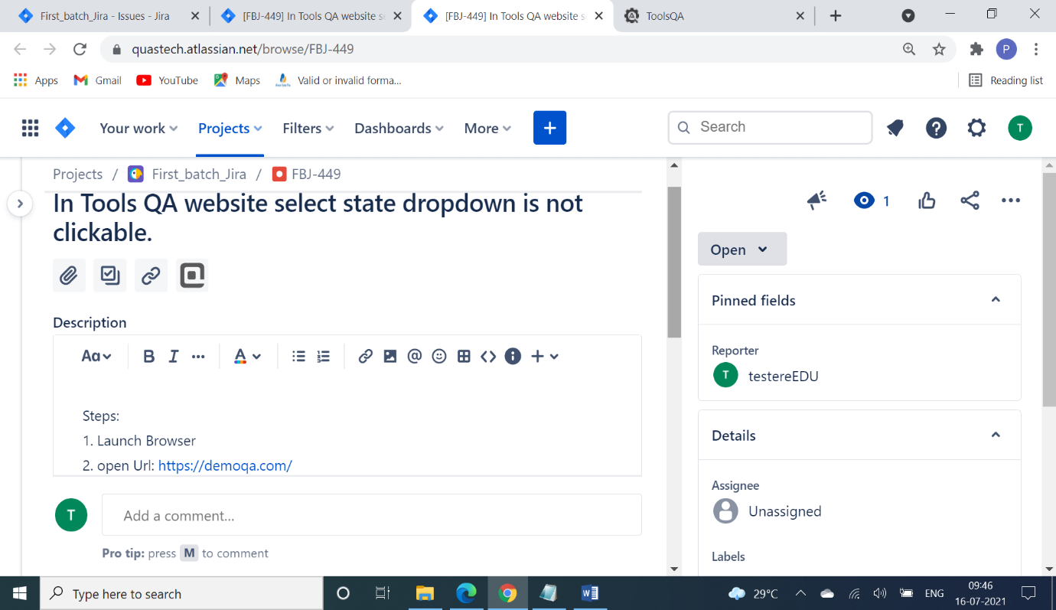

**TC41- Navigate back to ToolsQA page**

**Selenium WebDriver Test Script:**

w.navigate().to("https://demoqa.com/");

Thread.*sleep*(2000);

**TC42- To check Functionality Of Alerts,Frames & Windows Button**

**Selenium WebDriver Test Script:** w.findElement(By.*xpath*("//*[@id=\"app\"]/div/div/div[2]/div/div[3]")).click();

 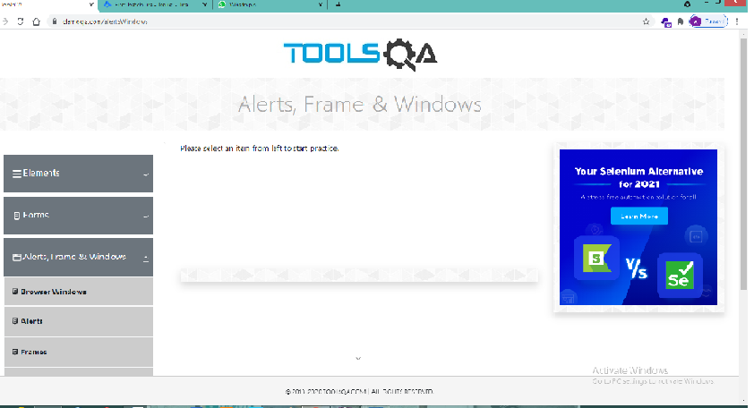

**TC43- To Check the text from Alert, Frame & windows module**

**Selenium WebDriver Test Script:**

System.***out***.println(w.findElement(By.*xpath*("//*[@id=\"app\"]/div/div/div[2]/div[2]")).getText());

**TC44- To check Title Of Alerts,Frames & Windows module**

**Selenium WebDriver Test Script:**

System.***out***.println("Title of Page="+w.getTitle());

**TC45- To check URL Of Alerts,Frames & Windows module**

**Selenium WebDriver Test Script:**

System.***out***.println("URL of Page=" +w.getCurrentUrl());

**TC46- To check Functionality of Browser Windows module**

**Selenium WebDriver Test Script:**

w.findElement(By.*xpath*("//span[contains(text(),'Browser Windows')]")).click();

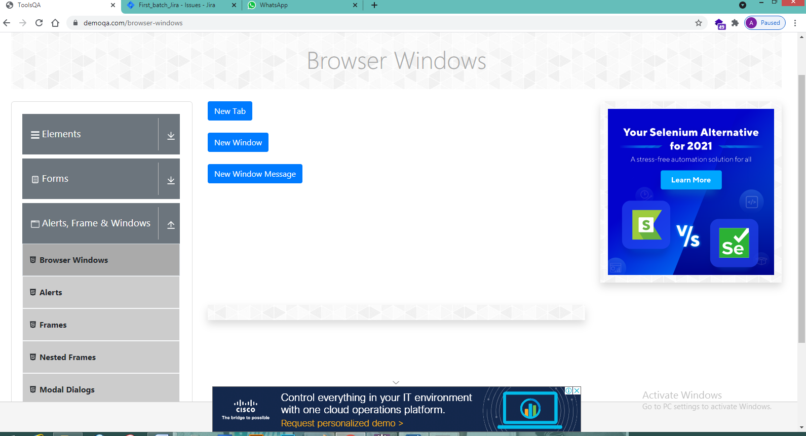

**TC47- To check Functionality Of New Tab Button**

**Selenium WebDriver Test Script:**

w.findElement(By.*id*("tabButton")).click();

Set <String> window1=w.getWindowHandles();

Iterator <String> it1=window1.iterator();

String par_win1=it1.next();

String child_win1=it1.next();

w.switchTo().window(par_win1);

Thread.*sleep*(1000);

w.switchTo().window(child_win1);

System.***out***.println(w.findElement(By.*id*("sampleHeading")).getText());

w.switchTo().window(par_win1);

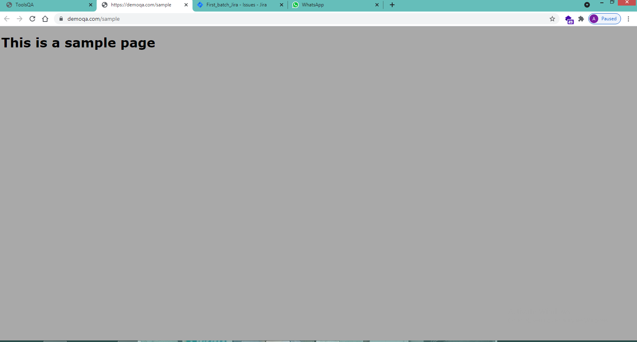

**TC48- To check Functionality Of New Window Button**

**Selenium WebDriver Test Scrip**t:

w.findElement(By.*id*("windowButton")).click();

Set <String> window2=w.getWindowHandles();

Iterator <String> it2=window2.iterator();

String par_win2=it2.next();

String child_win2=it2.next();

w.switchTo().window(par_win2);

Thread.*sleep*(1000);

w.switchTo().window(child_win2);

System.***out***.println(w.findElement(By.*id*("sampleHeading")).getText());

w.switchTo().window(par_win2);

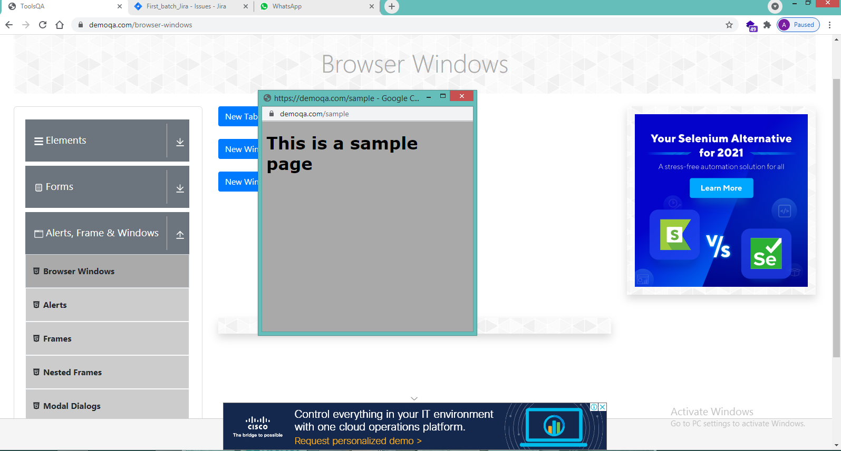

**TC49- To check Functionality Of New Window Message Button**

**Selenium WebDriver Test Script:**

w.findElement(By.*id*("messageWindowButton")).click();

Set <String> window3=w.getWindowHandles();

Iterator <String> it3=window3.iterator();

String par_win3=it3.next();

String child_win3=it3.next();

w.switchTo().window(par_win3);

Thread.*sleep*(1000);

w.switchTo().window(child_win3);

System.***out***.println(w.findElement(By.*xpath*("//html")).getText());

Thread.*sleep*(1000);

w.switchTo().window(par_win3);

**TC50- To check Functionality Of Alert tab.**

**Selenium WebDriver Test Script:**

w.findElement(By.*xpath*("//span[contains(text(),'Alerts')]")).click();

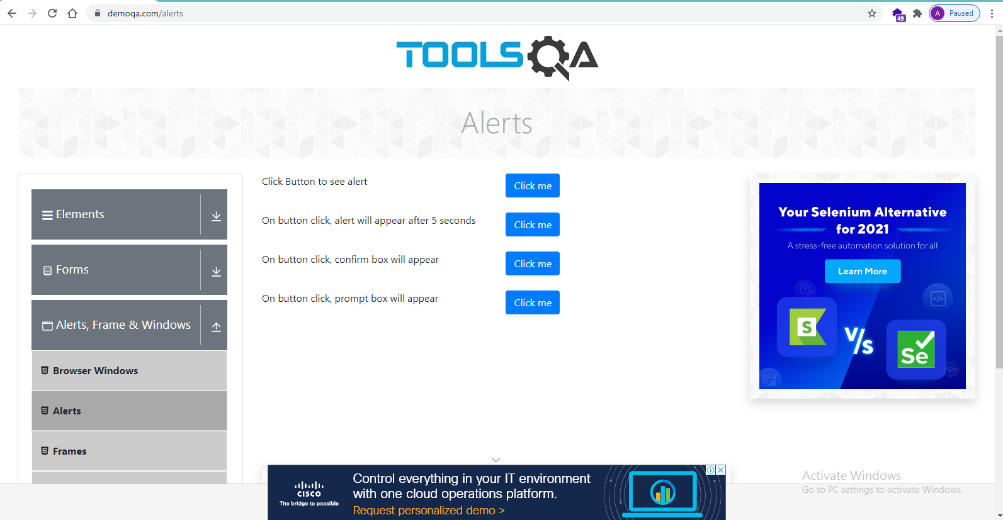

**TC51- To check Functionality Of Click me button in simple alert.**

**Selenium WebDriver Test Script:**

w.findElement(By.*id*("alertButton")).click();

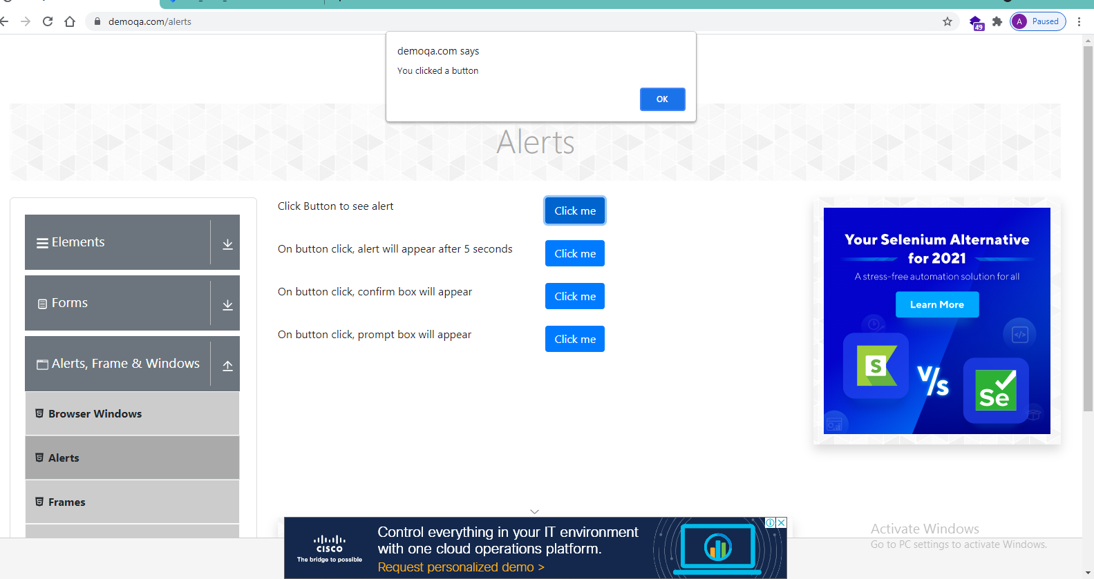

**TC52- To check Functionality Of Accepting simple alert.**

**Selenium WebDriver Test Script:**

Alert a1=w.switchTo().alert();

System.***out***.println(a1.getText());

System.***out***.println("Simple Alert");

a1.accept();

System.***out***.println("Simple Alert accepted");

**TC53- To check Functionality Of Click me button in Wait alert.**

**Selenium WebDriver Test Script:**

w.findElement(By.*id*("timerAlertButton")).click();

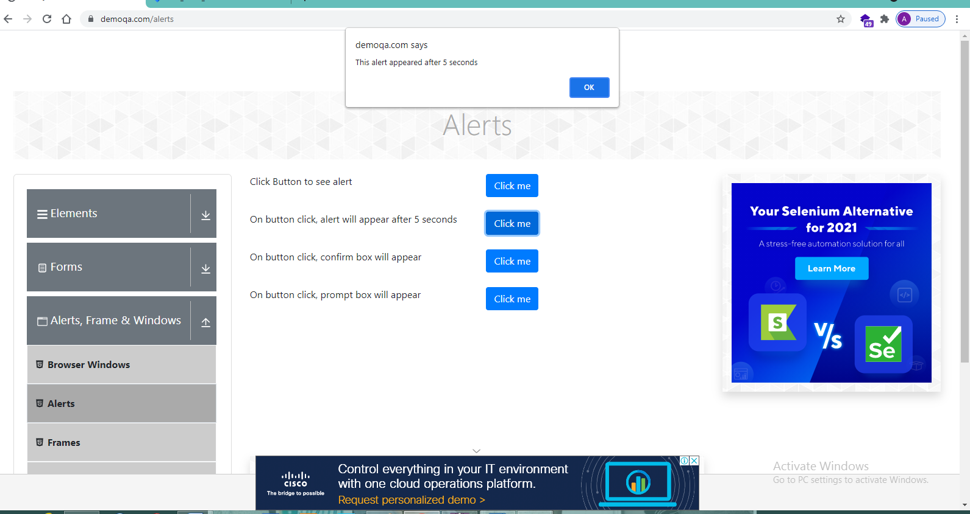

**TC54- To check Functionality Of Accepting simple alert.**

**Selenium WebDriver Test Script:**

Alert a2=w.switchTo().alert();

System.***out***.println(a2.getText());

System.***out***.println("wait alert");

a2.accept();

System.***out***.println("wait Alert accepted");

**TC55- To check Functionality Of Click me button in Confirm alert.**

**Selenium WebDriver Test Script:**

w.findElement(By.*id*("confirmButton")).click();

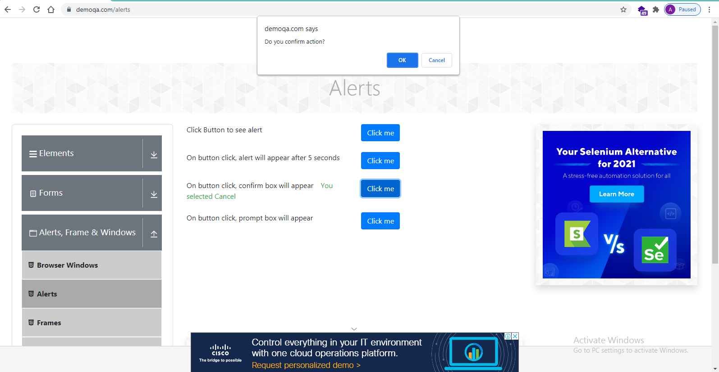

**TC56- To check Functionality Of Accepting Confirm alert.**

**Selenium WebDriver Test Script:**

Alert a3=w.switchTo().alert();

System.***out***.println(a3.getText());

Thread.*sleep*(1000);

System.***out***.println("confirm alert");

a3.accept();

System.***out***.println("confirm Alert accepted");

**TC57- To check Functionality Of Dismiss Confirm alert.**

**Selenium WebDriver Test Script:**

a3=w.switchTo().alert();

System.***out***.println(a3.getText());

Thread.*sleep*(1000);

System.***out***.println("confirm alert");

a3.dismiss();

System.***out***.println("confirm Alert dismissed");

**TC58- To check Functionality Of Click me button in Prompt alert.**

**Selenium WebDriver Test Script:**

w.findElement(By.*id*("promtButton")).click();

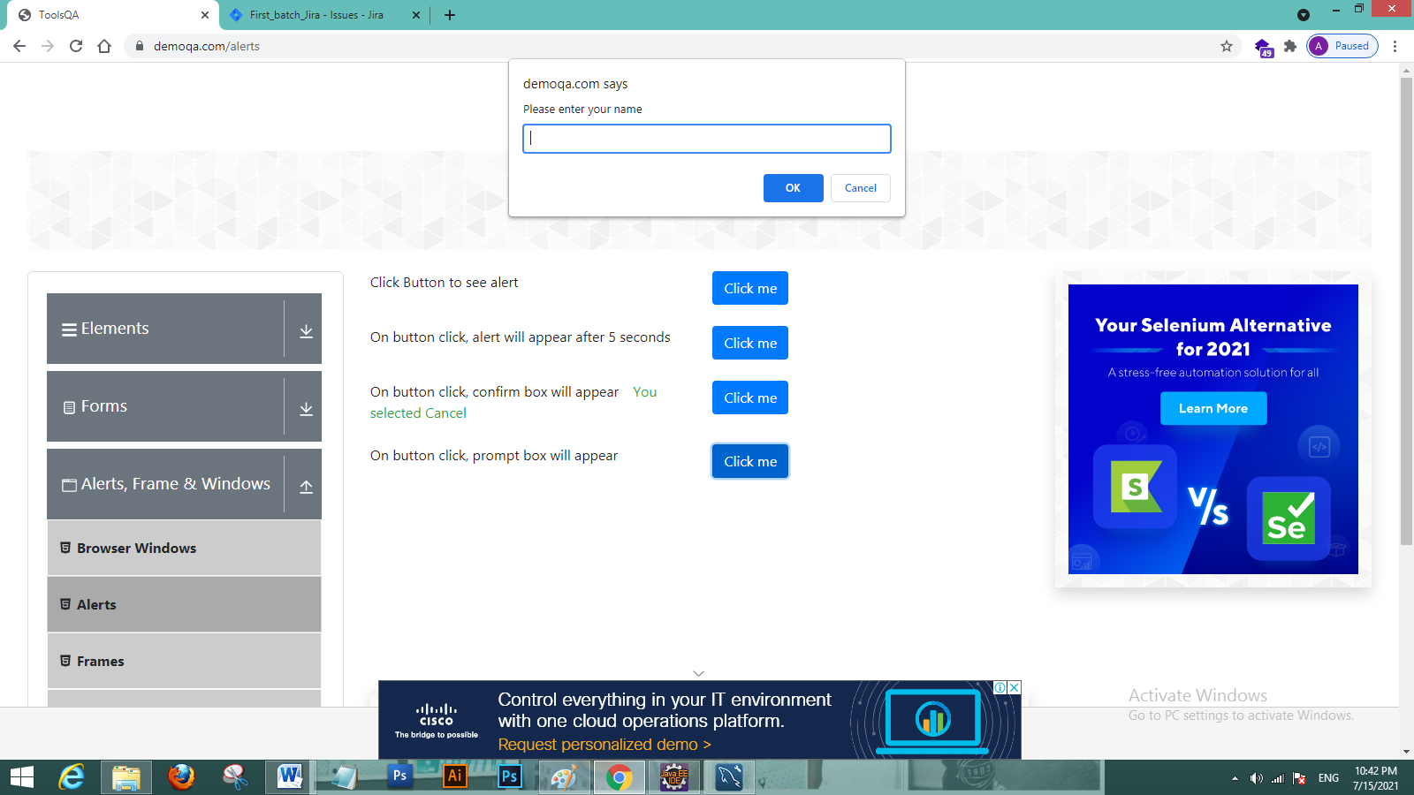

**TC59- To check Functionality Of Accepting prompt alert.**

**Selenium WebDriver Test Script:**

Alert a4=w.switchTo().alert();

a4.sendKeys("abc123");

System.***out***.println(a4.getText());

Thread.*sleep*(1000);

System.***out***.println("prompt alert");

a4.accept();

System.***out***.println("prompt Alert accepted");

**Defect** :Fig- Screenshot of Jira tool for reporting defect in prompt alert

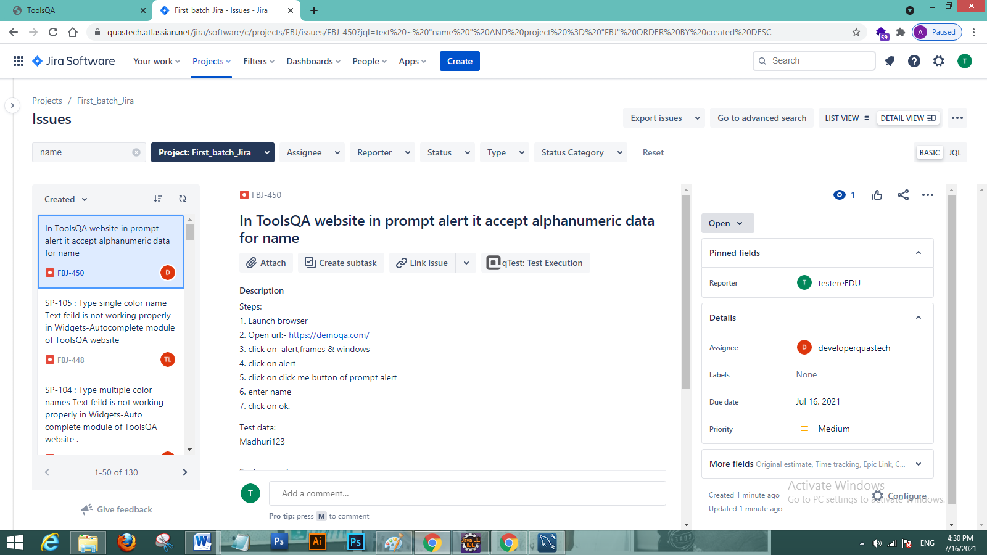

**TC60- To check Functionality of Dismiss prompt alert.**

**Selenium WebDriver Test Script:**

a4=w.switchTo().alert();

a4.sendKeys("madhuri");

System.***out***.println(a4.getText());

Thread.*sleep*(1000);

System.***out***.println("prompt alert");

a4.dismiss();

System.***out***.println("prompt Alert dismissed");

**TC61- To check Functionality Of Frames tab.**

**Selenium WebDriver Test Script:**

w.findElement(By.*xpath*("//body/div[@id='app']/div[1]/div[1]/div[2]/div[1]/div[1]/div[1]/div[3]/div[1]/ul[1]/li[3]/span[1]")).click();

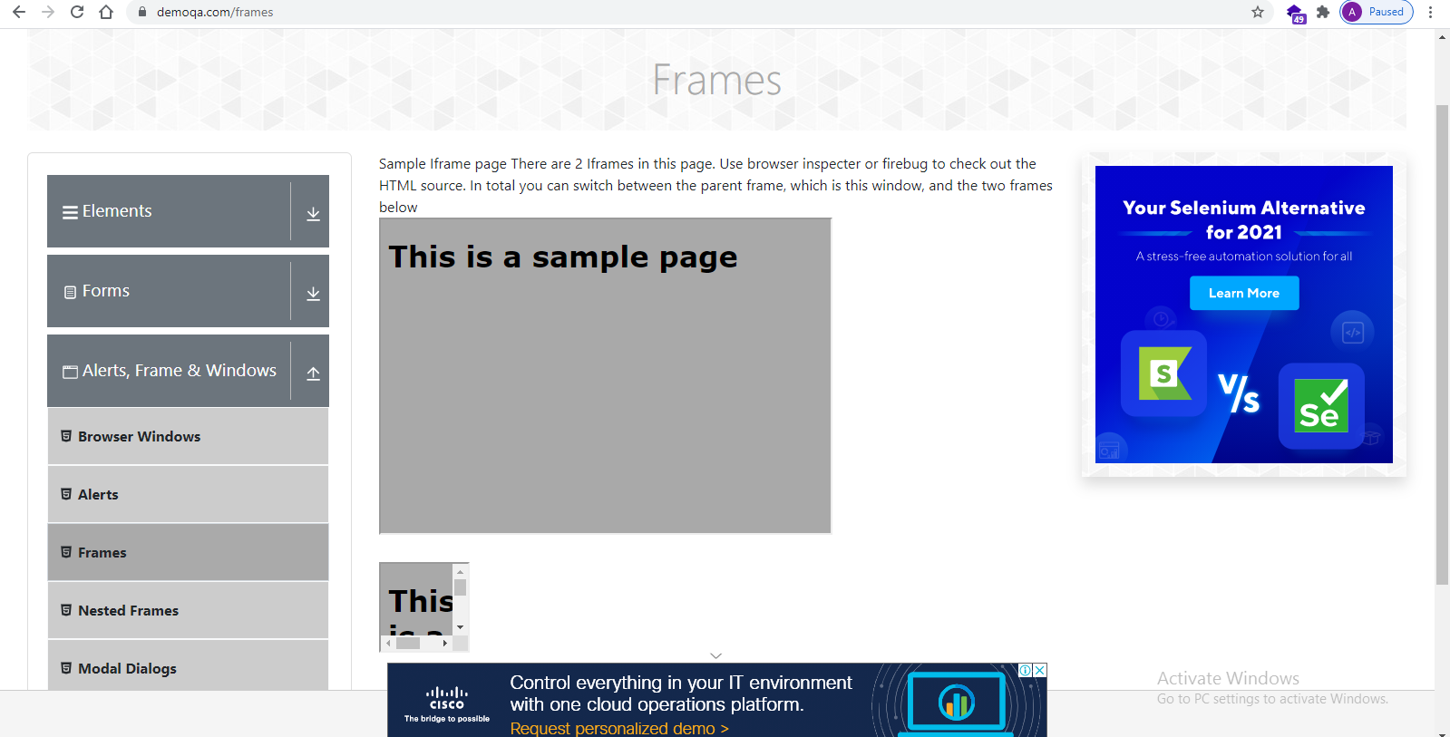

**TC62- To Get text from Frame 1**

**Selenium WebDriver Test Script:**

w.switchTo().frame("frame1");

System.***out***.println(w.findElement(By.*id*("sampleHeading")).getText());

System.***out***.println("from frame1");

w.switchTo().defaultContent();

**TC63- To Get text from Frame 2**

**Selenium WebDriver Test Script:**

w.switchTo().frame("frame2");

System.***out***.println(w.findElement(By.*id*("sampleHeading")).getText());

System.***out***.println("from frame2");

**TC64- To Count Total number of Frames in Current page**

**Selenium WebDriver Test Script:**

List<WebElement> l=w.findElements(By.*tagName*("iframe"));

System.***out***.println("Total iframes="+ l.size());

**TC65- To Count Total number of Frames in Nested Frame page**

**Selenium WebDriver Test Script**

List<WebElement> l2=w.findElements(By.*tagName*("iframe"));

System.***out***.println("Total iframes in nested iframes="+ l2.size());

**TC66- To check Functionality Of Small Modal Button.**

**Selenium WebDriver Test Script:**

w.findElement(By.*id*("showSmallModal")).click();

System.***out***.println(w.findElement(By.*xpath*("/html/body/div[4]/div/div/div[2]")).getText();

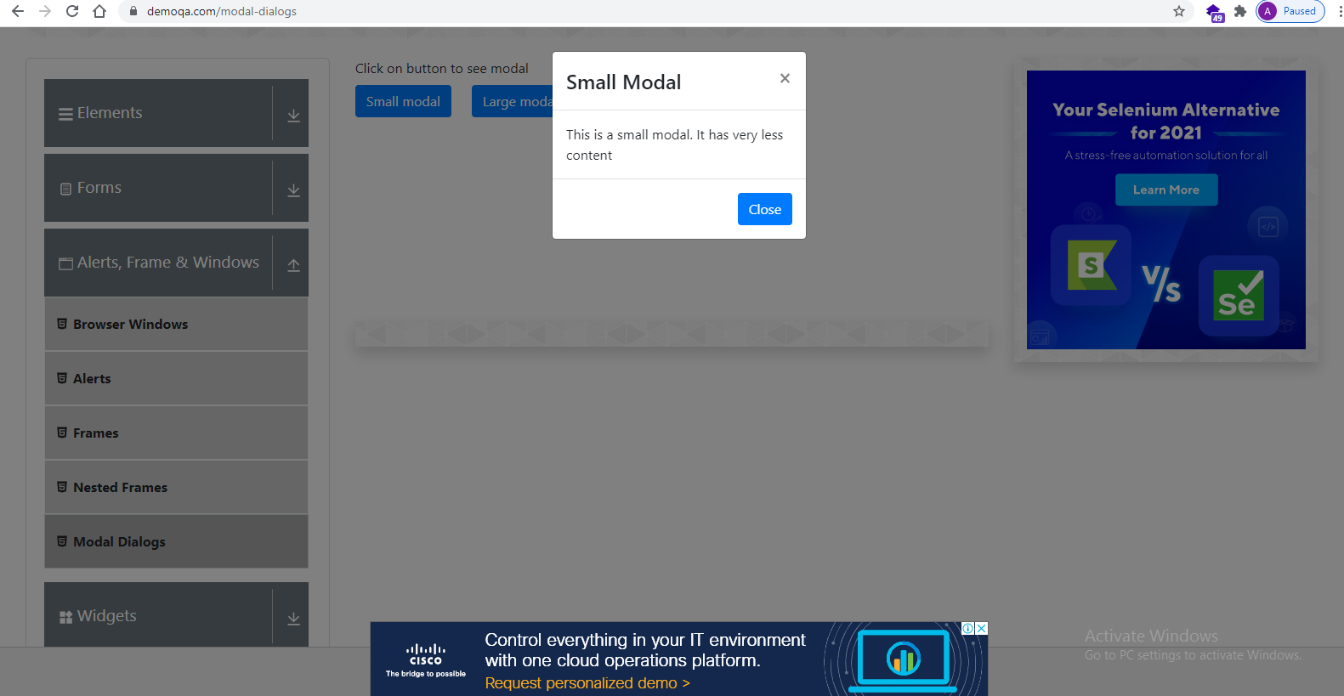

**TC67- To check Functionality Of close Button in Small Modal.**

**Selenium WebDriver Test Script:**

w.findElement(By.*id*("closeSmallModal")).click();

**TC68- To check Functionality Of Large Modal Button.**

**Selenium WebDriver Test Script:**

w.findElement(By.*id*("showLargeModal")).click();

System.***out***.println(w.findElement(By.*xpath*("//p[contains(text(),'Lorem Ipsum is simply dummy text of the printing a')]")).getText());

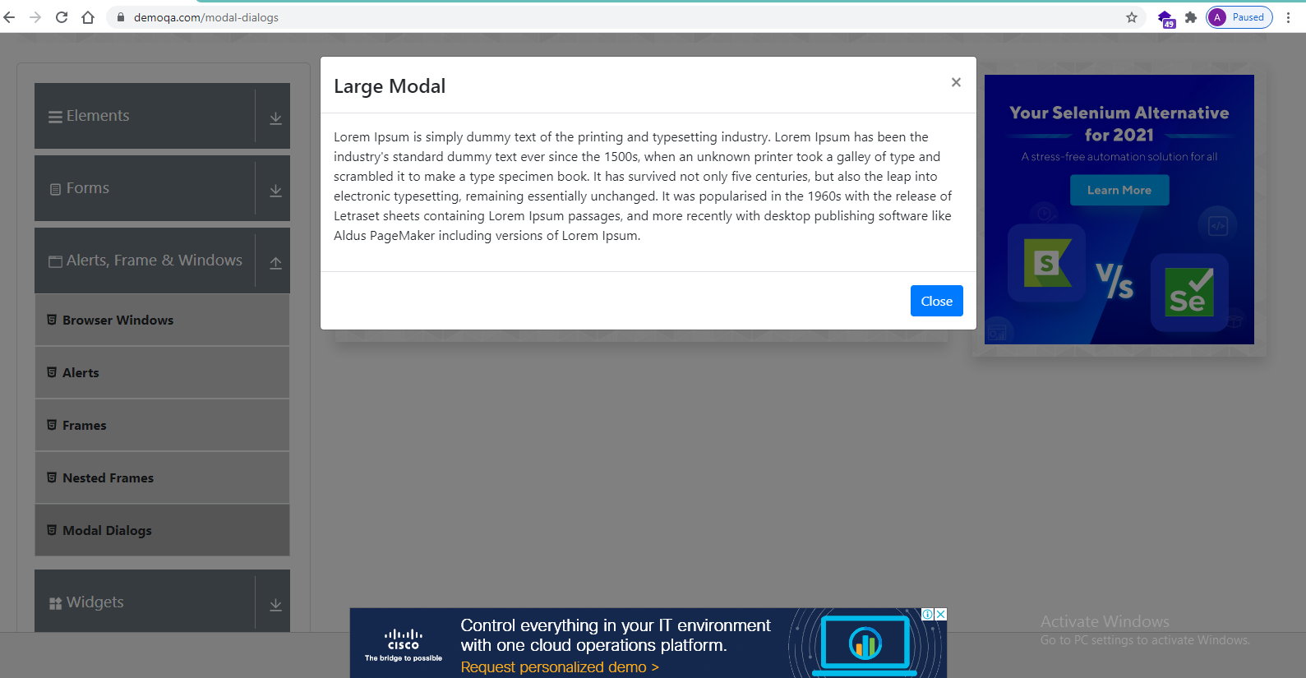

**TC69- To check Functionality of close Button in Small Modal.**

**Selenium WebDriver Test Script:**

w.findElement(By.*id*("closeLargeModal")).click();

**TC70-To Check the functionality of Widgets Button**

**Selenium WebDriver Test Script :**

w.findElement(By.xpath("//h5[contains(text(),'Widgets')]")).click();

w.manage().window().maximize();

js.executeScript("window.scrollBy(0, 500)");

Thread.sleep(2000);

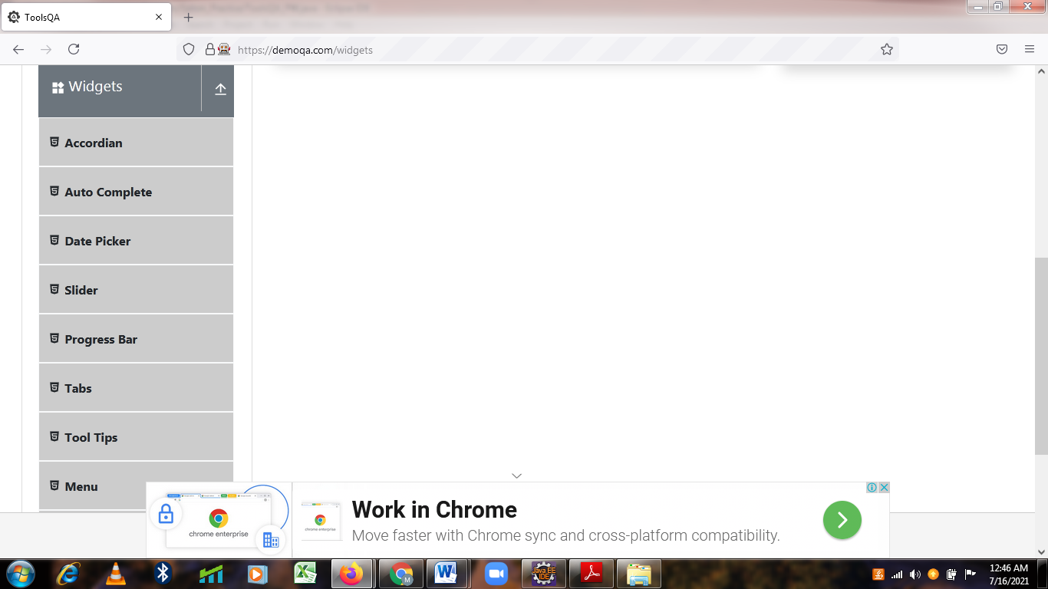

**TC71-To verify and Display the Title of current page of browser**

**Selenium WebDriver Test Script :**

w.getTitle();

System.out.println("Title of Current page is : "+w.getTitle());

**TC72- To verify and Display the URL of current page of browser**

**Selenium WebDriver Test Script :**

w.getCurrentUrl();

System.out.println("Current URL is : " +w.getCurrentUrl());

**TC73-To Check the Functionality Accordian Button**

**Selenium WebDriver Test Script :**

js.executeScript("window.scrollBy(0,500)");

Thread.sleep(2000);

w.findElement(By.xpath("/html[1]/body[1]/div[2]/div[1]/div[1]/div[2]/div[1]/div[1]/div[1]/div[4]/div[1]/ul[1]/li[1]/span[1]")).click();

Thread.sleep(2000);

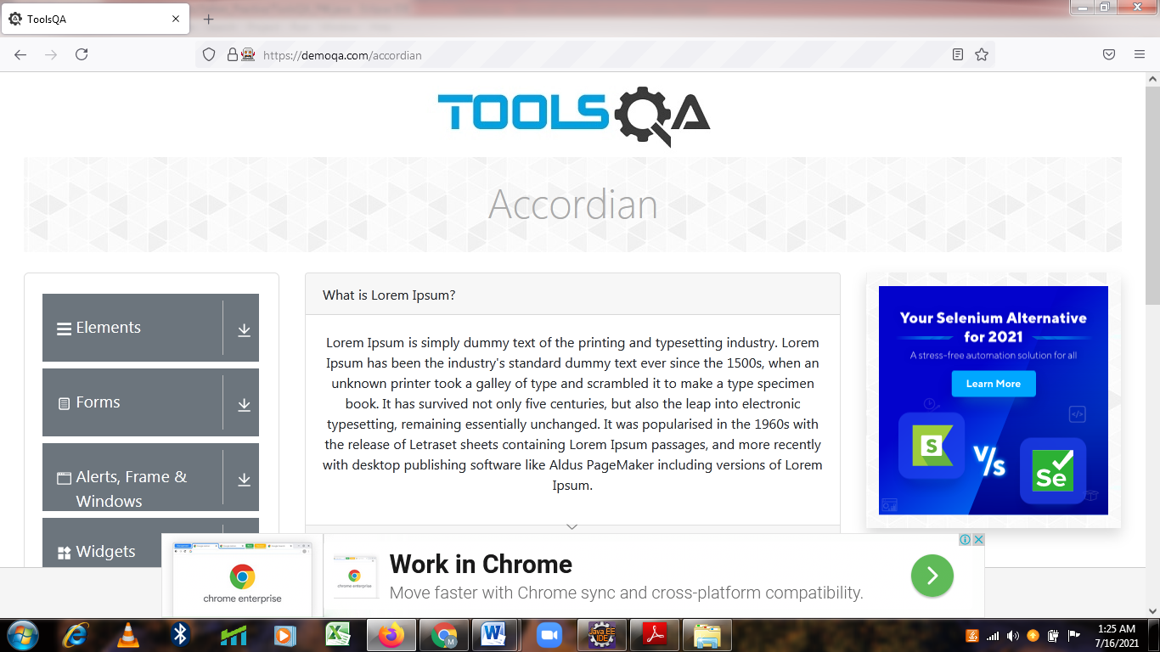

**TC74-To check the functionality of What is Lorem Ipsum? Link**

**Selenium WebDriver Test Script :**

w.findElement(By.xpath("//div[@id='section1Heading']")).click();

Thread.sleep(2000);

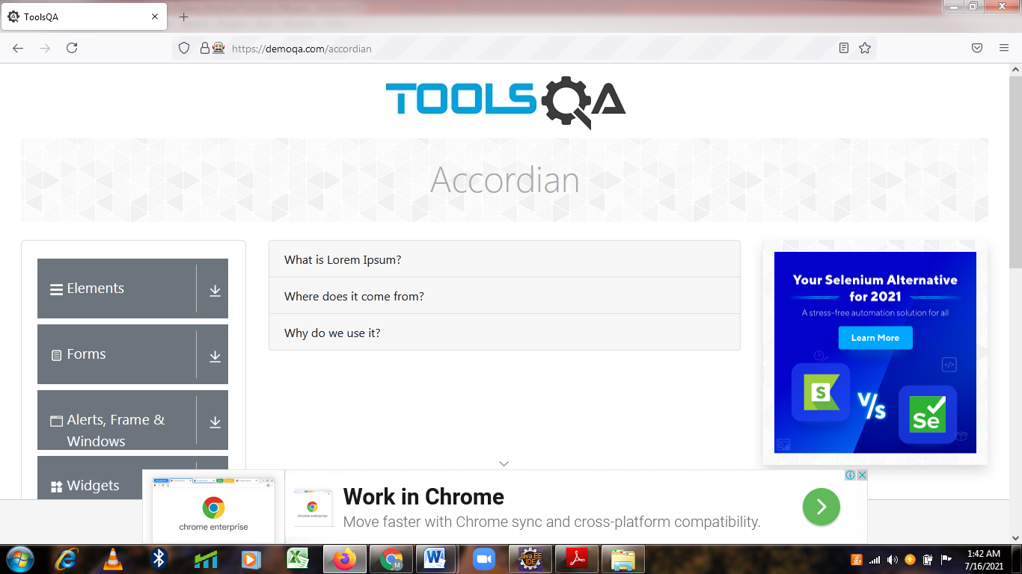

**TC75-To Check the functionality Where does it come from? Link**

**Selenium WebDriver Test Script :**

w.findElement(By.id("section2Heading")).click();

Thread.sleep(2000);

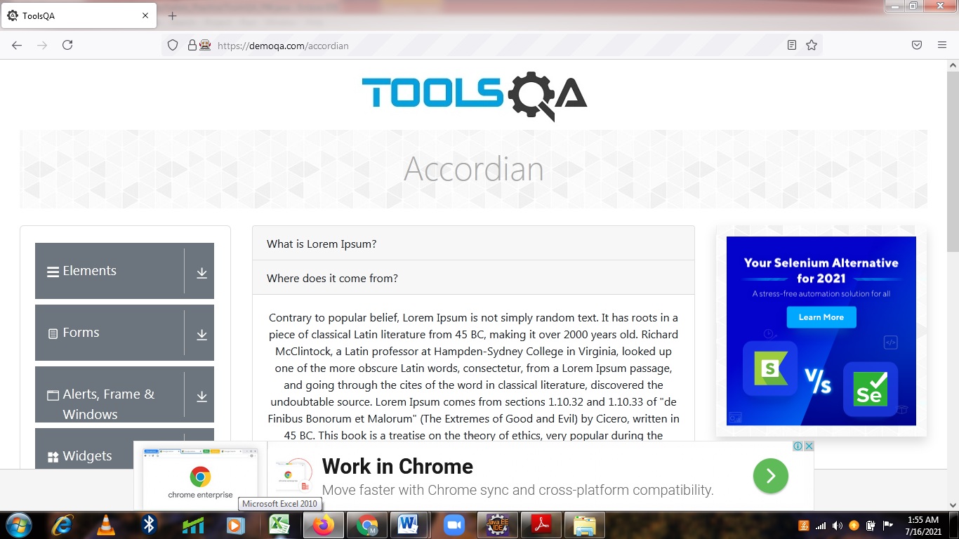

**TC76-To Check the functionality of Why do we use it? Link**

**Selenium WebDriver Test Script :**

js.executeScript("window.scrollBy(0,300)");

Thread.sleep(2000);

w.findElement(By.xpath("//*[@id=\"section3Heading\"]")).click();

Thread.sleep(2000);

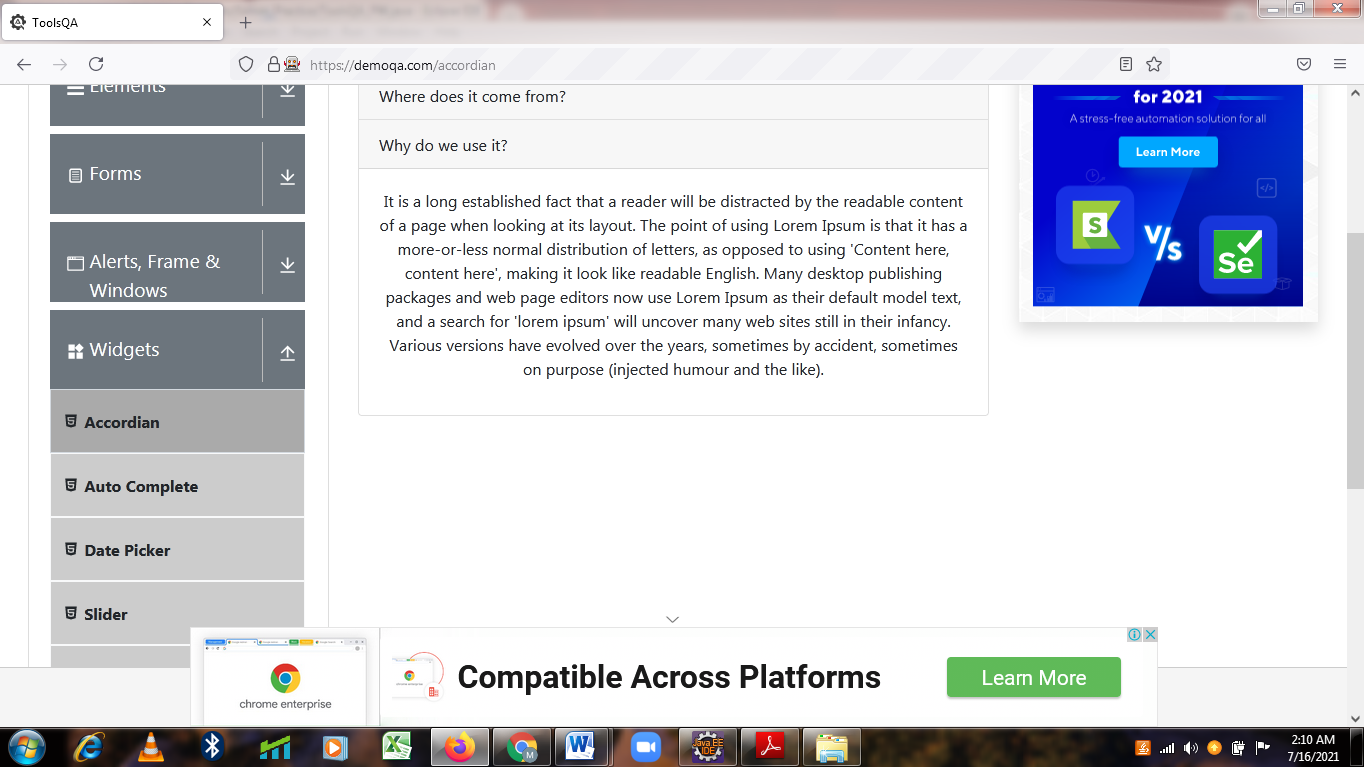

**TC77-To Verify and Display the Link size of Current page of Browser**

**Selenium WebDriver Test Script :**

List<WebElement> L= w.findElements(By.tagName("a"));

System.out.println("Total Links are : "+L.size());

w.navigate().back();

Thread.sleep(2000);

**TC78- To check the functionality of Auto Complete Button**

**Selenium WebDriver Test Script :**

js.executeScript("window.scrollBy(0,500)");

w.findElement(By.xpath("//span[contains(text(),'Auto Complete')]")).click();

Thread.sleep(2000);

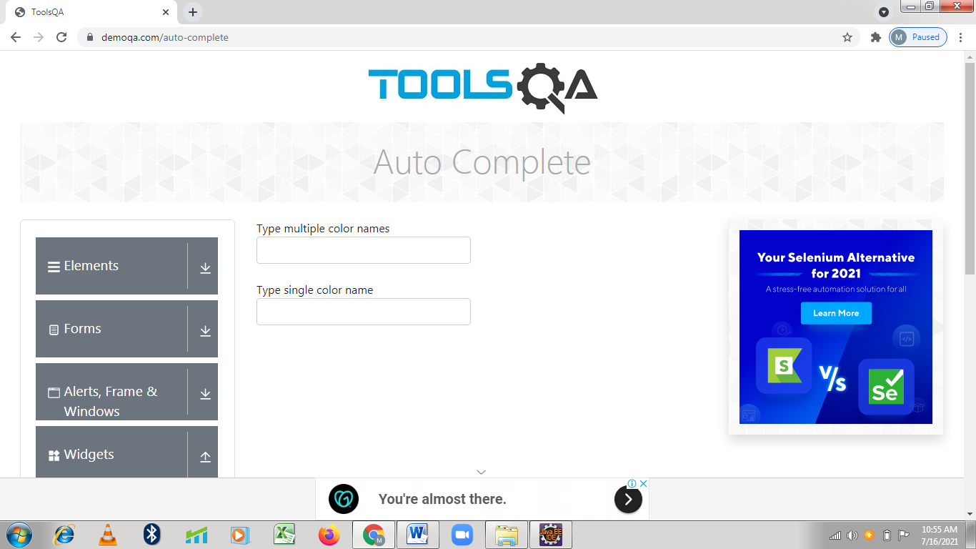

**TC79-To check the functionality of Type multiple color names Textfeild**

**Selenium WebDriver Test Script :**

w.findElement(By.xpath("//body/div[@id='app']/div[1]/div[1]/div[2]/div[2]/div[1]/div[1]/div[1]/div[1]/div[1]/div[1]/div[1]")).click();

w.findElement(By.xpath("//div[contains(text(),'Red')]")).click();

w.findElement(By.xpath("//div[contains(text(),'Purple')]")).click();

w.findElement(By.xpath("//div[contains(text(),'Indigo')]")).click();

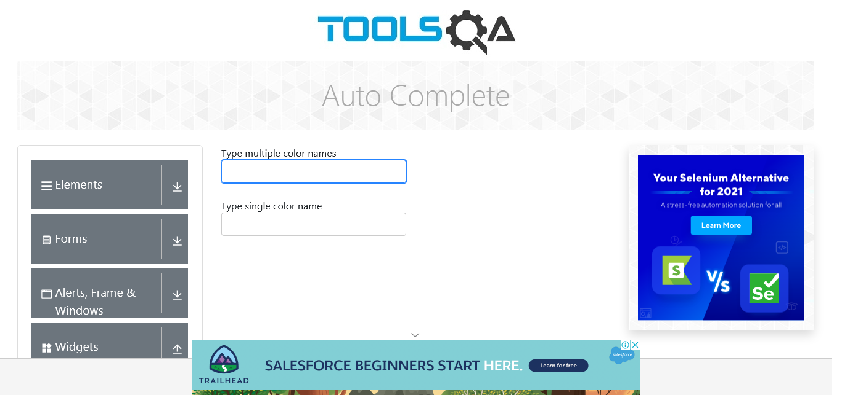Thread.sleep(2000);

**Defect**

In Auto complete Type multiple color names Textfeild not accepting the data in Automatic way

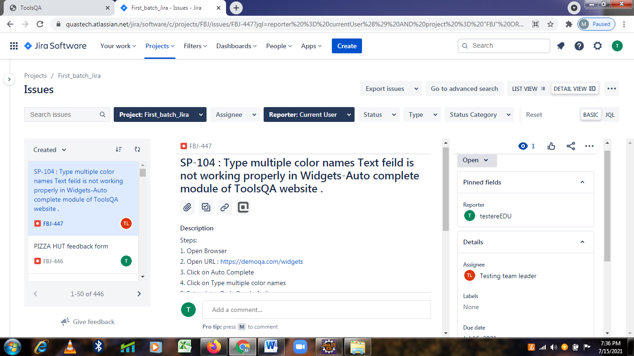

**TC80-To check the functionality of Type single color name Textfeild**

**Selenium WebDriver Test Script:**

w.findElement(By.xpath("//*[@id=\"autoCompleteSingleContainer\"]/div/div[1]")).click();

w.findElement(By.xpath("//*[@id=\"autoCompleteSingleContainer\"]/div/div[1]/div[1]")).

click();

w.navigate().back();

Thread.sleep(2000);

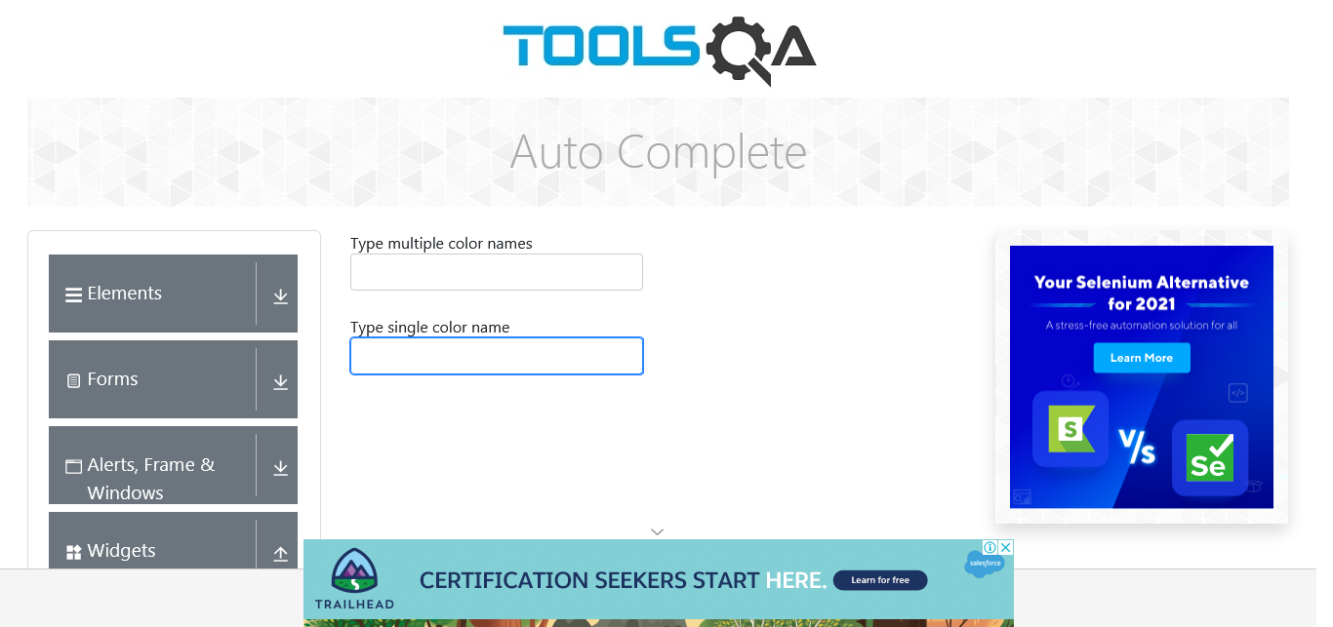

**Defect**

# In Auto complete Type single color name Textfeild not accepting the data in Automatic way

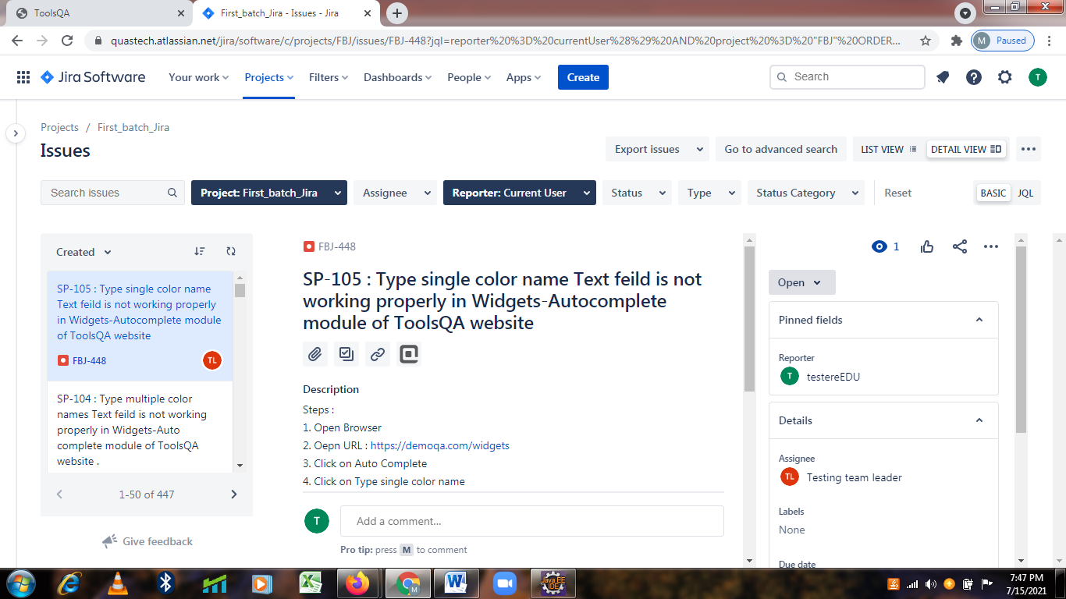

**TC81-To check the functionality of Date Picker Button**

**Selenium WebDriver Test Script:**

js.executeScript("window.scrollBy(0,250)");

Thread.sleep(2000);

w.findElement(By.xpath("//span[contains(text(),'Date Picker')]")).click();

Thread.sleep(2000);

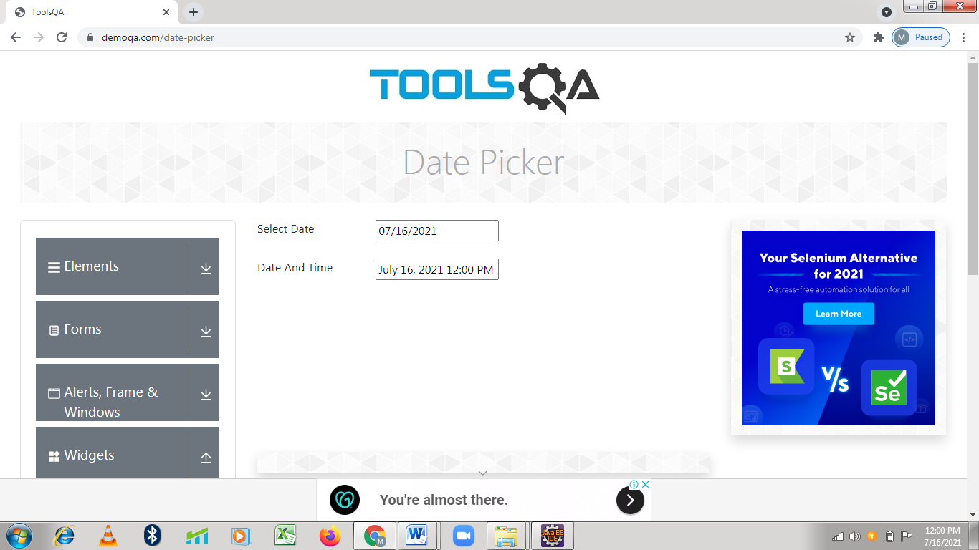

**TC82-To check the functionality of Select Date Button**

**Selenium WebDriver Test Script:**

w.findElement(By.id("datePickerMonthYearInput")).click();

Select s1= new Select(w.findElement(By.className("react-datepicker__month-select")));

s1.selectByValue("4");

Thread.sleep(2000);

Select s2= new Select(w.findElement(By.className("react-datepicker__year-select")));

s2.selectByVisibleText("1993");

Thread.sleep(2000);

w.findElement(By.xpath("//body/div[@id='app']/div[1]/div[1]/div[2]/div[2]/div[1]/div[1]/div[2]/div[2]/div[2]/div[1]/div[1]/div[2]/div[2]/div[5]/div[5]")).click();

Thread.sleep(2000);

System.out.println("05/27/1993 Date is selected");

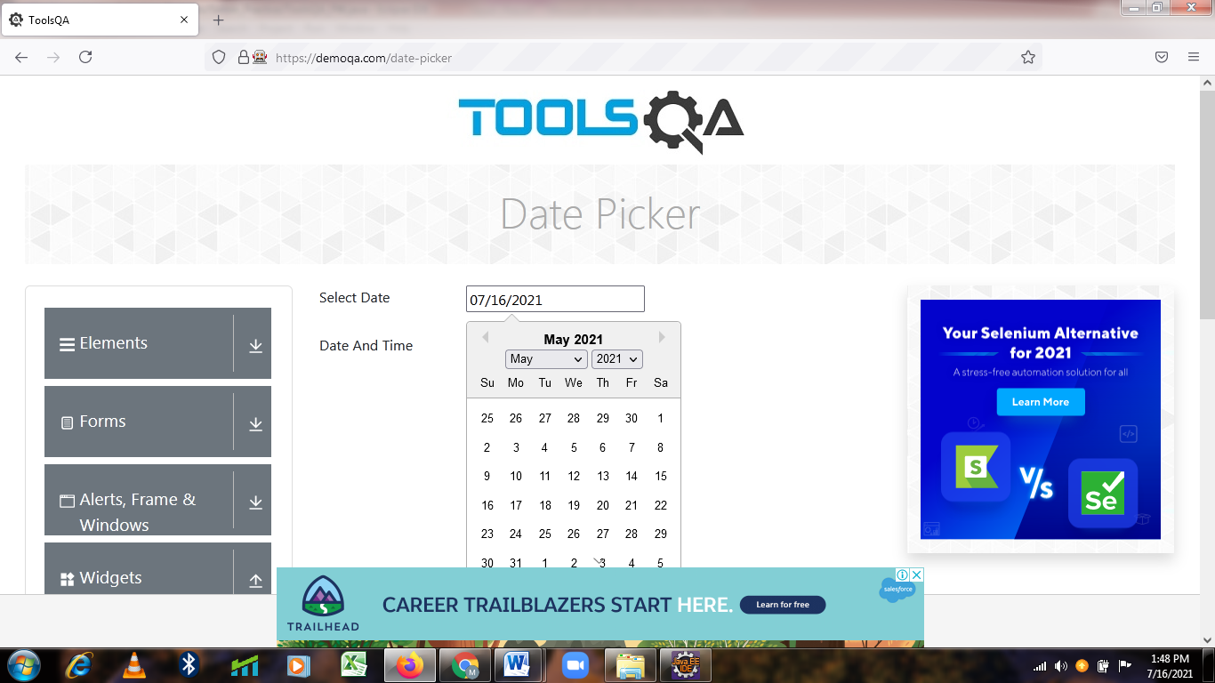

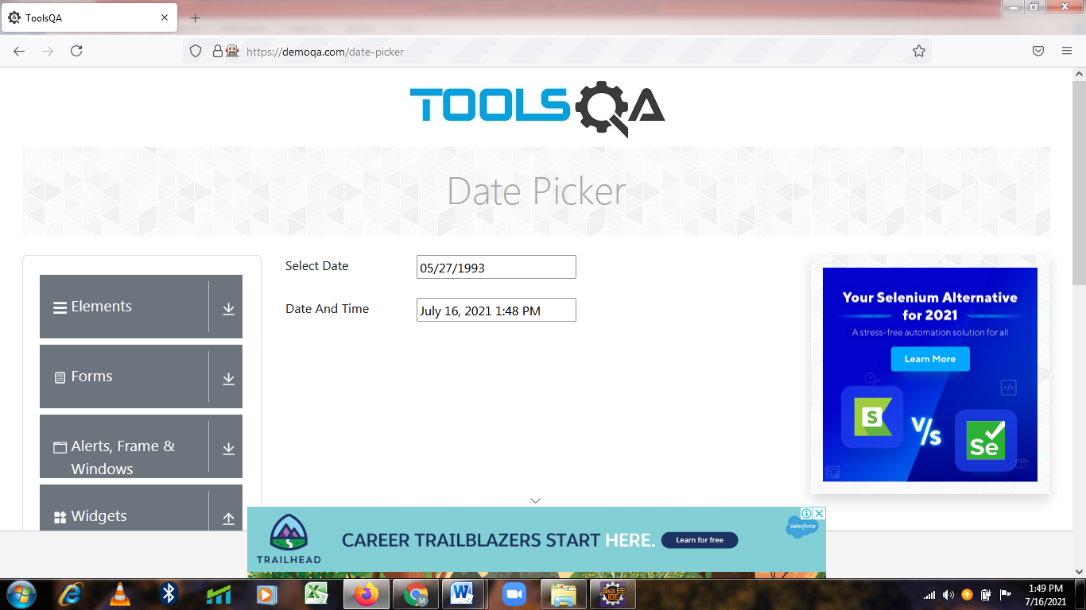

**TC83-To check the functionality of Date And Time Button**

**Selenium WebDriver Test Script:**

w.findElement(By.id("dateAndTimePickerInput")).click();

js.executeScript("window.scrollBy(0,350)");

w.findElement(By.xpath("//body/div[@id='app']/div[1]/div[1]/div[2]/div[2]/div[1]/div[2]/div[2]/div[2]/div[2]/div[1]/div[1]/div[2]/div[1]/div[2]/div[1]/div[1]/span[1]")).click();

Thread.sleep(2000);

w.findElement(By.xpath("//*[@id=\"dateAndTimePicker\"]/div[2]/div[2]/div/div/div[2]/div[1]/div[2]/div[1]/div[1]/div[6]")).click();

Thread.sleep(2000);

w.findElement(By.xpath("//*[@id=\"dateAndTimePicker\"]/div[2]/div[2]/div/div/div[2]/div[1]/div[2]/div[2]/div/span[1]")).click();

Thread.sleep(2000);

w.findElement(By.xpath("//body/div[@id='app']/div[1]/div[1]/div[2]/div[2]/div[1]/div[2]/div[2]/div[2]/div[2]/div[1]/div[1]/div[2]/div[1]/div[2]/div[2]/div[1]/div[13]/a[1]")).click();

Thread.sleep(2000);

w.findElement(By.xpath("//body/div[@id='app']/div[1]/div[1]/div[2]/div[2]/div[1]/div[2]/div[2]/div[2]/div[2]/div[1]/div[1]/div[2]/div[1]/div[2]/div[2]/div[1]/div[1]/a[1]")).click();

Thread.sleep(2000);

w.findElement(By.xpath("//*[@id=\"dateAndTimePicker\"]/div[2]/div[2]/div/div/div[2]/div[1]/div[2]/div[2]/div[1]/div[6]")).click();

w.findElement(By.xpath("//div[contains(text(),'10')]")).click();

Thread.sleep(2000);

w.findElement(By.id("dateAndTimePickerInput")).click();

js.executeScript("window.scrollBy(0,300)");

Thread.sleep(2000);

w.findElement(By.xpath("/html[1]/body[1]/div[2]/div[1]/div[1]/div[2]/div[2]/div[1]/div[2]/div[2]/div[2]/div[2]/div[1]/div[1]/div[3]/div[1]/div[1]")).click();

js.executeScript("window.scrollBy(0,200)");

w.findElement(By.xpath("//li[contains(text(),'17:30')]")).click();

Thread.sleep(2000);

System.out.println("June/10/2022 5:30 PM Date & time is selected");

w.navigate().back();

Thread.sleep(2000)

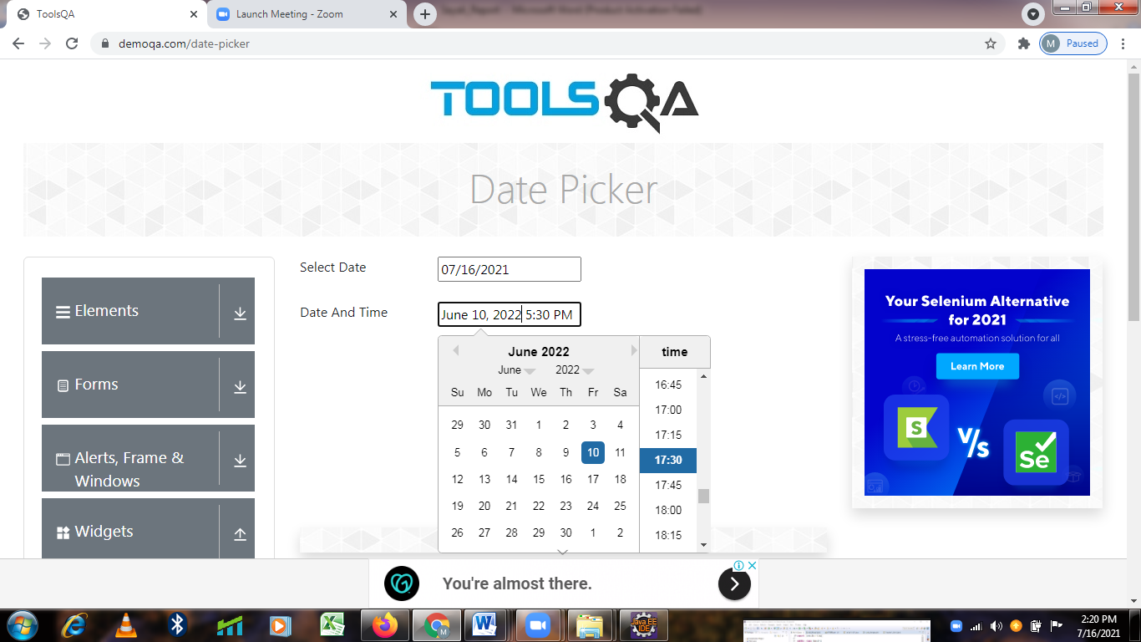

**TC84-To check the functionality of Slider Button**

**Selenium WebDriver Test Script:**

js.executeScript("window.scrollBy(0,300)");

Thread.sleep(2000);

w.findElement(By.xpath("//span[contains(text(),'Slider')]")).click();

System.out.println("Slider WebPage is open");

Thread.sleep(2000);

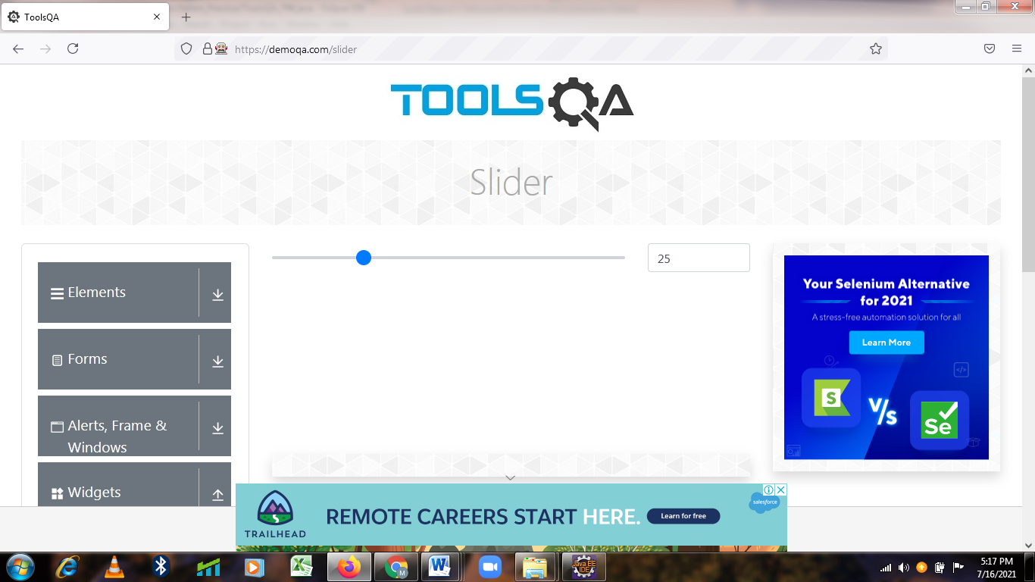

**TC85-To check the functionality of Slider move Backward & Forward**

**Selenium WebDriver Test Script :**

WebElement slider=w.findElement(By.xpath("//*[@id=\"sliderContainer\"]/div[1]/span/input"));

Actions act= new Actions(w);

act.dragAndDropBy(slider,-150, 100).perform();

Thread.sleep(2000);

act.dragAndDropBy(slider, 200, 100).perform();

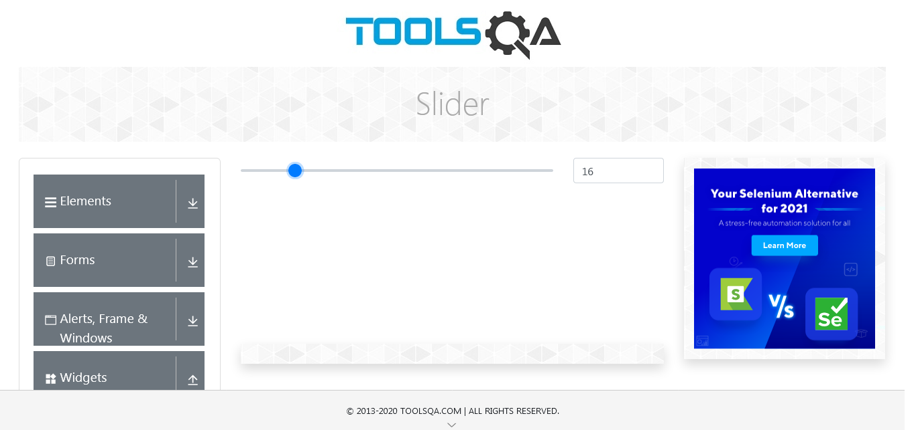Thread.sleep(2000);

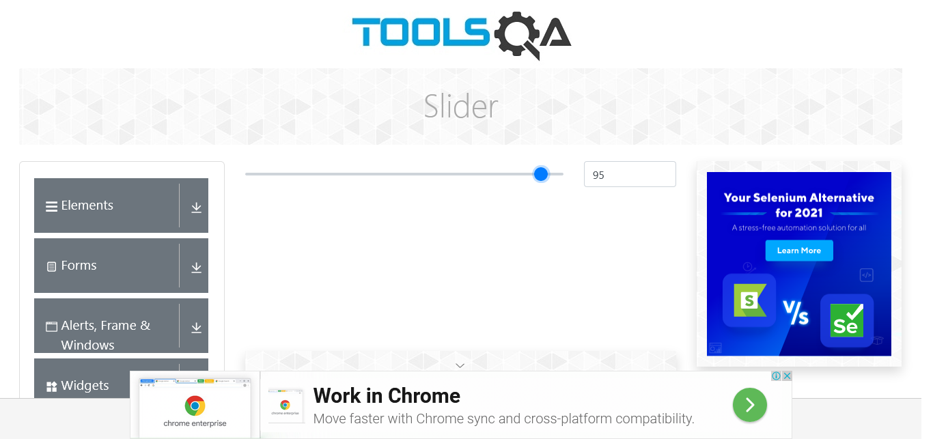

**TC86-To Take Screenshot of output**

**Selenium WebDriver Test Script :**

TakesScreenshot t = (TakesScreenshot) w;

File src= t.getScreenshotAs(OutputType.FILE);

Files.copy(src, new File ("D:\\Backup\\Desktop\\Selenm\\Screenshot\\slider2.jpeg"));

w.navigate().back();

Thread.sleep(2000);



**TC87-To check the functionality of Progress Bar Button**

**Selenium WebDriver Test Script :**

js.executeScript("window.scrollBy(0,500)");

w.findElement(By.xpath("//span[contains(text(),'Progress Bar')]")).click();

System.out.println("Progress Bar WebPage is open");

Thread.sleep(2000);

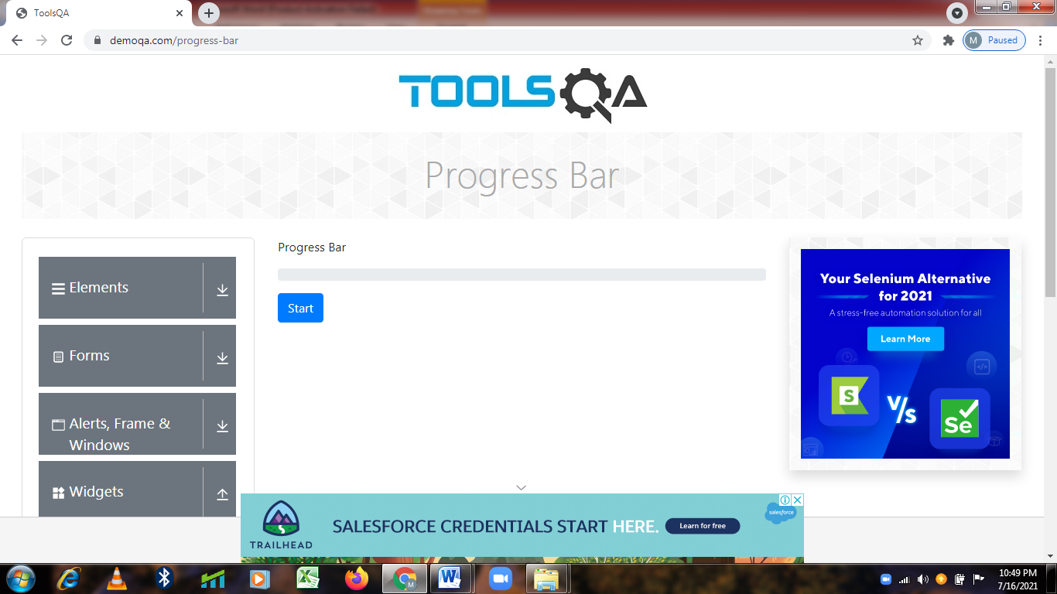

**TC88-To check the functionality of Progress Bar-Start_Stop Button**

**Selenium WebDriver Test Script :**

w.findElement(By.xpath("//*[@id=\"startStopButton\"]")).click();

Thread.sleep(4000);

w.findElement(By.xpath("/html[1]/body[1]/div[2]/div[1]/div[1]/div[2]/div[2]/div[1]/button[1]")).click();

Thread.sleep(2000);

w.navigate().back();

Thread.sleep(2000);

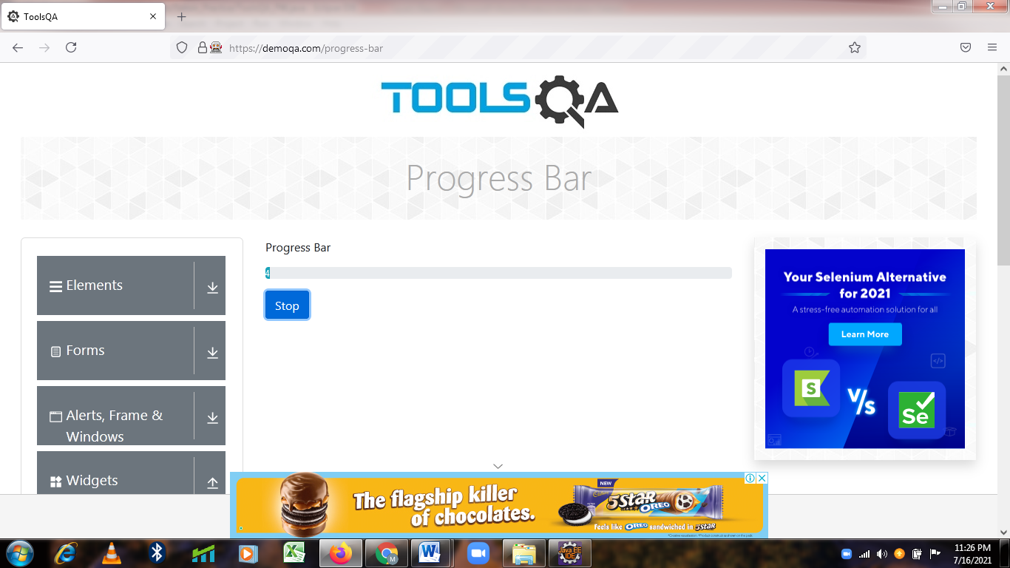

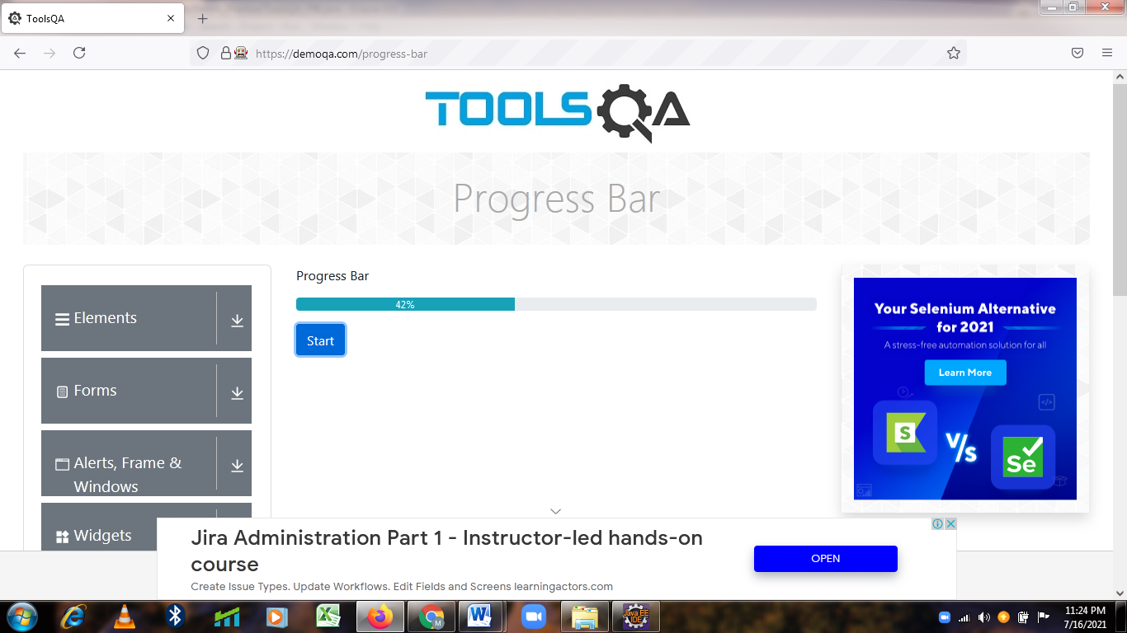

**TC89-To check the functionality of Tabs Button**

**Selenium WebDriver Test Script :**

js.executeScript("window.scrollBy(0,500)");

Thread.sleep(2000);

w.findElement(By.xpath("//span[contains(text(),'Tabs')]")).click();

System.out.println("Tabs WebPage is open");

Thread.sleep(2000);

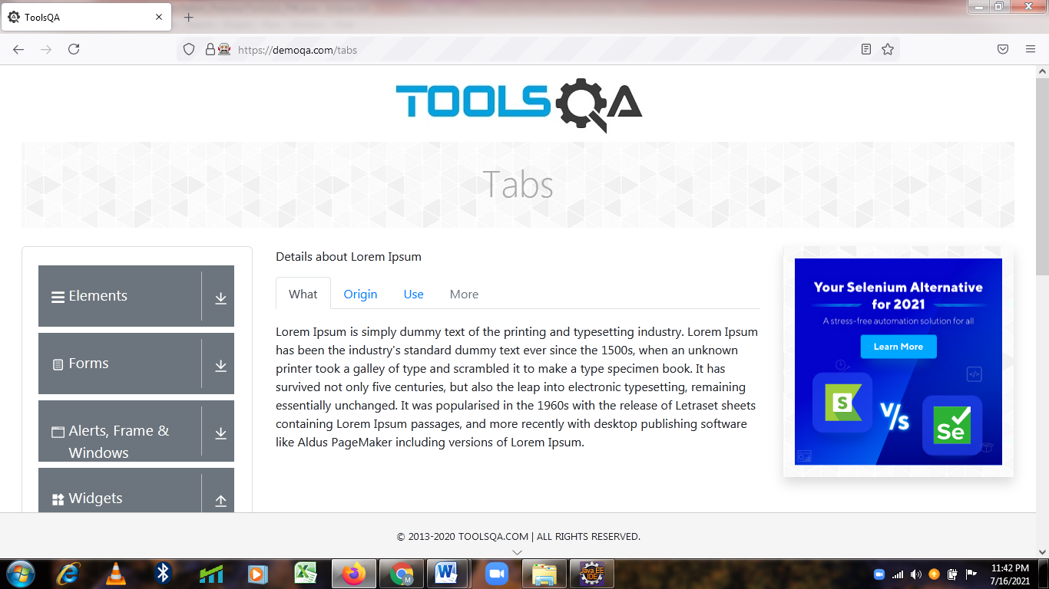

**TC90-To check the functionality of Tabs-Origin Tab Button**

**Selenium WebDriver Test Script :**

w.findElement(By.id("demo-tab-origin")).click();

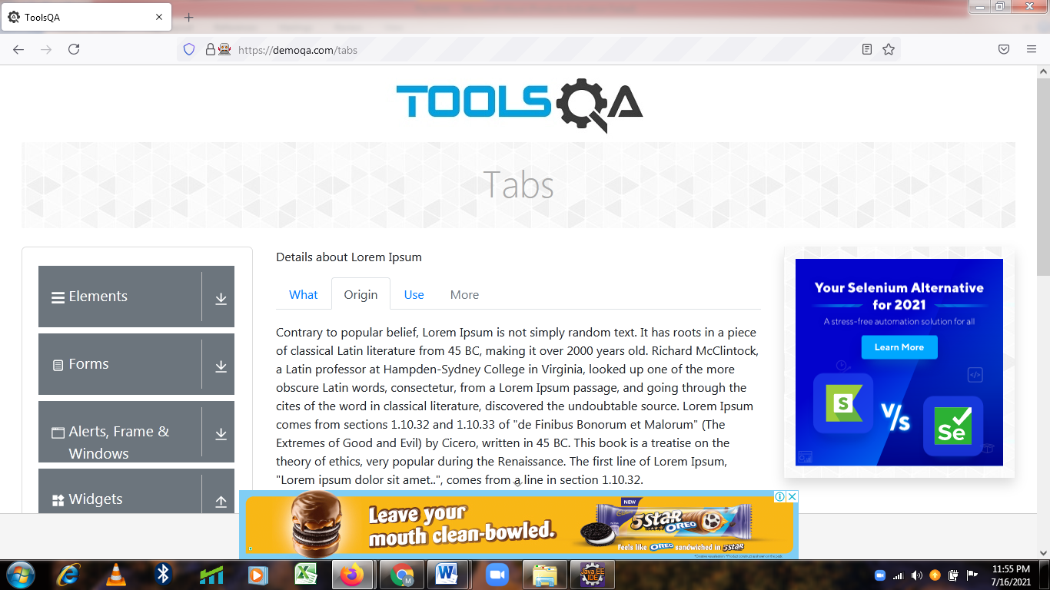Thread.sleep(2000);

**TC91-To Check the Functionality of Tabs-What Tab Button**

**Selenium WebDriver Test Script :**

w.findElement(By.id("demo-tab-what")).click();

Thread.sleep(2000);

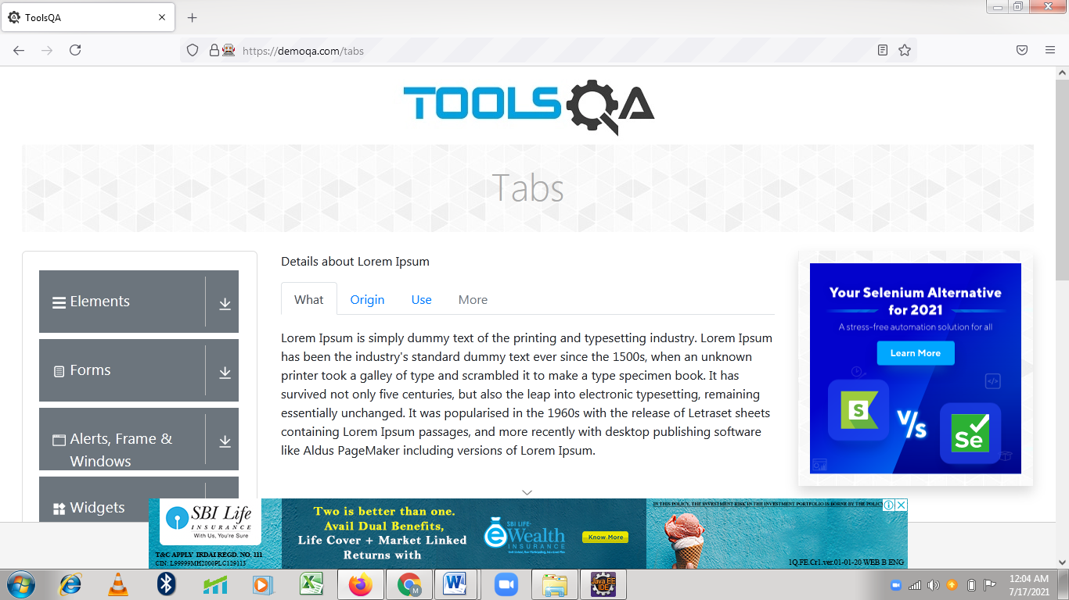

**TC92-To Check the Functionality of Tabs-Use Tab Button**

**Selenium WebDriver Test Script :**

w.findElement(By.linkText("Use")).click();

Thread.sleep(2000);

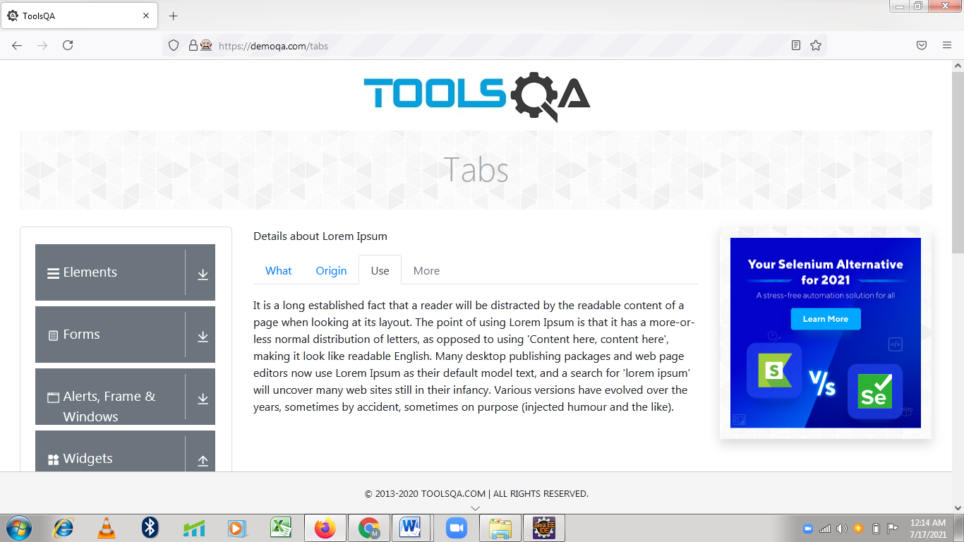

**TC93-To Check the Functionality of Tabs-More Tab Button**

**Selenium WebDriver Test Script :**

w.findElement(By.xpath("/html[1]/body[1]/div[2]/div[1]/div[1]/div[2]/div[2]/div[1]/nav[1]/a[4]")).click();

boolean eleEnabled=

w.findElement(By.xpath("/html[1]/body[1]/div[2]/div[1]/div[1]/div[2]/div[2]/div[1]/nav[1]/a[4]")).isEnabled();

System.out.println(eleEnabled);

Thread.sleep(2000);

w.navigate().back();

Thread.sleep(2000);

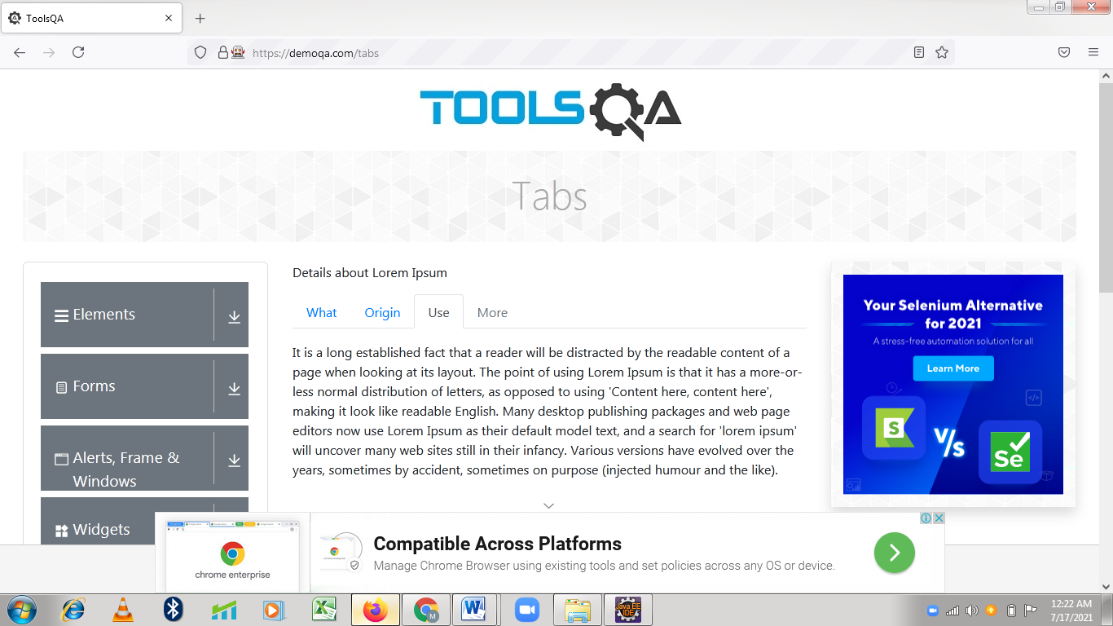

**Defect**

In Tabs-More Tab Button is not clickable in Automatic way & Manul way also.

# 

**TC94-To check the functionality of Tool Tips Button**

**Selenium WebDriver Test Script :**

js.executeScript("window.scrollBy(0,500)");

Thread.sleep(2000);

w.findElement(By.xpath("//span[contains(text(),'Tool Tips')]")).click();

System.out.println("Tool Tips WebPage is open");

Thread.sleep(2000);

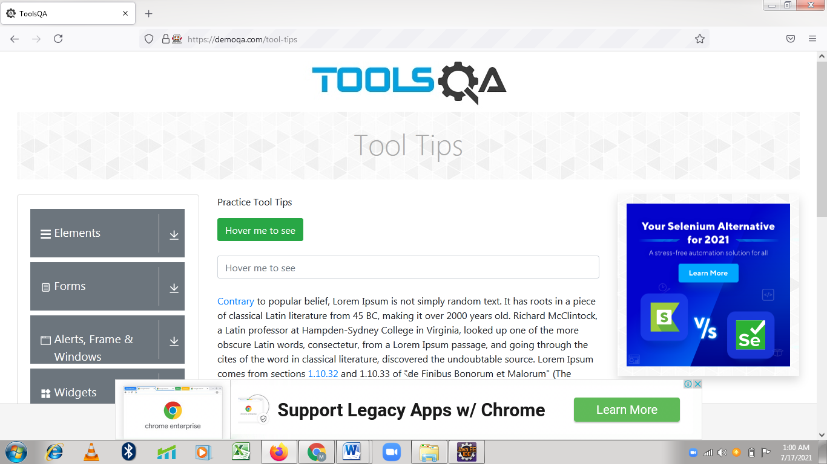

**TC95-To check the functionality of Hover me to see Button**

**Selenium WebDriver Test Script :**

Actions A1 = new Actions(w);

A1.moveToElement(w.findElement(By.xpath("//button[@id='toolTipButton']"))).perform();

Thread.sleep(2000);

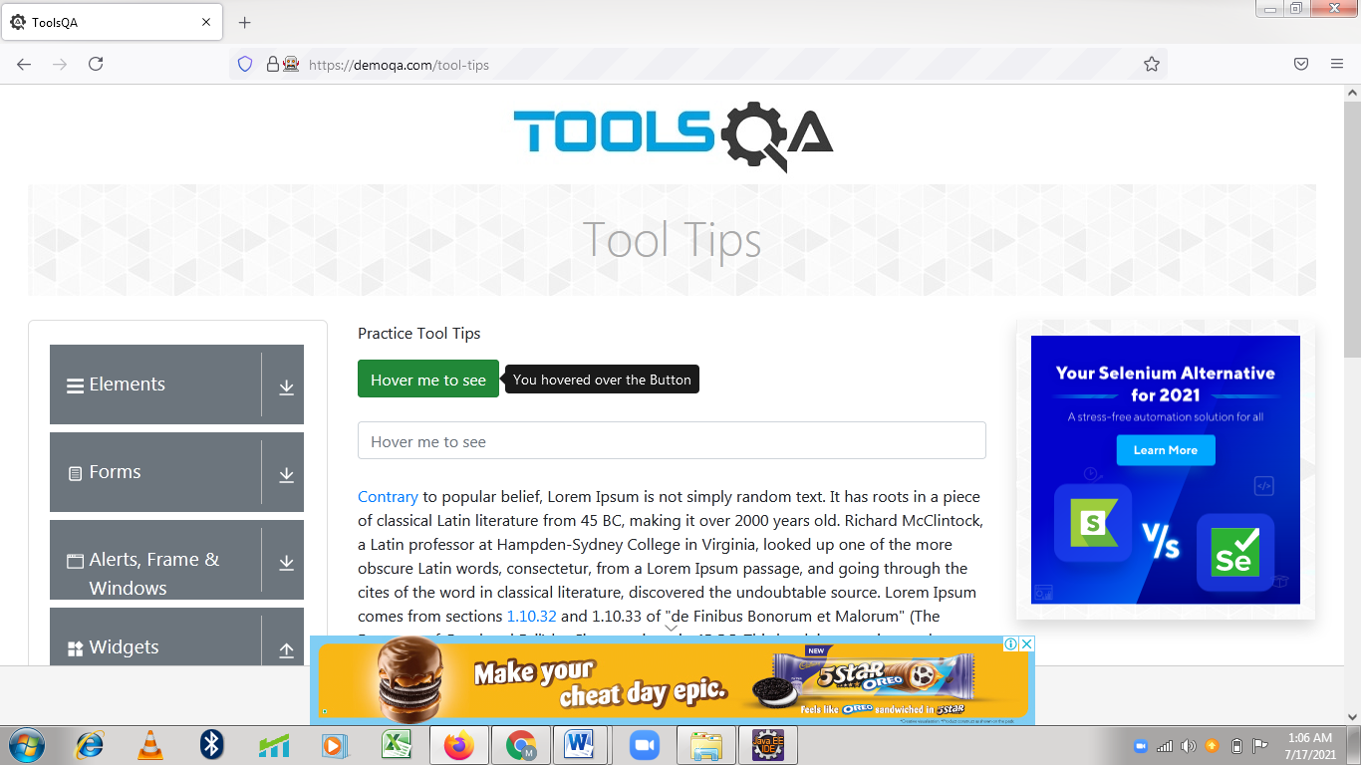

**TC96-To Check the Functionality Hover me to see TextFeild**

**Selenium WebDriver Test Script :**

WebElement text=w.findElement(By.xpath("//input[@id='toolTipTextField']"));

Actions A2 = new Actions(w);

A2.moveToElement(text).click().keyDown(Keys.SHIFT).sendKeys("Hello").build().

perform();

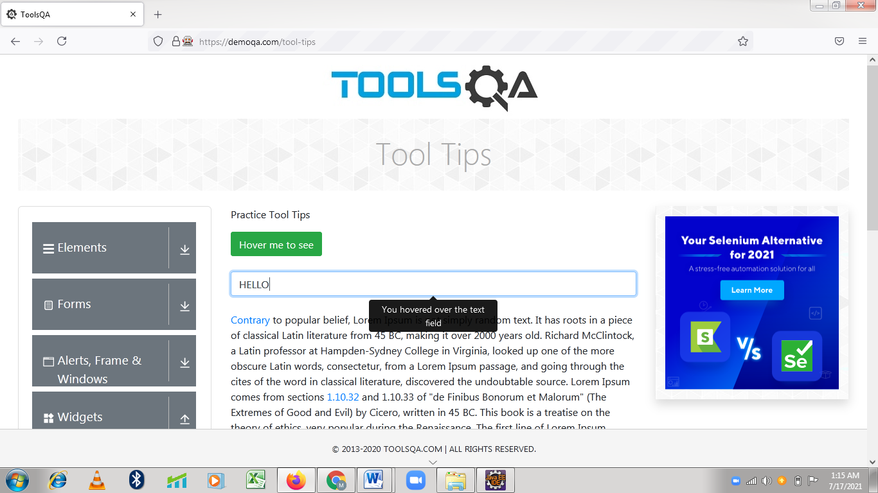

**TC97-To check the functionality** [**Contrary**](javascript:void(0)) **&** [**1.10.32**](javascript:void(0)) **Link Hovering**

**Selenium WebDriver Test Script :**

Actions A3 = new Actions(w);

A3.moveToElement(w.findElement(By.xpath("//a[contains(text(),'Contrary')]"))).perform();

Thread.sleep(2000);

js.executeScript("window.scrollBy(0,300)");

Actions A4 = new Actions(w);

A4.moveToElement(w.findElement(By.xpath("//a[contains(text(),'1.10.32')]"))).perform();

Thread.sleep(2000);

w.navigate().back();

Thread.sleep(2000);

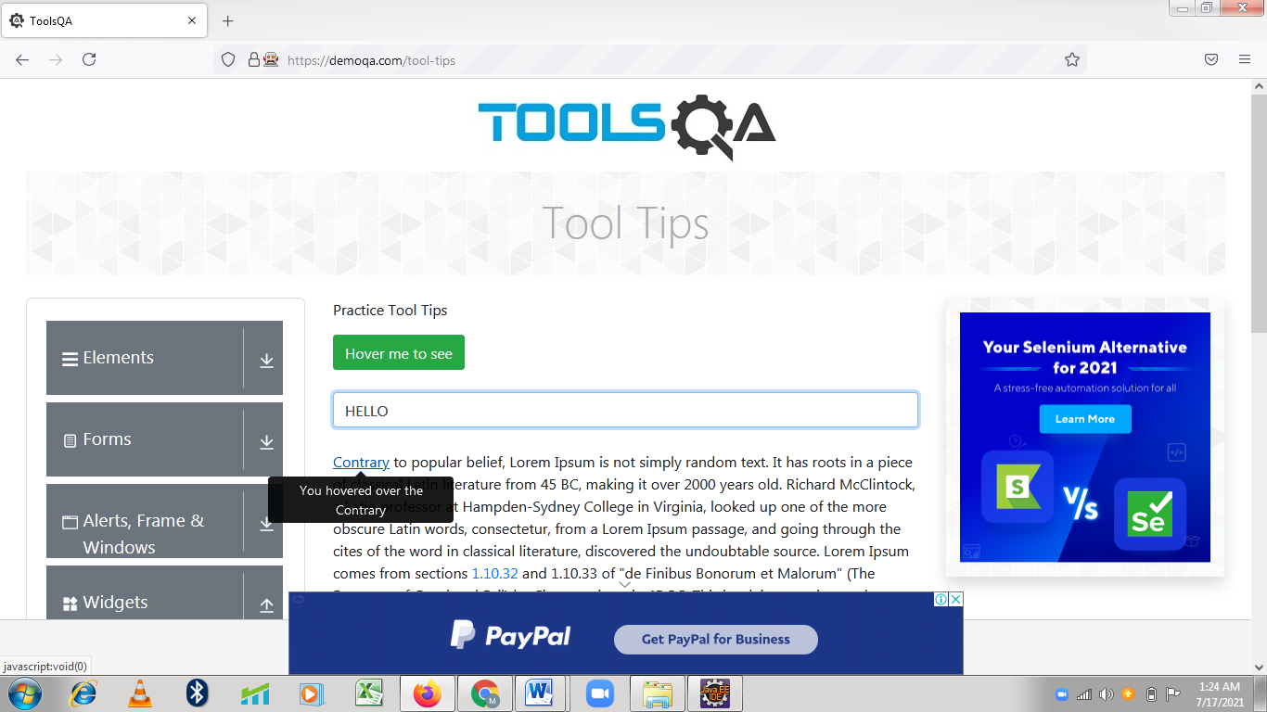

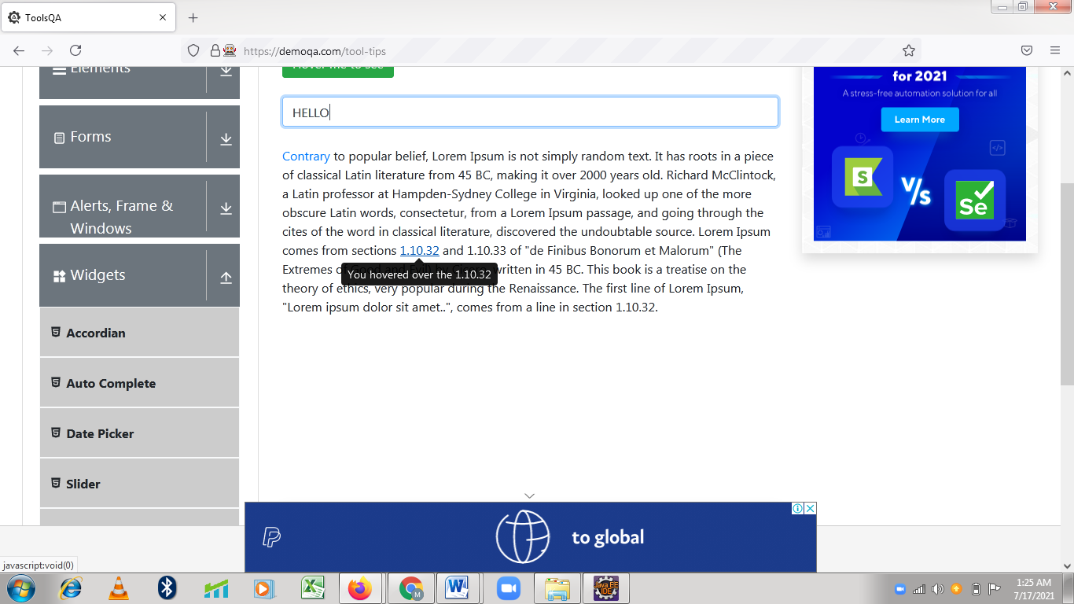

**TC98-To check the functionality of Menu Button**

**Selenium WebDriver Test Script :**

js.executeScript("window.scrollBy(0,600)");

Thread.sleep(2000);

w.findElement(By.xpath("/html[1]/body[1]/div[2]/div[1]/div[1]/div[2]/div[1]/div[1]/

div[1]/div[4]/div[1]/ul[1]/li[8]/span[1]")).click();

System.out.println("Menu WebPage is open");

Thread.sleep(2000);

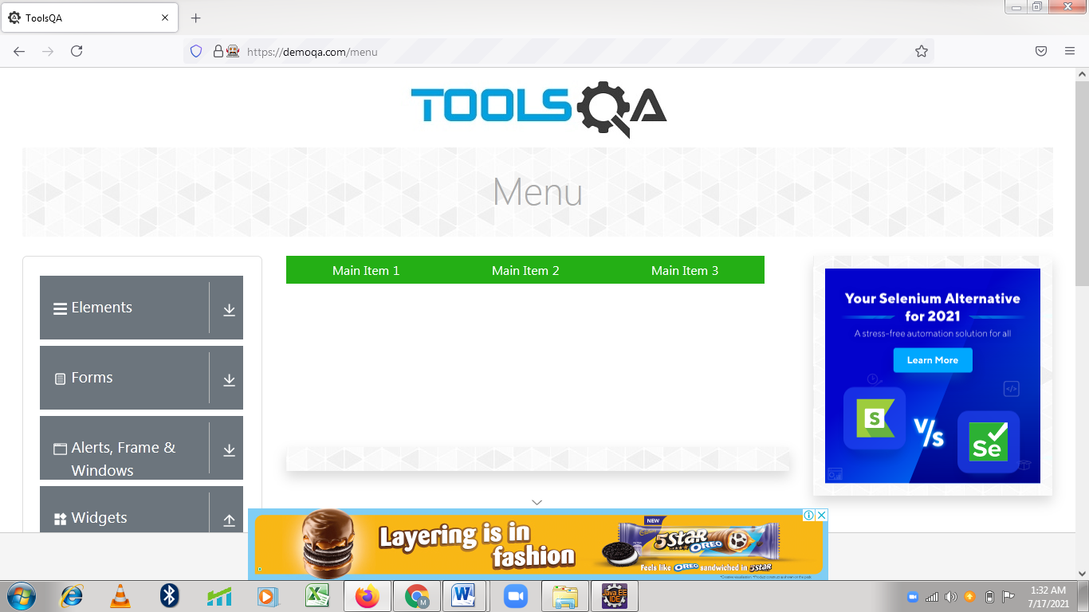

**TC99- To Check the functionality of Main Item 1 Button**

**Selenium WebDriver Test Script :**

w.findElement(By.linkText("Main Item 1")).click();

Thread.sleep(2000);

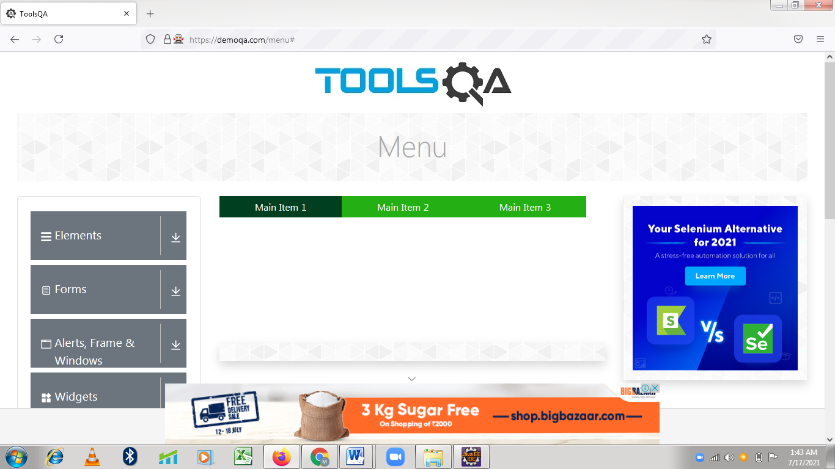

**TC100- To Check the functionality of Main Item 2 Button to choose Sub Item**

**Selenium WebDriver Test Script :**

Actions A5 = new Actions(w);

A5.moveToElement(w.findElement(By.xpath("//a[contains(text(),'Main Item2')]")))

.perform();

w.findElement(By.linkText("Sub Item")).click();

Thread.sleep(3000);

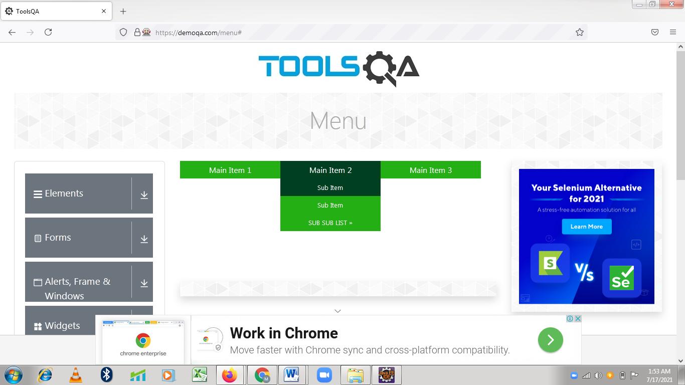

**TC101- To Check the functionality of Main Item 2 Button to choose Sub Sub Item &**

**Main Item 3**

**Selenium WebDriver Test Script :**

Actions A6 = new Actions(w);

A6.moveToElement(w.findElement(By.xpath("//a[contains(text(),'MainIte2')]"))).

perform();

A6.moveToElement(w.findElement(By.xpath("//a[contains(text(),'SUB SUB LIST»')]")))

.perform();

w.findElement(By.xpath("//a[contains(text(),'Sub Sub Item 2')]")).click();

Thread.sleep(2000);

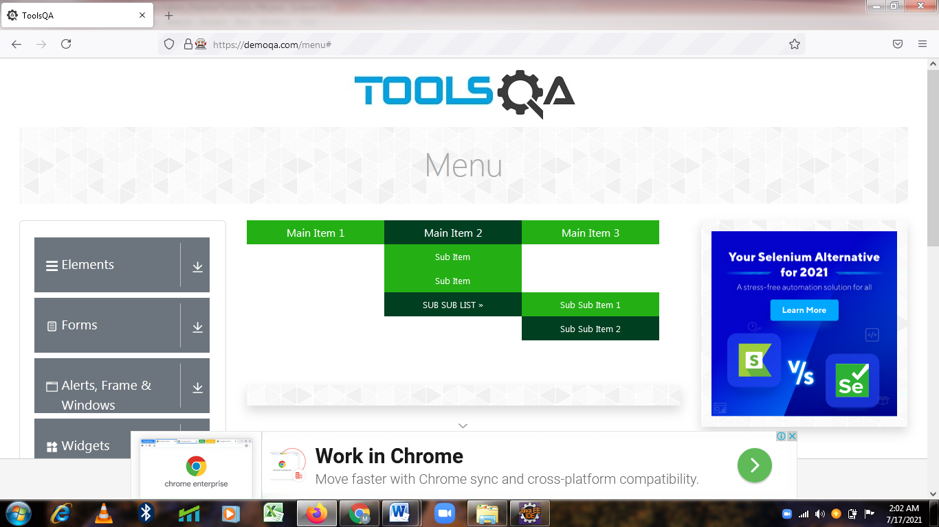

w.findElement(By.xpath("//a[contains(text(),'Main Item 3')]")).click();

w.navigate().back();

w.navigate().back();

Thread.sleep(2000); 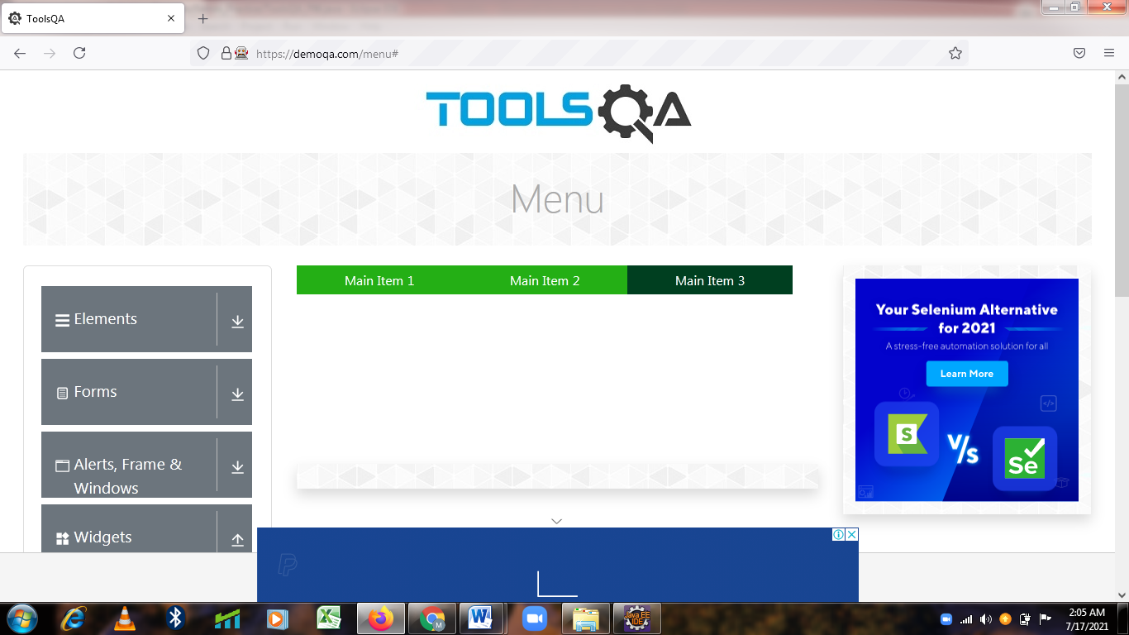

**TC102-To check the functionality of Select Menu Button**

**Selenium WebDriver Test Script :**

js.executeScript("window.scrollBy(0,600)");

Thread.sleep(2000);

w.findElement(By.xpath("/html[1]/body[1]/div[2]/div[1]/div[1]/div[2]/div[1]/div[1]/div[1]/div[4]/div[1]/ul[1]/li[9]/span[1]")).click();

System.out.println("Select Menu WebPage is open");

Thread.sleep(2000);

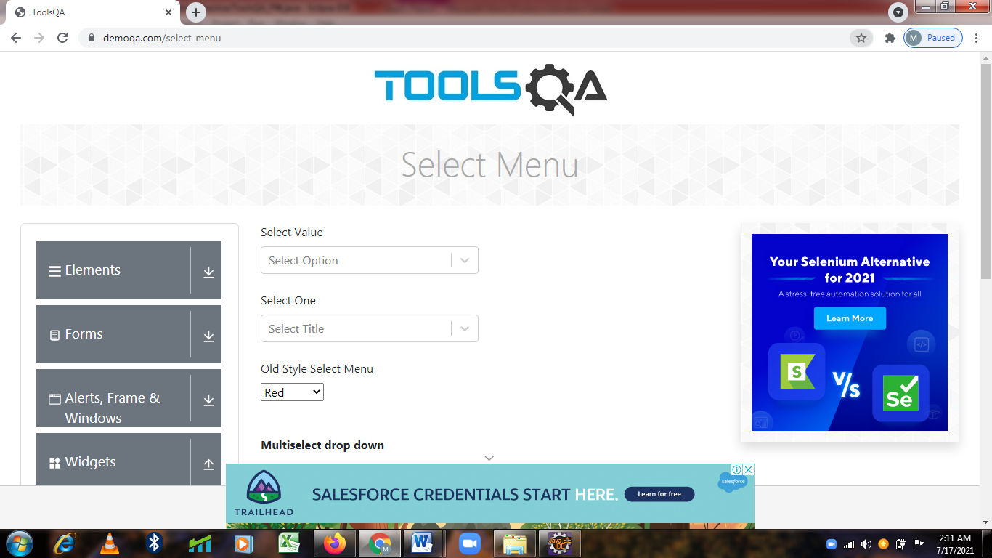

**TC103-To check the functionality of Select Value Button**

**Selenium WebDriver Test Script :**

w.findElement(By.xpath("//*[@id=\"withOptGroup\"]/div/div[1]/div[1]")).click();

w.findElement(By.xpath("//div[contains(text(),'Group 2, option 1')]")).click();

Thread.slee(2000);

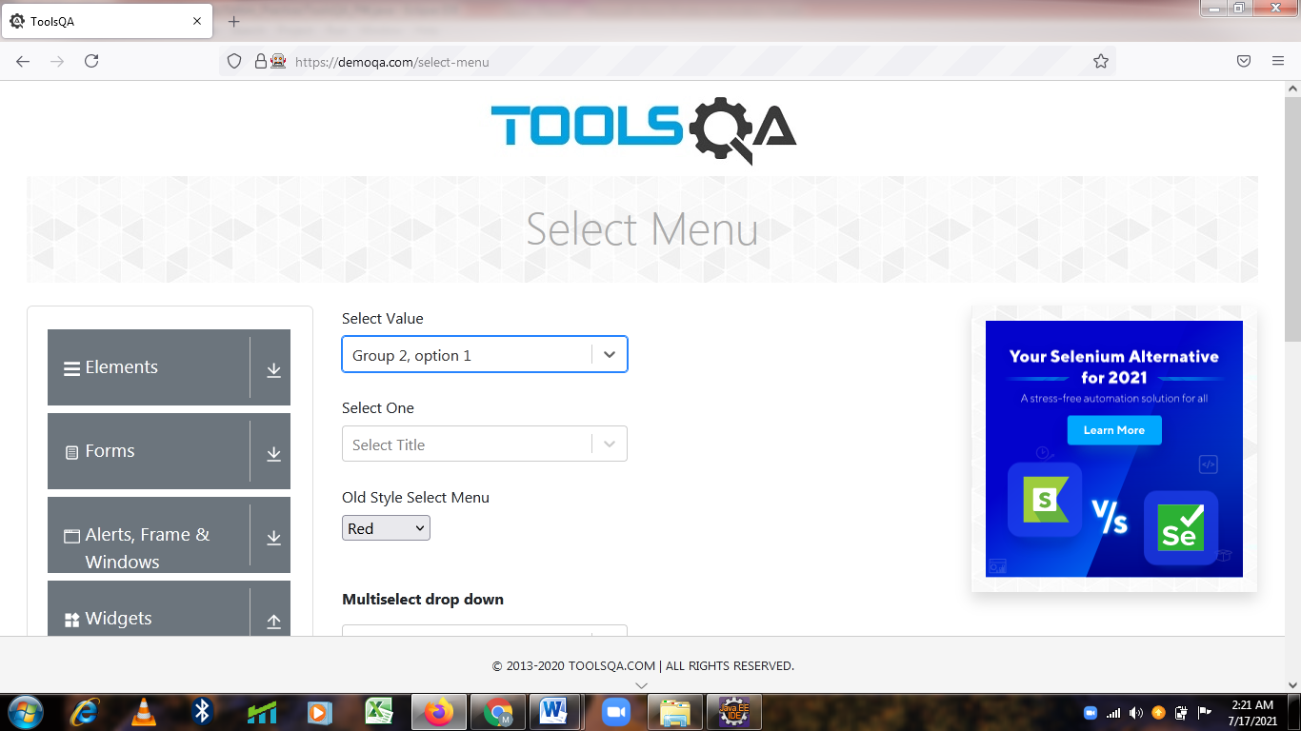

**TC104-To check the functionality of Select One Button**

**Selenium WebDriver Test Script :**

w.findElement(By.xpath("//*[@id=\"selectOne\"]/div/div[1]")).click();

w.findElement(By.xpath("//div[contains(text(),'Ms.')]")).click();

Thread.sleep(2000);

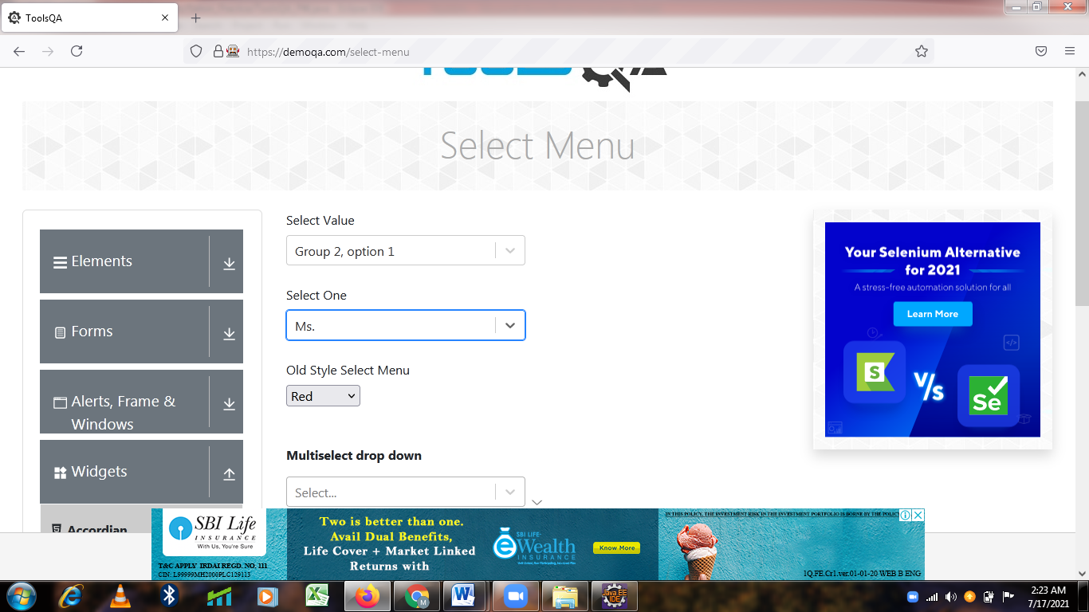

**TC105-To check the functionality of Old Style Select Menu Button**

**Selenium WebDriver Test Script :**

Select s3= new Select(w.findElement(By.xpath("//select[@id='oldSelectMenu']")));

s3.selectByValue("4");

Thread.sleep(2000);

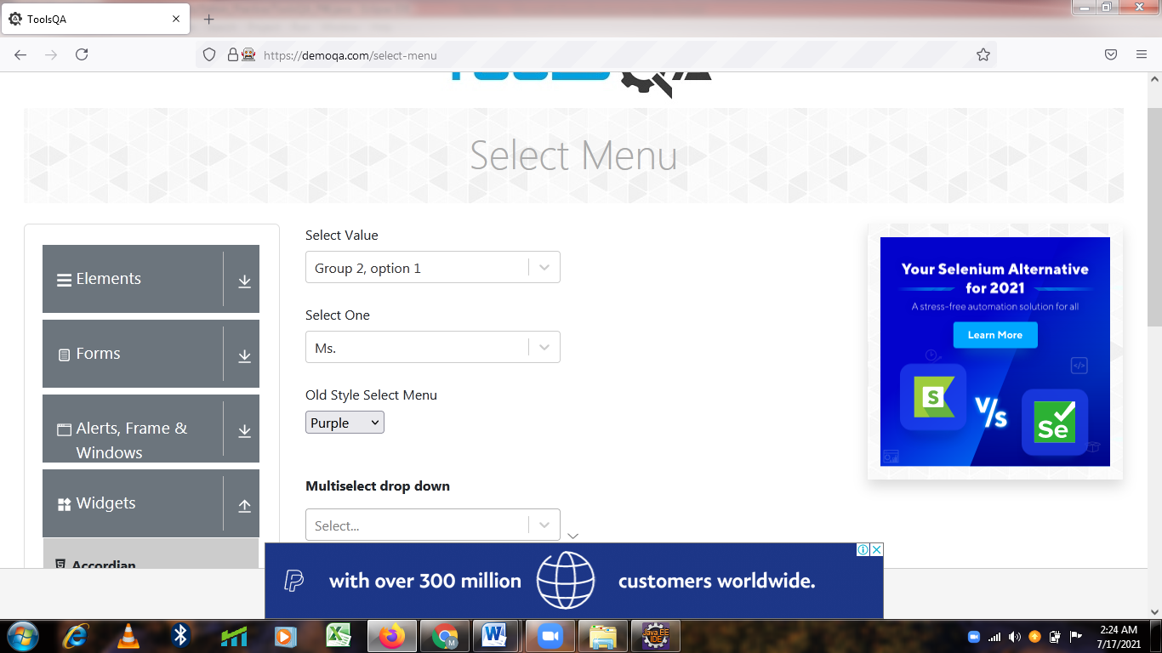

**TC106-To check the functionality of Multiselect drop down Button**

**Selenium WebDriver Test Script :**

js.executeScript("window.scrollBy(0, 400)", "");

w.findElement(By.xpath("//*[@id=\"selectMenuContainer\"]/div[7]/div/div/div/div[1]"))

.click();

w.findElement(By.xpath("//div[contains(text(),'Blue')]")).click();

Thread.sleep(2000);

w.findElement(By.xpath("//div[contains(text(),'Black')]")).click();

Thread.sleep(2000);

w.findElement(By.xpath("//div[contains(text(),'Green')]")).click();

Thread.sleep(2000);

w.findElement(By.xpath("//body/div[@id='app']/div[1]/div[1]/div[2]/div[2]/div[1]/div[7]/div[1]/div[1]/div[1]/div[1]/div[3]/div[1]/div[2]/*[1]")).click();

Thread.sleep(2000);

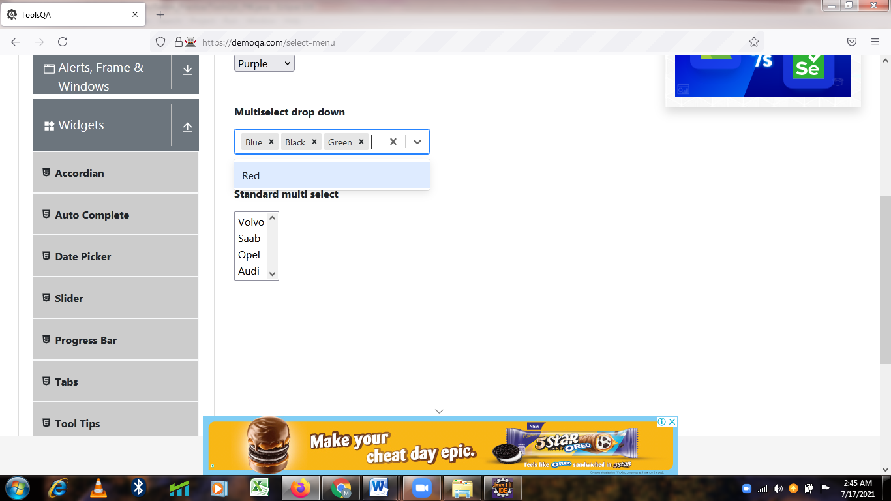

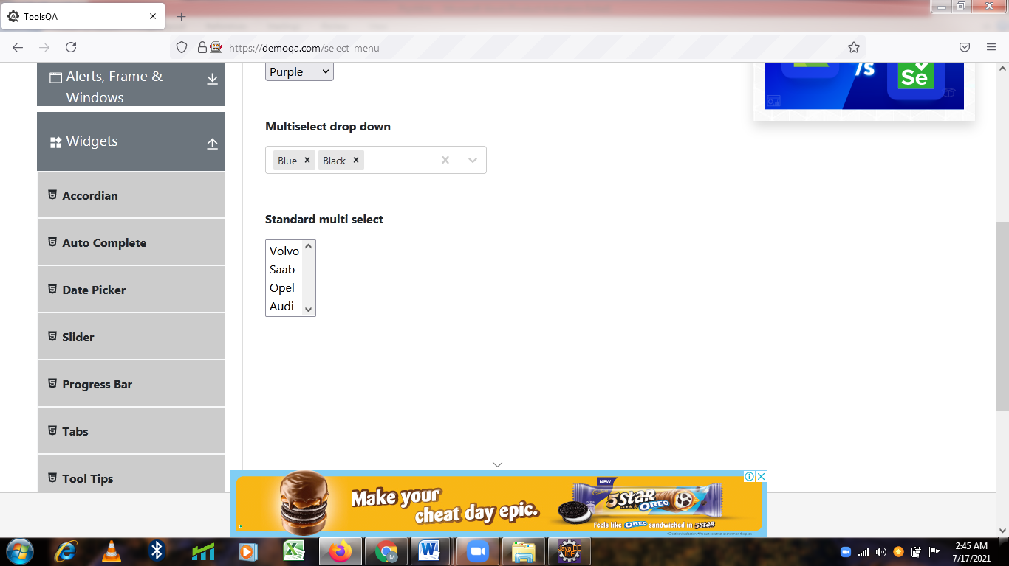

**TC107-To Check the functionality of Standard multi Select Button**

**Selenium WebDriver Test Script :**

Select s4= new Select(w.findElement(By.xpath("/html[1]/body[1]/div[2]/div[1]/div[1]/div[2]/div[2]/div[1]/div[8]/div[1]/select[1]")));

s4.selectByVisibleText("Volvo");

s4.selectByValue("audi");

Thread.sleep(2000);

System.out.println(w.findElement(By.xpath("//*[@id=\"app\"]/div/div/div[1]/div")).getText());

w.navigate().back();

w.navigate().back();

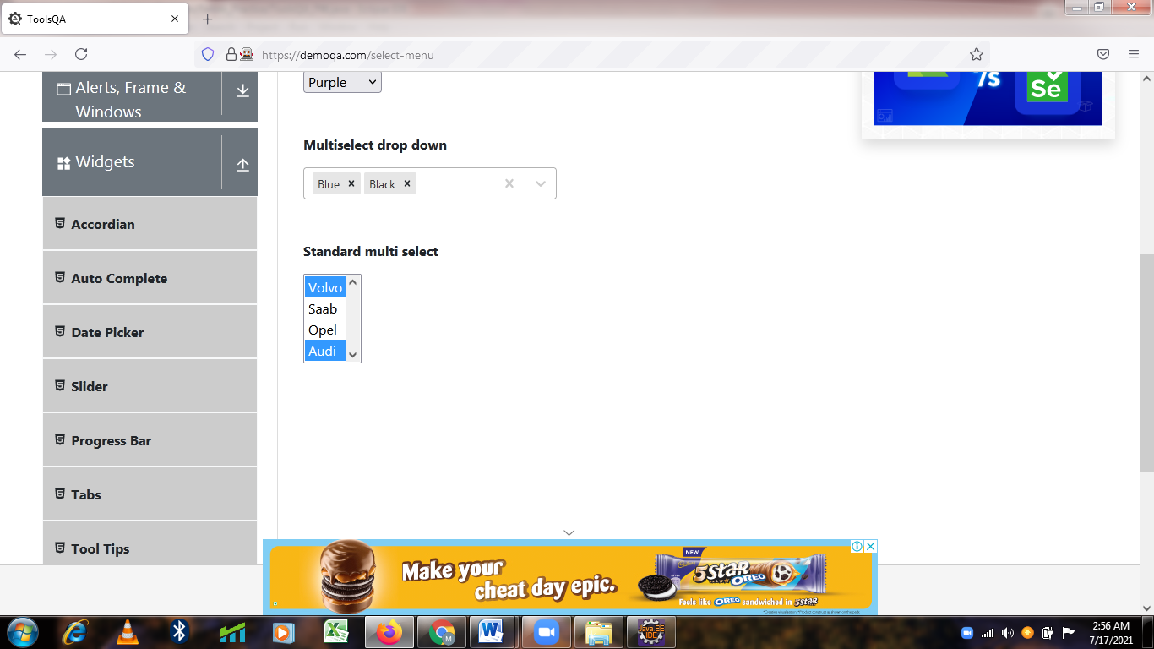

**TC 108– To check the functionality of interaction button**

**Selenium Webdriver test script:**

JavascriptExecutor jss = (JavascriptExecutor) w;

jss.executeScript("window.scrollBy(0,1500)");

w.findElement(By.xpath("//*[@id=\"app\"]/div/div/div[2]/div/div[5]/div/div[3]/h5")).click();

Thread.*sleep*(3000);

System.***out***.println(w.findElement(By.*xpath*("//body/div[@id='app']/div[1]/div[1]/div[1]")).getText());

System.***out***.println(w.findElement(By.*xpath*("//body/div[@id='app']/div[1]/div[1]/div[2]/div[2]")).getText());

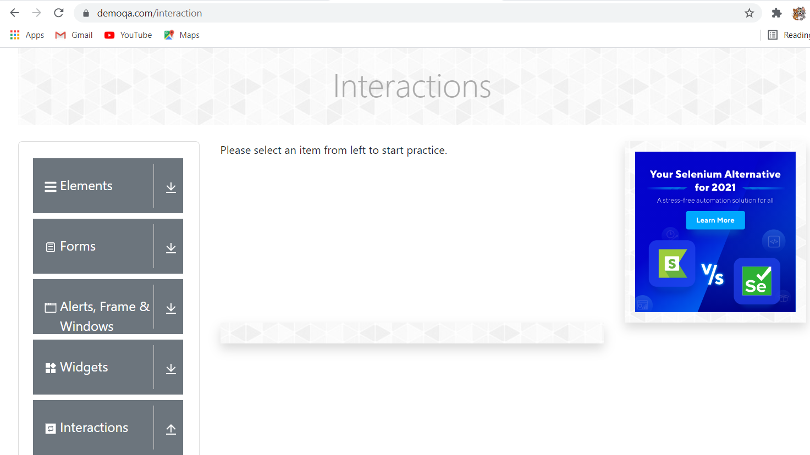

**TC 109– To check the functionality of Interaction- sortable button**

**Selenium Webdriver test script:**

JavascriptExecutor jss1 = (JavascriptExecutor) w;

jss1.executeScript("window.scrollBy(0,1500)");

Thread.*sleep*(2000);

w.findElement(By.*xpath*("//span[contains(text(),'Sortable')]")).click();

Thread.*sleep*(3000);

System.***out***.println(w.findElement(By.*xpath*("//body/div[@id='app']/div[1]/div[1]/div[1]")).getText());

//list

WebElement dr = w.findElement(By.*xpath*("//*[@id=\"demo-tabpane-list\"]/div/div[1]"));

WebElement dp = w.findElement(By.*xpath*("//*[@id=\"demo-tabpane-list\"]/div/div[4]"));

Actions A = **new** Actions (w);

A.dragAndDrop(dr,dp).build().perform();

Thread.*sleep*(3000);

System.***out***.println("Sortable List");

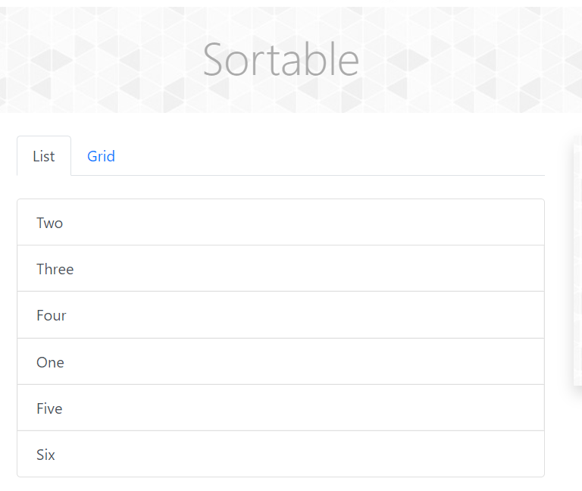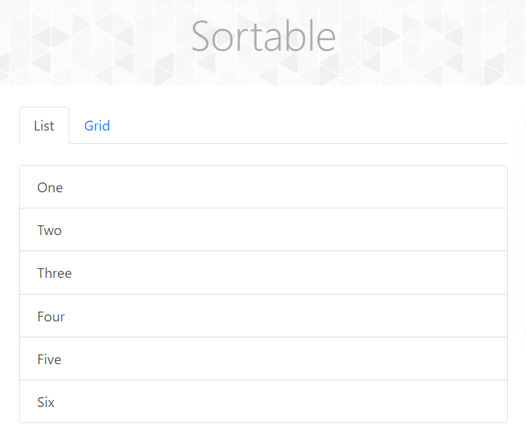//before //afte

**TC 110 – To check the functionality of Interaction- sortable – grid button**

**Selenium Webdriver test script:**

w.findElement(By.*linkText*("Grid")).click();

Thread.*sleep*(3000);

WebElement dr1 = w.findElement(By.*xpath*("//*[@id=\"demo-tabpane-grid\"]/div/div/div[2]"));

WebElement dp1 = w.findElement(By.*xpath*("//*[@id=\"demo-tabpane-grid\"]/div/div/div[8]"));

Actions A1 = **new** Actions (w);

A1.dragAndDrop(dr1,dp1).build().perform();

Thread.*sleep*(3000);

System.***out***.println("Sortable Gird");

//before //after

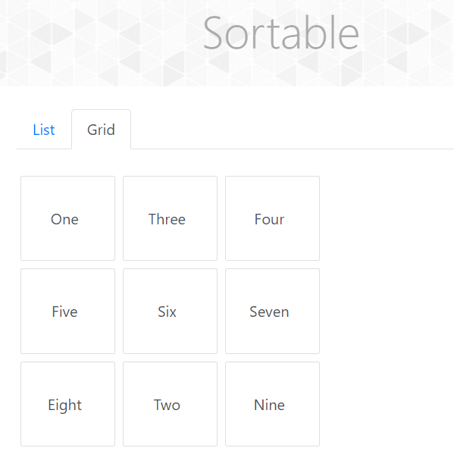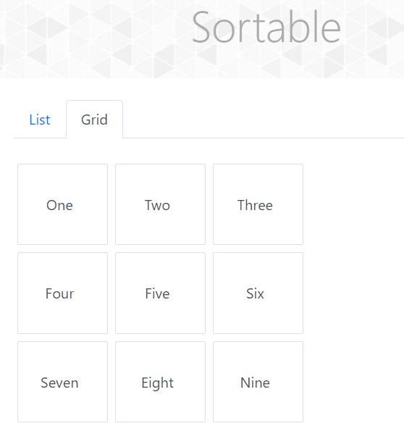

**Selenium Webdriver test script:**

**TC 111–To check the functionality of Interaction- Selectable button**

JavascriptExecutor jss2 = (JavascriptExecutor) w;

jss2.executeScript("window.scrollBy(0,1500)");

Thread.*sleep*(2000);

w.findElement(By.*xpath*("//span[contains(text(),'Selectable')]")).click();

Thread.*sleep*(3000);

System.***out***.println(w.findElement(By.*xpath*("//body/div[@id='app']/div[1]/div[1]/div[1]")).getText());

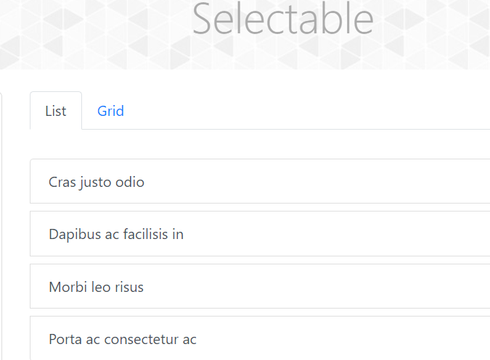

//list

w.findElement(By.*xpath*("//li[contains(text(),'Dapibus ac facilisis in')]")).click();

w.findElement(By.*xpath*("//li[contains(text(),'Porta ac consectetur ac')]")).click();

Thread.*sleep*(3000);

System.***out***.println("Selectable List");

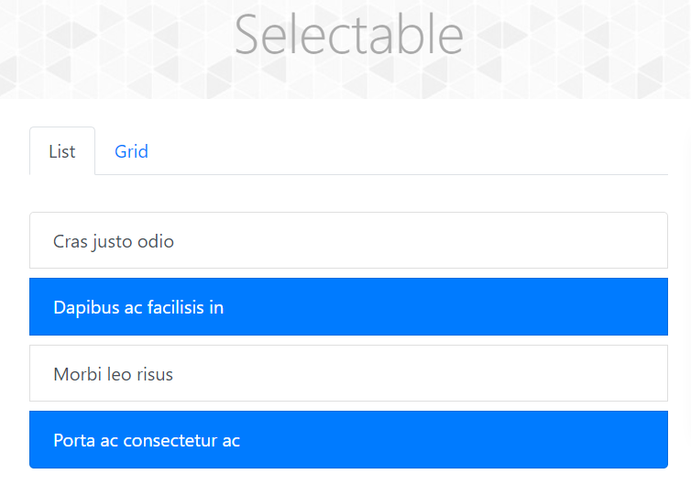

**TC 112– To check the functionality of Interaction- Selectable – grid button**

**Selenium Webdriver test script:**

w.findElement(By.*linkText*("Grid")).click();

Thread.*sleep*(3000);

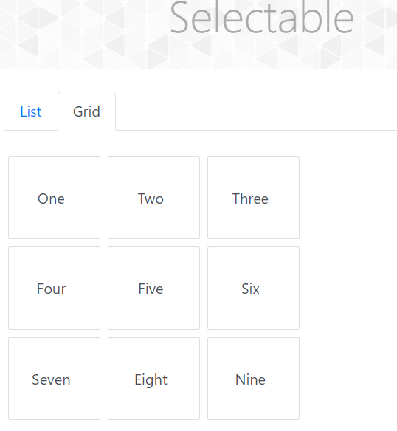

w.findElement(By.*xpath*("//li[contains(text(),'Five')]")).click();

w.findElement(By.*xpath*("//li[contains(text(),'Three')]")).click();

w.findElement(By.*xpath*("//li[contains(text(),'Seven')]")).click();

Thread.*sleep*(3000);

System.***out***.println("Selectable Grid");

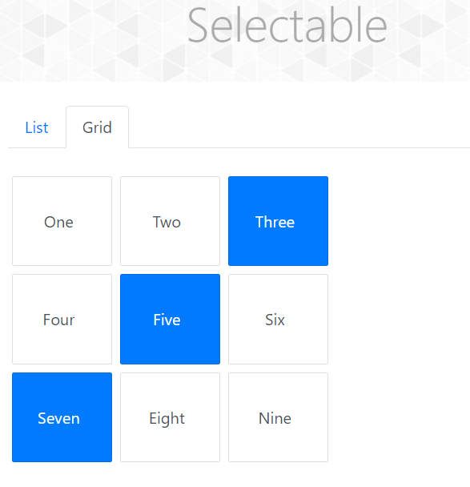

**TC 113 – To check the functionality of Interaction- resizable button**

**Selenium Webdriver test script:**

JavascriptExecutor jss3 = (JavascriptExecutor) w;

jss3.executeScript("window.scrollBy(0,1500)");

Thread.*sleep*(2000);

w.findElement(By.*xpath*("//span[contains(text(),'Resizable')]")).click();

Thread.*sleep*(3000);

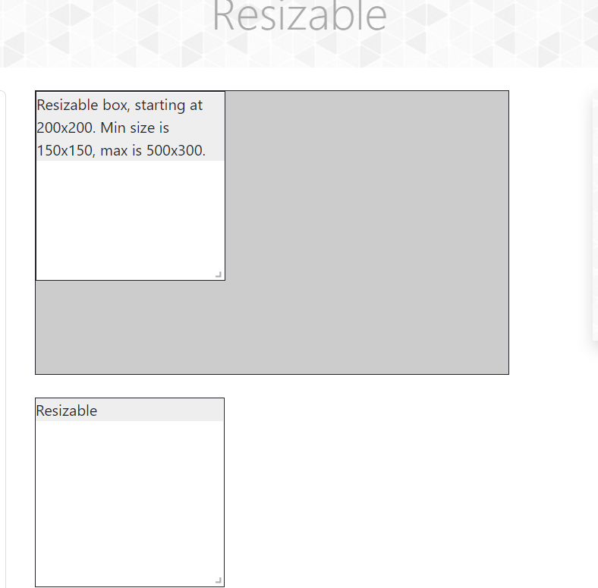

System.***out***.println(w.findElement(By.*xpath*("//body/div[@id='app']/div[1]/div[1]/div[1]")).getText());

WebElement re = w.findElement(By.*xpath*("//*[@id=\"resizableBoxWithRestriction\"]/span"));

WebElement re1 = w.findElement(By.*xpath*("//body/div[@id='app']/div[1]/div[1]/div[2]/div[2]/div[1]/div[2]/div[1]/span[1]"));

Actions resize = **new** Actions(w);

//provide x and y offset

resize.dragAndDropBy(re, 150, 180).build().perform();

Thread.*sleep*(3000);

JavascriptExecutor jss4 = (JavascriptExecutor)w;

jss4.executeScript("window.scrollTo(0,document.body.scrollHeight)");

Thread.*sleep*(3000);

resize.dragAndDropBy(re1, 200, 40).build().perform();

Thread.*sleep*(3000);

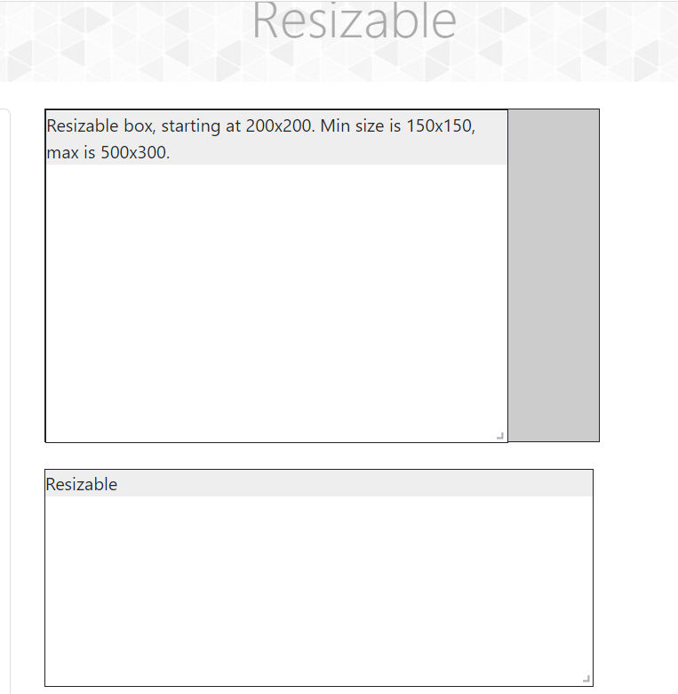

**TC 114– To check the functionality of droppable button**

**Selenium Webdriver test script:**

JavascriptExecutor jss5 = (JavascriptExecutor) w;

jss5.executeScript("window.scrollBy(0,1500)");

Thread.*sleep*(2000);

w.findElement(By.*xpath*("//span[contains(text(),'Droppable')]")).click();

Thread.*sleep*(3000);

System.***out***.println(w.findElement(By.*xpath*("//body/div[@id='app']/div[1]/div[1]/div[1]")).getText());

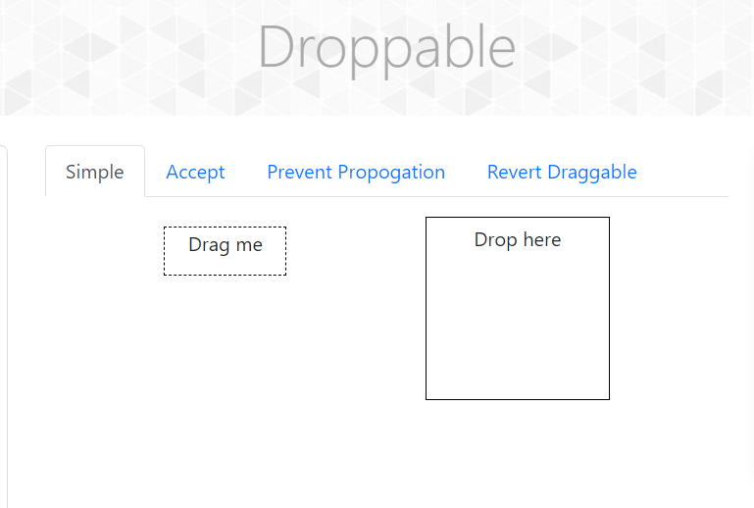

**TC 115 – To check the functionality of droppable - simple button**

**Selenium Webdriver test script:**

WebElement dr2 = w.findElement(By.*id*("draggable"));

WebElement dp2 = w.findElement(By.*id*("droppable"));

Actions A3 = **new** Actions(w);

A3.dragAndDrop(dr2, dp2).build().perform();

Thread.*sleep*(3000);

System.***out***.println("Droppable Simple");

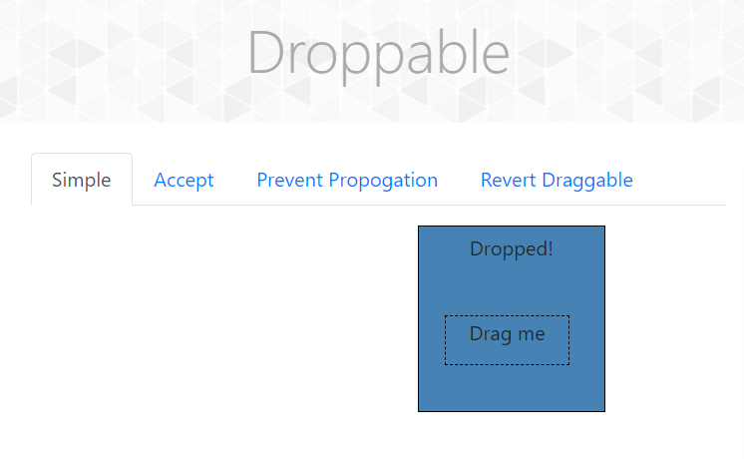

**TC 116– To check the functionality of droppable - Accept button**

**Selenium Webdriver test script:**

w.findElement(By.*linkText*("Accept")).click();

Thread.*sleep*(3000);

WebElement dr3 = w.findElement(By.*id*("acceptable"))

WebElement dp3 = w.findElement(By.*xpath*("//div[@id='acceptDropContainer']//div[@id='droppable']"));

Actions A4 = **new** Actions(w);

A4.dragAndDrop(dr3, dp3).build().perform();

Thread.*sleep*(3000);

WebElement dr4 = w.findElement(By.*id*("notAcceptable"));

WebElement dp4 = w.findElement(By.*xpath*("//div[@id='acceptDropContainer']//div[@id='droppable']"));

Actions A5 = **new** Actions(w);

A5.dragAndDrop(dr4, dp4).build().perform();

Thread.*sleep*(3000);

System.***out***.println("Droppable Accept");

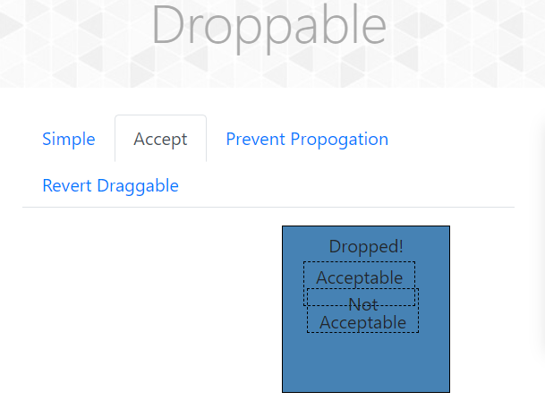

**Defect:**

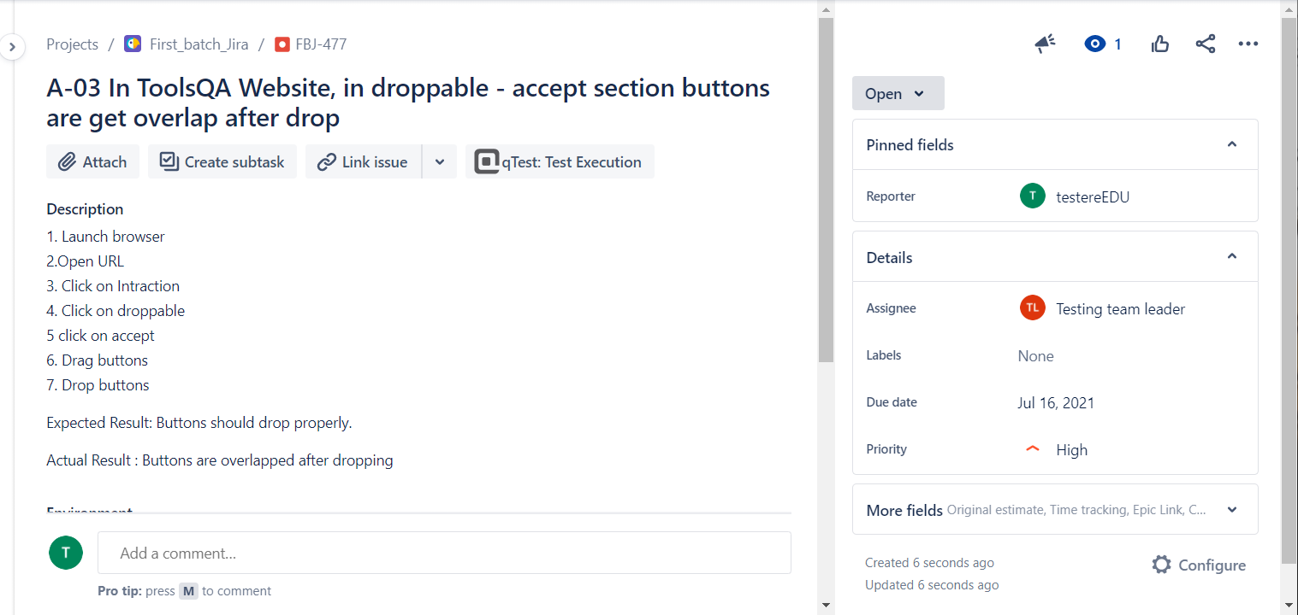

**TC 117– To check the functionality of droppable - Prevent Propogation button**

**Selenium Webdriver test script:**

w.findElement(By.*linkText*("Prevent Propogation")).click();

Thread.*sleep*(3000);

WebElement dr5 = w.findElement(By.*id*("dragBox"));

WebElement dp5 = w.findElement(By.*id*("notGreedyInnerDropBox"));

Actions A6 = **new** Actions(w);

A6.dragAndDrop(dr5, dp5).build().perform();

Thread.*sleep*(3000);

System.***out***.println("Droppable prevent propogation");

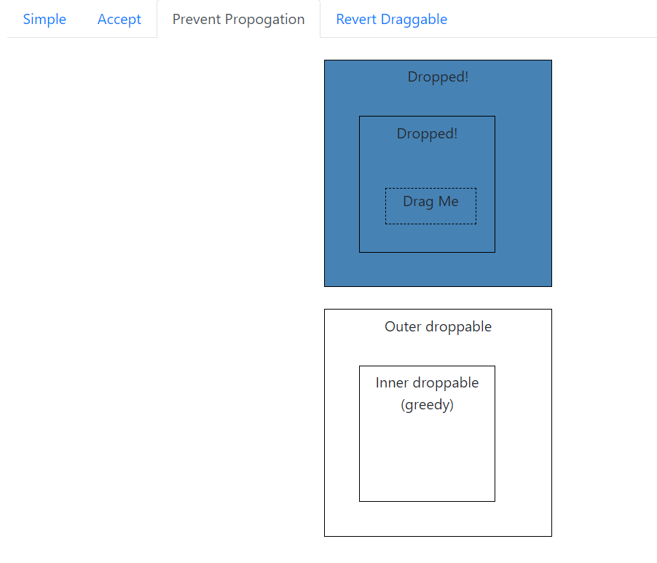

**TC 118 – To check the functionality of droppable - button**

**Selenium Webdriver test script:**

w.findElement(By.*linkText*("Revert Draggable")).click();

Thread.*sleep*(3000);

WebElement dr6 = w.findElement(By.*xpath*("//div[@id='notRevertable']"));

WebElement dp6 = w.findElement(By.*xpath*("//div[@id='revertableDropContainer']//div[@id='droppable']"));

Actions A7 = **new** Actions(w);

A7.dragAndDrop(dr6, dp6).build().perform();

WebElement dr7 = w.findElement(By.*id*("revertable"));

WebElement dp7 = w.findElement(By.*xpath*("//div[@id='revertableDropContainer']//div[@id='droppable']"));

Actions A8= **new** Actions(w);

A8.dragAndDrop(dr7, dp7).build().perform();

Thread.*sleep*(3000);

System.***out***.println("Droppable revert draggable");

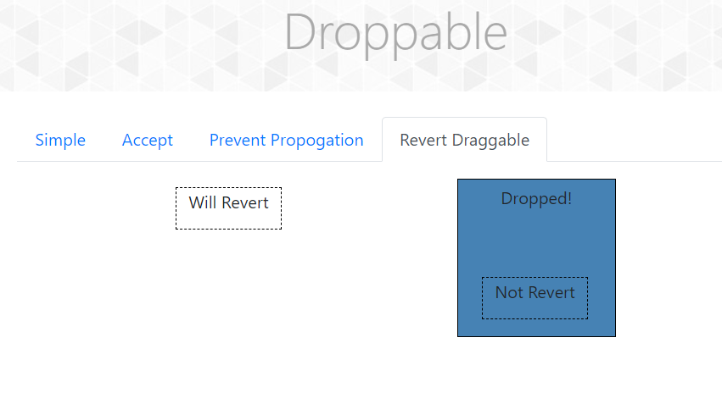

**TC 119 – To check the functionality of draggable - button**

**Selenium Webdriver test script:**

JavascriptExecutor jss6 = (JavascriptExecutor)w;

jss6.executeScript("window.scrollBy(0,1500)");

Thread.*sleep*(2000);

w.findElement(By.*xpath*("//span[contains(text(),'Dragabble')]")).click();

Thread.*sleep*(2000);

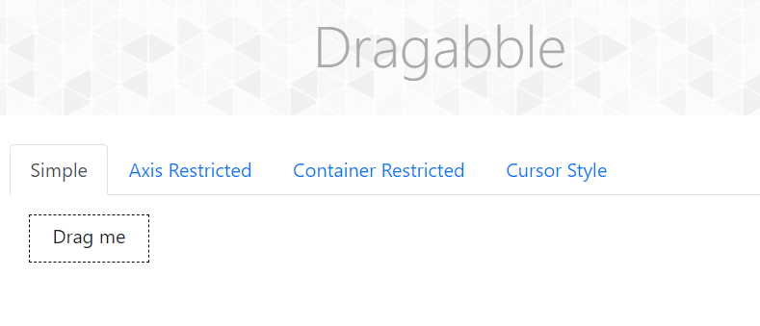System.***out***.println(w.findElement(By.*xpath*("//body/div[@id='app']/div[1]/div[1]/div[1]")).getText());

**TC 120– To check the functionality of draggable-simple button**

**Selenium Webdriver test script:**

WebElement dr8 = w.findElement(By.*id*("dragBox"));

Actions AA8 = **new** Actions(w);

AA8.dragAndDropBy(dr8, 60, 50).build().perform();

Thread.*sleep*(3000);

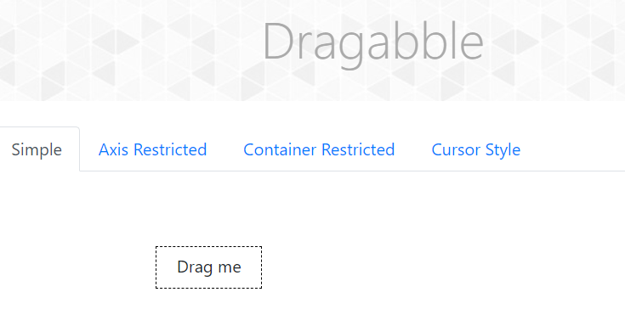System.***out***.println("Draggable Simple");

**TC 121– To check the functionality of draggable-Axis restricted button**

**Selenium Webdriver test script:**

w.findElement(By.*linkText*("Axis Restricted")).click();

Thread.*sleep*(2000);

WebElement x=w.findElement(By.*id*("restrictedX"));

WebElement y=w.findElement(By.*id*("restrictedY"));

Actions A9 = **new** Actions(w);

A9.dragAndDropBy(x, 80, 0).build().perform();

Thread.*sleep*(2000);

A9.dragAndDropBy(y, 0, 110).build().perform();

Thread.*sleep*(3000);

System.***out***.println("Draggable Axis restricted");

//before

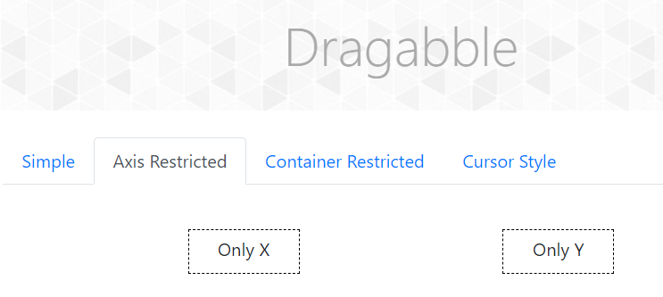

//after

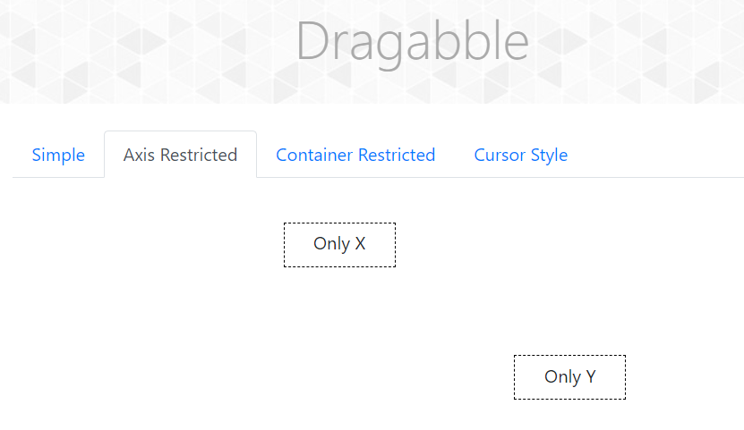

**TC 122– To check the functionality of draggable-container restricted button**

**Selenium Webdriver test script:**

w.findElement(By.*linkText*("Container Restricted")).click();

Thread.*sleep*(2000);

WebElement within =w.findElement(By.*xpath*("//div[contains(text(),\"I'm contained within the box\")]"));

WebElement outside =w.findElement(By.*xpath*("//span[contains(text(),\"I'm contained within my parent\")]"));

Actions A10 = **new** Actions(w);

A10.dragAndDropBy(within, 100, 40).build().perform();

Thread.*sleep*(2000);

A9.dragAndDropBy(outside, 20, 50).build().perform();

Thread.*sleep*(3000);

System.***out***.println("Draggable Container restricted");

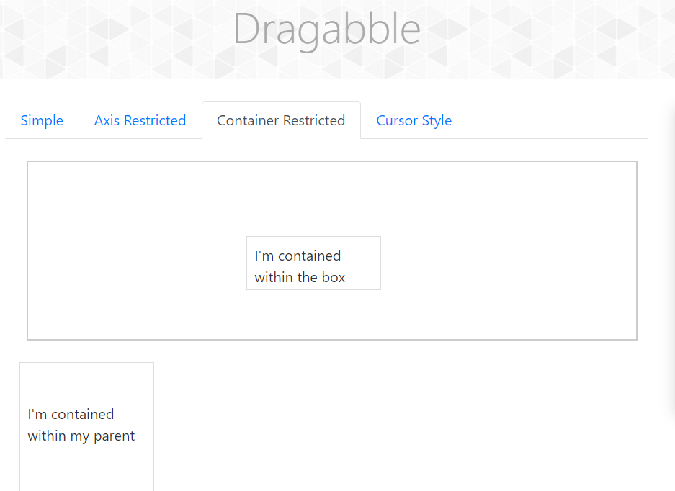

**TC 123– To check the functionality of draggable-cursor style button**

**Selenium Webdriver test script:**

w.findElement(By.*linkText*("Cursor Style")).click();

Thread.*sleep*(2000);

WebElement center =w.findElement(By.*id*("cursorCenter"));

WebElement top =w.findElement(By.*id*("cursorTopLeft"));

WebElement bottom =w.findElement(By.*id*("cursorBottom"));

Actions A11 = **new** Actions(w);

A11.dragAndDropBy(center, 290, 260).build().perform();

Thread.*sleep*(2000);

A11.dragAndDropBy(top,0,0).build().perform();

Thread.*sleep*(2000);

JavascriptExecutor jss7 = (JavascriptExecutor) w;

jss7.executeScript("window.scrollBy(0,2000)");

Thread.*sleep*(2000);

A11.dragAndDropBy(bottom, 0, 240).build().perform();

Thread.*sleep*(3000);

System.***out***.println("Draggable cusor style");

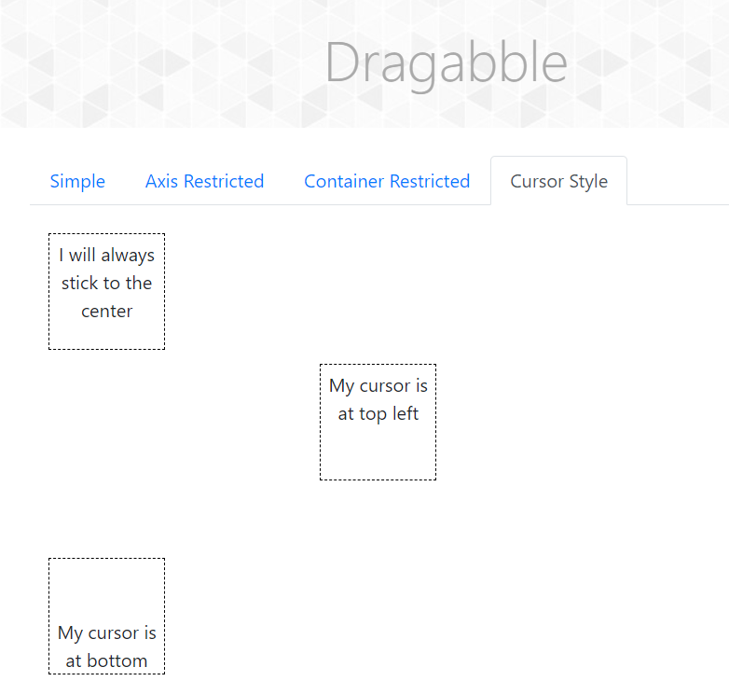

**TC 124- To Check Functionality of Scrolling Window**

**Selenium WebDriver Test Script:**

JavascriptExecutor js=(JavascriptExecutor) w;

js.executeScript("window.scrollBy(0,1500)");

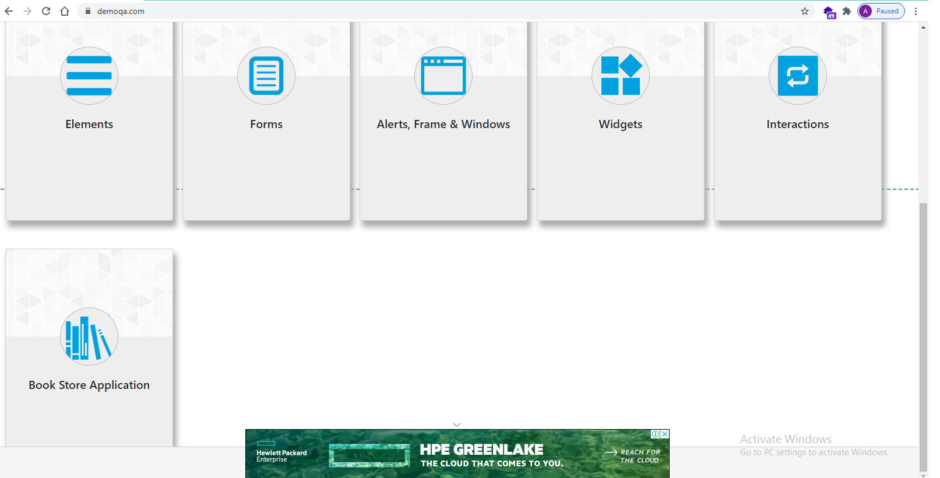

**TC 125- To Check Functionality of Book store Application**

**Selenium WebDriver Test Script:**

w.findElement(By.*xpath*("//body/div[@id='app']/div[1]/div[1]/div[2]/div[1]/div[6]/div[1]/div[2]/*[1]")).click();

System.***out***.println("from Book Store module");

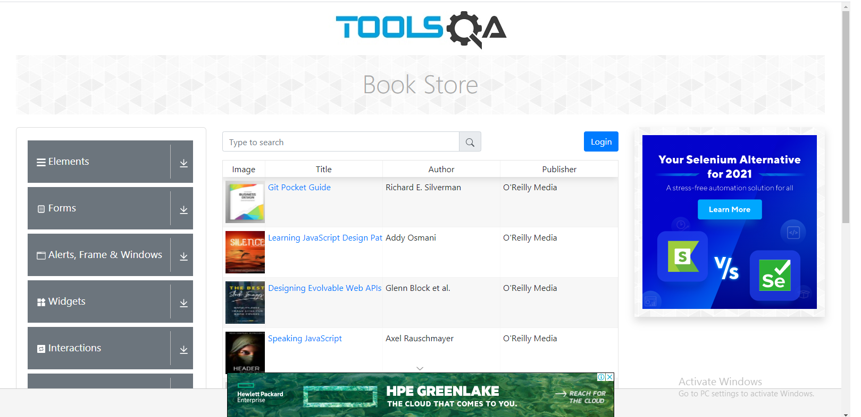

**TC 126- To Get the URL Book Store Application page**

**Selenium WebDriver Test Script:**

System.***out***.println("URL of page="+w.getCurrentUrl());

**TC 127- To check The Functionality of Login Tab**

**Selenium WebDriver Test Script:**

w.findElement(By.*xpath*("//span[contains(text(),'Login')]")).click();

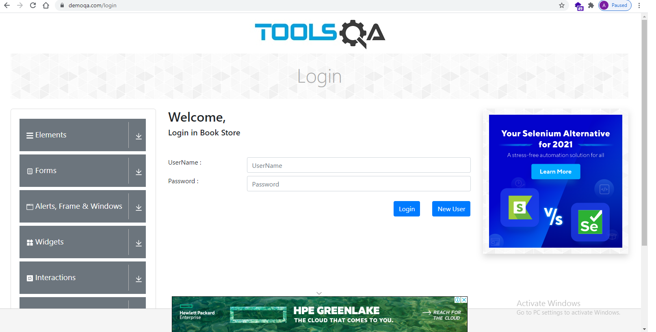

**TC 128- To check the Functionality of New User Button**

**Selenium WebDriver Test Script:**

w.findElement(By.*xpath*("//button[@id='newUser']")).click();

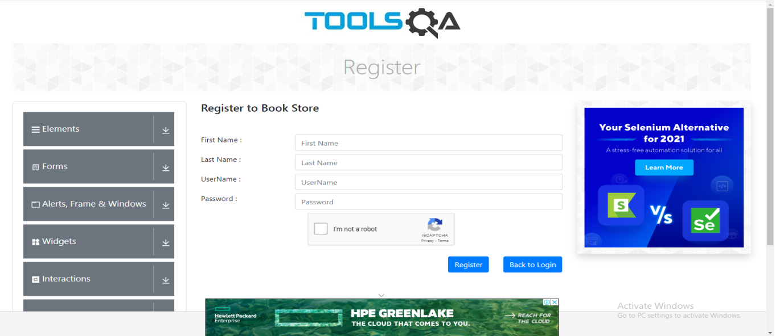

**TC 129- To check Functionality of Back to login Button**

**Selenium WebDriver Test Script:**

w.findElement(By.*xpath*("//*[@id=\"gotologin\"]")).click();

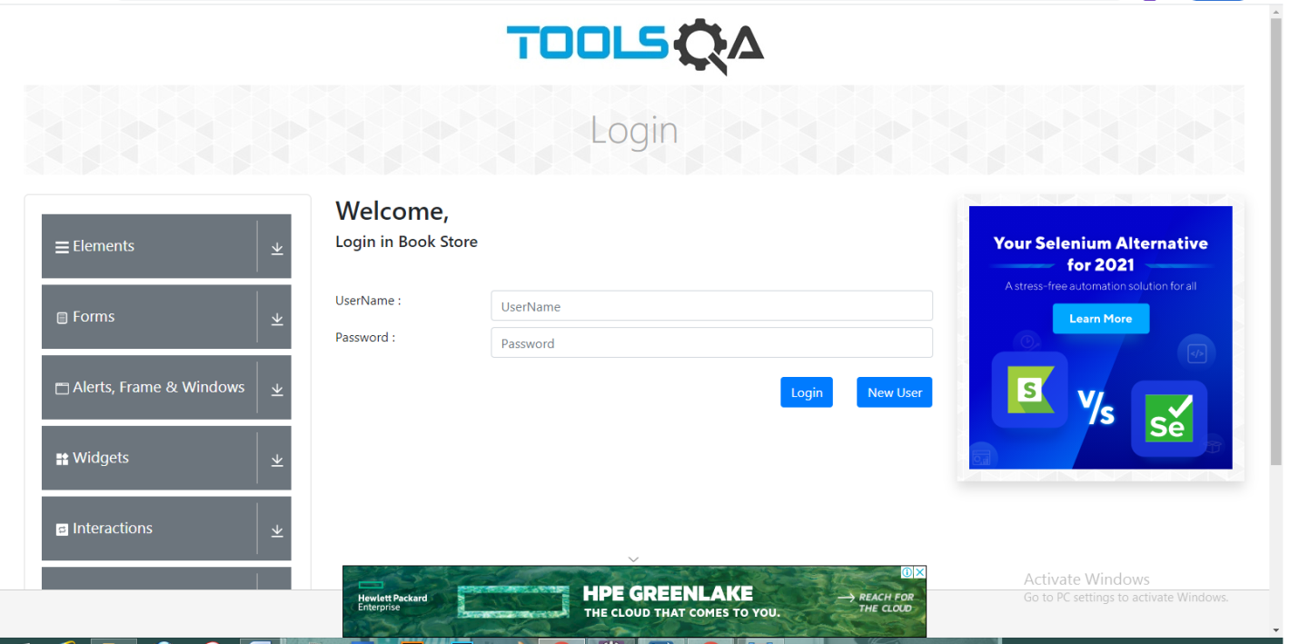

**TC 130- To check Functionality of Book store Login button with valid data**

**Selenium WebDriver Test Script:**

w.findElement(By.*xpath*("//*[@id=\"userName\"]")).sendKeys("Madhuri123");

w.findElement(By.*xpath*("//*[@id=\"password\"]")).sendKeys("Madhuripatil@123");

w.findElement(By.*xpath*("//*[@id=\"login\"]")).click();

System.***out***.println("login done with valid data");

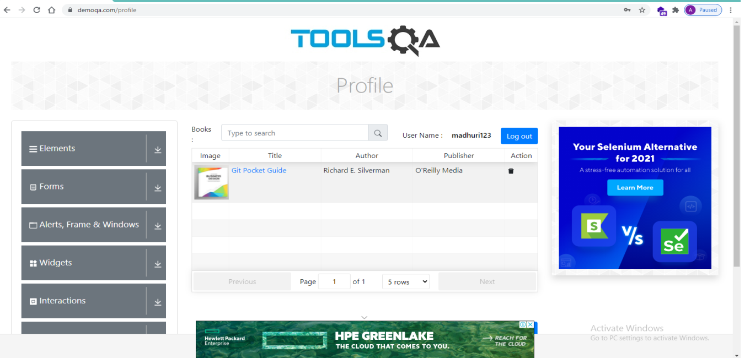

**TC 131- To check Functionality of Git Pocket Guide link**

**Selenium WebDriver Test Script:**

w.findElement(By.*linkText*("Git Pocket Guide")).click();

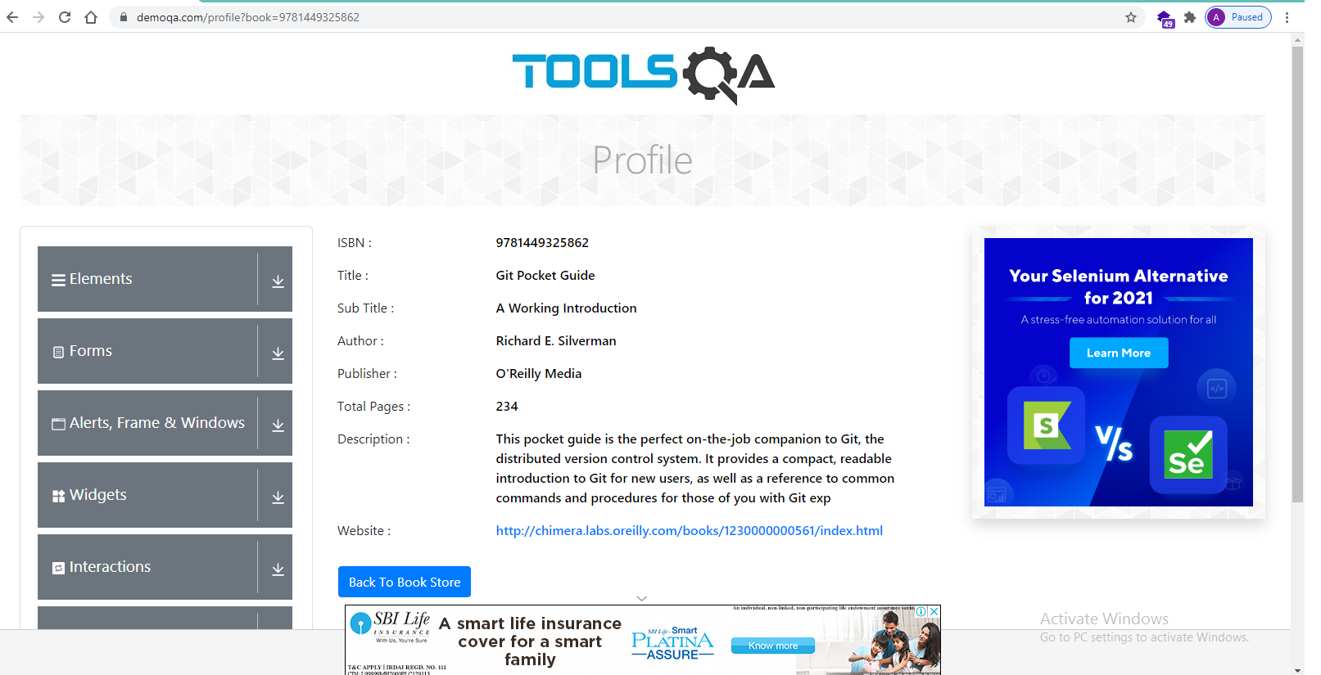

**TC 132- To check Functionality of Book Store Login with Invalid data**

**Selenium WebDriver Test Script:**

w.findElement(By.*xpath*("//*[@id=\"userName\"]")).sendKeys("Abc123");

w.findElement(By.*xpath*("//*[@id=\"password\"]")).sendKeys("Abc@123");

w.findElement(By.*xpath*("//*[@id=\"login\"]")).click();

System.***out***.println(w.findElement(By.*xpath*("/html[1]/body[1]/div[2]/div[1]/div[1]/div[2]/div[2]/div[1]/form[1]/div[5]/div[1]/p[1]")).getText());

System.***out***.println("Login failed with invalid data");

